* Oscar and the Universe *

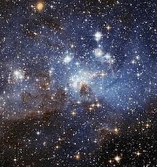

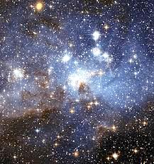
The Fate of the Universe
A Bit of Chit-Chat

Mr V:
Oscar, even the stars will rust,
Will oxidise away into
Cold lumps of metal drifting through
The voids of interstellar dust.

The stars will rust, will rust away!
God’s eye, in which you put such faith,
Will yellow and go blind, and death,
Oh death! will have the final say.

Come, dear, do not encourage God’s
Inveterate Hamlet tendency
To ask, To be or not to be.
To live is to defy the odds,

And life needs all the help that it
Can get. If God were Schopenhauer—
Which, God forbid!—he, being sour
And grim, would cite the infinite

Superiority of death
To life, with its blind, brutish will,
Trade fiat lux for fiat nil,
There’d be no lungs to draw a breath

And we would not be talking here
Of life and death, the universe,
And other things. Don’t think a hearse
Is the last stop in Life’s career,

At least don’t treat it as a fait
That’s destined to be accompli.
The Cosmos must be made to see
That things need not turn out that way.

We are the only means by which
This universe can understand
Itself. It needs a helping hand.
In turn it should not simply switch

The lights off—not, at least, without
Consulting us. We have a stake!
It must not make this grave mistake.
It must be cured of its self-doubt.

And I am very sure of this:
It’s sensitive to what we say.
Don’t tell it it will die one day.
No, tell the universe it is

Immortal, and, if it believes
You, what you say may well prove true.
God doesn’t know quite what to do,
He grieves how things went wrong, He grieves,

And sometimes His believers have
To talk Him out of suicide.
What would we do, if poor God died?
The cosmos would become a grave.

He looked upon his Work, and saw
It might be good, but wasn’t sure.
This is what makes the Lord so dour:
His Plan may have a fatal flaw.

He fears exactly what you fear,
That all will end in dust and rust.
Let’s reassure Him, dear—we must!
Or every where will be nowhere.

Material substance, too, can’t quite
Decide to exist or not exist.
If not, ah, how it would be missed!
We should encourage it to fight

The impulse to annihilate
Itself in any way we can.
We should present it with a plan—
Which would be? To procrastinate!

