* Authors and Arthurs *

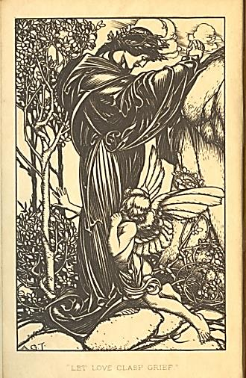

♫

Tennyson and I

Table of Contents

Urania or Uranus? 3

In Memoriam A.H.H. 9

The Arthur Cycle 18

By the Ivory Gate 29

Valediction Forbidding Mourning 32

Appendix: Musical Program 34

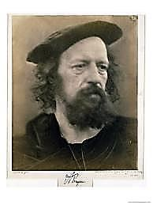
Tennyson and I
Urania or Uranus?

My mind has wandered onto the
estate of his childhood and youth,
Somersby, still haunted by his ghost.

1.
I stand before your old yew tree;
It sends up, at my tender stroke,
‘A fruitful cloud’, and I invoke See In Memoriam, Section 39.
Melodious Melpomene,

As once you did. I wear the buskin
And not the comic sock; in umber
And solemn black arrayed, I number
Myself among the sons of Ruskin:

A fallen son, who lost his way
To Ferry Hinksey, and in the mire
Found an unclean Sublime. Desire,
Mad passion, rubbed his art away

To show, beneath its satin sheen,
The cankers on his pagan soul.—
What, am I maudlin? But the rôle
Demands it!—I will set the scene

Inside a hotel, or a prison,
Or nowhere. My soul wears a hair
Shirt, ugly, itchy. A cast is there
Of spirits made of books. I listen

To the Heavenly Hosts of Literature.
You had a higher Muse, Alfred:
Urania, with her star-crowned head,
The Muse of Faith. Here I demur:

For my Urania, ‘Heavenly Muse
That on the sacred top,’ and so
Forth, was Uranian, you know,
And given, thus, to different views

On Heaven, and Hell, and good and evil,
And, certainly, of false and true.
Do I seem evil, false to you?
One man’s God is another’s Devil.

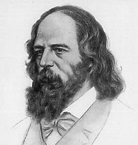
I doubt it will much please the Saints
To see an unrepentant son
Of Sodom at the Gates. They’d shun
A man like me. My poor heart faints!

With trepidation will I cross
The bar. Till then I, too, would speak
Of tragic love; for I, too, seek
What gain a soul may glean from loss.

2.
You and that love of yours! You lost
Your dignity and honour for it.
You would not let the world ignore it.
My dear sir, was it worth the cost?

To indulge a not-so-secret shame
You killed the heart of your good wife,
And ruined your own brilliant life
For ‘Love that dare not speak its name’. He quotes the fateful closing line from
Alfred Douglas’s poem, ‘Two Loves’,
As for your two poor sons: you made used against me in the Trials.
Them orphans! When all’s said and done
Are not these two the same and one,
‘The lips betraying, the life betrayed’? From my poem, ‘Humanitad’.

3.
Let’s talk about your love, my friend:
Look in your heart, sir: are you sure
That it was all so very pure
And virtuous as you pretend?

You read through the Symposium
Together, surely (doubtless on
A riverbank or rich green lawn):
Did not your heart beat like a drum?

Was not this love you think ‘Platonic’
A thing much deeper, more intense,
Compounded of both soul and sense,
Its sheer persistence half-daemonic?—

Uranus sired the goddess whose
Dominion is our sort of love.
Why strain to set yourself above
Your nature by a moral ruse?
Your words are truer than you know See In Memoriam,
When you compare your love for him Section 60.
To one a wife, or maiden slim,
Feels for her husband or her beau.

You pair your love with the Bard’s for
His friend, the beautiful young man.
‘I love thee,’ so you write, ‘nor can
The soul of Shakespeare love thee more’.—

Shakespeare, whose name will never fade,
Whose passion for his Willie Hughes See The Portrait of Mr W.H.
(That boyish, sorrow-bringing Muse)
Put the Dark Lady in the shade!

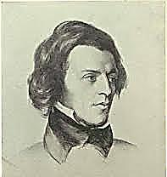
Metaphor may poeticise
Or render vague, but not conceal
A truth you can’t help but reveal
To all initiated eyes;

Reveal it even to the Press,
That Cerberus ever-set to pounce:
Did not the thunderous Times denounce Arthur Hallam.
Your ‘amatory tenderness’?

Love longs for immortality, As Socrates argues in The Symposium.
And what is In Memoriam
If not a great love poem? I am
Dismayed by your perversity.

4.
How can you speak such blasphemies!
Things so impertinent, so wrong!
Stealing the measure of my song
To mock a friendship’s Mysteries!

If you had known my noble friend
You might have put yourself to school
And never played the brazen fool
Who came to such a wretched end.

‘Apostle of Beauty’! Ah, the shame
You brought upon Art’s sacred cause,
For fame, for money and applause!
You made it seem a sordid game.

You were committed, not to art,
But to celebrity.—I was
My art! Indeed, a noble cause!
How bravely you took Oscar’s part!

What you committed, petty crime
Against true art, but paved the way for
Much greater crimes you justly pay for.
Your ‘Mrs Grundy’ is sublime!
Ah, what a shame, how you betrayed
Your special gift—the sensuous, free
Yet serious play of imagery
And sound—as you grew old and staid!

Weren’t you an aesthete in your youth,
Drunk on the beauty of your rhymes?
You aged, you truckled to the times,
And cant usurped poetic truth.

I truckled, sir? Recall the way
You curried the disfavour of press
And public; you were lost—confess!—
With no bourgeois to épater.

What insolence you showed! (The scorn
You heaped upon the public was
Such public scorn.). They let it pass
Till too outrageous to be borne.

5.
How public was the private pain
You uttered in an elegy
That’s more autobiography
Than paean to a fallen swain!

The uses of adversity
Are bittersweet. The elegies
Became a habit, a release,
A spur to creativity;

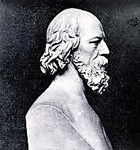
Grief was convenient to your Muse.
For if—to put it cynically—
To love is good for poetry,
‘Tis better still to love and lose.

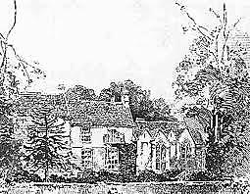
Did I not own it half a sin
To put in words the grief I felt,
To make parade of pain, and melt
In idle tears, as if to win

The praise that comes to constancy?
The questions and objections I
Put to myself did I not try Somersby Manor.
To answer, with sincerity,

By crying out for all mankind
Against the loss of dearest things?
And though my faith had injured wings,
And skipped and fluttered in the wind,
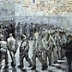
It kept its homing instinct sound.
Through doubt’s obscure and savage wood
It struggled towards whatever good
Might in the truth of things be found,

And found it in futurity,
In progress towards perfection of
A race sworn to the God of Love—
A humanised divinity.

6.
Then you turned Sage, and so became Worse, ‘The Ancient Sage’.
The official portrait of yourself,
A bust upon a study shelf
With an august and chiseled name.

One thinks of Wordsworth, once how great!
Who sold his soul, and did not know it;
Who, born a visionary poet,
Died a mere Poet Laureate.

You have your epigrams, that hallow
The superficial and the shallow,
The sophomoric and the callow
And have the pith of a marshmallow!

A corpulent heresiarch,
You stooped to wallow in the mire
Of unimaginative desire
And drowned in lust your spirit’s spark.

A dissipated Magus, with
Your cult of poets, catamites
And stable boys, you taught them rites
Of shameful gnosis, and a myth

To flatter all the prettiest faces,
Perfumed with Platonism, and
Keats, and the Higher Twaddle, and grand
Gestures, and wine, and cigarette cases!

What have you given our English Youth?
An overstimulated brain,
An underfed soul, and disdain
For wisdom, decency, and truth.

Of all things new most reverent,
In awe of vogue, and trend, and pose,
They have, beneath their stylish clothes,
The soul of an adverstisement.

Their only god ‘Self-Realisation,’
They live in slavery to their senses,
Consumers of experiences
With a bankrupt imagination.
Now Tennyson resembles Curzon
And that poetic cant about speaking against my nomination to
The Child as model for us all! the Crabbett Club (summer of 1891?).
What is it but a gilded pall
For sins you would not live without?

You wonder why good folk take fright
To see unsteadily walking past
An unrepentant paederast,
And shield their children from the sight?

Without a conscience or an aim
You lived and wrote; your room and board
Most richly you deserve.—My Lord,
May I say nothing?—Shame, sir, shame! He and Somersby Manor vanish.
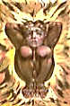
In Memoriam A.H.H.
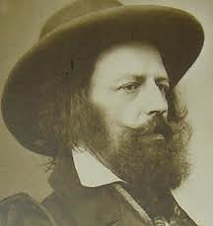
Somersby Manor.

1.
Read with kind eyes, dear Tennyson,
This Grieving Song. Grudge not to lend
The form in which you mourned your friend
To one who asks your benison.

I add a fin-de-siècle clarity
As muttering winds, bleak, Hyperborean,
Fan the ashes of our Victorian
Bonfire of Empire and austerity.

So loftily vulgar and virtue-bent,
This so-progressive century,
Now burying both itself and me,
Deserves a stranger testament.

Tastefully grand, your Hall of Woe—
And yet (I trust you’ll take me lightly)
I thought I might refurbish slightly,
Adding a touch more Art Nouveau?

My sorrow takes a different path
Than yours. My style of grief demands a
Boudoir, an intimate sort of stanza,
Where (prelude, tryst, and aftermath)

Love lives its brief ABBAs;
Where eyes, then hands, then lips may meet
Blissfully, till reluctant feet
Bear them upon their separate ways.

2.
Your stanza is a coach and four:
The pace is slow and funerary;
Inside the coach, a solitary
Passenger sits head bowed, heart-sore.

Solemnly onward the wheels roll,
Bearing you and your weary load
Of grief down the high royal road
Into the vexed Victorian soul,

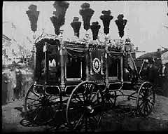
That shrinks from science’s cold facts,
Not knowing what her fate shall be,
Survival or blank nullity,
Whilst space’s vast and empty tracts,

When at the sky she dares to look,
Stretch out before her on all sides,
And in her nameless fear she hides
Her fragile faith inside a Book.

For what does science leave us with,
That gives the soul no food, no scope?
‘Immortal soul….’ A desperate hope
In the survival of a myth.

Your elegiac coach was half
An ambulance. Even the Queen ‘Next to the Bible, In Memoriam
Upon your sturdy words would lean is my comfort’, she said, referring
In her long grief, as on a staff. to her grief over Prince Albert’s death.

This carriage I dare requisition
For curious jaunts far from the highways,
Down shady lanes and crooked byways,
Pursuing quite another vision.

Your vehicle, wheels by tears greased,
Determined to end cheerfully,
With a galop’s forced gaiety
Crashes into a wedding feast.

I choose to name it l’Hirondelle, ‘The Swallow’.
My borrowed, begged or stolen coach,
And warn all those who would approach
The black, vibrating vehicle

That what is going on inside
Is a thing sordid and illicit:
For though I will not be explicit,
I’ll say that the poor soul who died Emma Bovary, of course.

Drooling black liquids from her lips
Is in the throes of petit mort
Foreshadowing what will, before
Long, be the Great One. And the whip’s

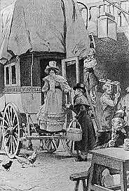
Reverberation as it cracks,
With creak of wheels and clatter of hooves
And driver cursing as it moves,
This coach, uneasily, leaving tracks

Down mud-bespattered Paris streets,
Is the fore-echo of her doom.
She writhes inside a rattling tomb.
The rain shakes down its winding sheets.

3.
Rein in your silly Pegasus,
Oscar. Your flights of fancy pall.
I ask, what right have you at all Actually, the form had been used before,
To use my unique stanza thus, by Lord Cherbury, among others.

Presume upon my poem’s title,
And light your small match at my bonfire?
Compared with which, yours is a wan fire.
All that you say is a recital,

A repetition or a theft.
You are no seer, merely a sayer,
A charlatan, a strolling player.
And look at you, you’ve nothing left!

A work of art’s no destination,
It is a starting point for new
Departures. What is one to do
But meet Creation with Creation?

Admittedly, my Lord, I was
Nothing if not jusque’au-boutiste
By taste and temperament, nor least
In the experimental Cause

I pressed in poetry and prose.
Extremes meet, in ways mystical,
For drinks, at the Café Royal.
And where the night may lead, who knows?

If you’re inviting me, thank you
No, though your offer’s very gracious.
Sarcasm in a soul as spacious
As yours, sir, seems somewhat voulu.

4.
You know I place you far above Discomfited by his angry attitude,
That singer with the honeyed lips, I attempt to flatter him by saying
He of the cognac and the whips, terrible things about his contemporaries,
So orotund when he drinks of opinions I do not in fact hold.

The ocean of alliteration:
How harmlessly the fires of sin burn
In the adolescent Hell of Swinburne!
Enfant terrible of the nation
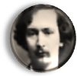
Once, spreading anarchy like rabies,
He goes to seed, a dry, deaf reed, in
His suburban Garden of Eden,
Watts-Duntonised, and kissing babies.

Arnold? The failing that defeats
His strengths strengthens his weaknesses.
The man is self-deceived: he is
A Keatsian poet who scorns Keats.

Look what a frigid elegy
He writes for his friend Arthur Clough!
Fine diction, images enough,
But a tone that says, Look at me!

I got it right. You went astray.
No note of genuine mourning pierces
The self-complacency of ‘Thyrsis’.
It is a cold and donnish lay.
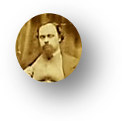
Through Mystery and Mystification
Rossetti leads us towards the Yonder,
But is at times inclined to wander
In mists of Personification.

Browning’s a genius, true, but wrong
Notes mar his measure. No, he lacks
Finesse. You, whilst he sometimes hacks
Through language, coax it into song.

His prosody I cannot brook.
He writes novels in rough blank verse;
Fiction’s blessing is poetry’s curse.
How fat a thing is Th’ Ring and th’ Book!

Inspired he often is—though one
Could wish it a more careful rapture.
And yet how deftly does he capture
Soul-states, he knows them to the bone! Alfred is not mollified.

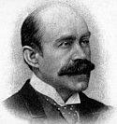
5.
As for your poetry, ‘tis all
Rank plagiarism—though that tinge
Of gaucherie that makes one cringe
Is, in its way, original.

A thing is public property
Once published; it is common food
For thought. Your stolen lines are good.
The rest is mediocrity,
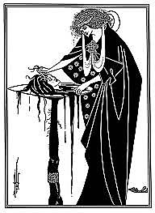
Inflated rhetoric, pastiche!
What reader of sound judgment thinks
Well of that stilted thing, ‘The Sphinx’?
Your Muse, sir, should be on a leash.

And how portentously you weary us
In Salomé, as hierophant
Of Symbolism! Ah, you can’t
Believe that you wrote something serious?

That flowery rant of Jokanaan…
‘The satyr and nymph have fled’? Has he
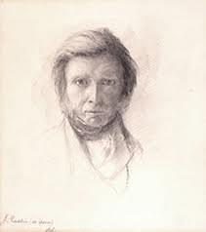
Been reading Monsieur Pierre Louÿs?
Oh how they all go on and on!

(It is my soul! Ruskin is John,
Pater is Salomé, who slays
The thing she loves—and ah, she pays
For that, as pay she must, anon!)

6.
Lord Alfred, let this rancour cease!
I didn’t mean to pain you when
I spoke so frankly. Once again
Have I burned through your masterpiece.

Pity me in my misery!
The light is dim, and I must strain
To parse your words. Alas, my brain
Is clouded. Keep me company.
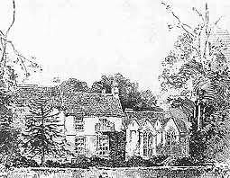
You found friendship a mystery,
With acolytes and lovers only
For company. Did you feel lonely,
At times, without quite knowing why?

Well, Oscar, let’s put by our quarrel
And talk about my poetry.
This time I promise to pass by
The question whether it was moral

Or otherwise, your fatal love
For that vain youth. Let us discuss
What in my poem touches us
As all-too-human creatures of

Religious longing. Endless Life
Is what we crave. Do we not need,
In this confounding world, a Creed
To guide us through the smoke and strife?

7.
Your nobly unpersuasive faith
Persuades us as a passionate doubt
We cannot help but care about
More deeply than we mourn the wraith

Of that young friend whose passing you
Immortalised in song. Oh how
You beg the seasons to avow
Their faith in what we humans do!

I cried to Nature, all unanswered,
To speak the holy name of God.
I could not bear to face this broad
Bewilderment unblessed, unsponsored.

Your soul speaks ever in ‘Two Voices,’
Of faith and doubt, hope and despair.
Which is the truer of the pair?
It’s clear: although your conscious choice is

To affirm and to believe, within
Your soul prevails that sad, that lonely
Voice, singing of its losses. Only
This sorrowing voice is genuine.

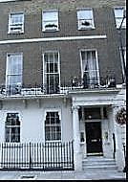
Nothing in art, or life, or science
Brings back the one you used to meet
At 67, Wimpole Street.
Religion fails the old reliance.

Lyell has changed all. Did Christ say,
Suffer the little dinosaurs
To come unto me? Who taught coarse
Darwinian ape-man how to pray?

Some things will thrive, the rest will fail.
From variations infinite
Evolves this Law austere, as it
♫
Is written in the Book of Shale.

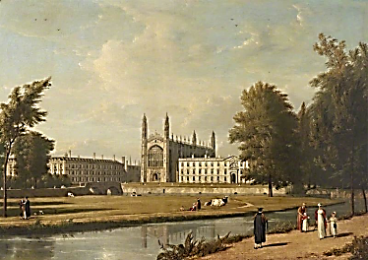
8.
Once, Oscar, on a mystic even
Out on this lawn, I felt a Soul
Breathe on my own, and make it whole.
(Two souls that touch touch also Heaven.)

The vision faded by and by,
But brought this hope, which eased my dread:
That Death itself had freed my dead
Dear friend to Life that cannot die;

That we in Heaven, hand in hand,
Might walk together, two as one,
Repeating in a finer tone
Words once exchanged on street and strand.

On quads of Art, and banks of Higher
Criticism, conversing by
A river, under a golden sky,
Amid the glittering dome and spire!

This would be very Heaven, surely:
A leisured University town,
Where Peter, dressed in cap and gown,
Directs a choir that sings demurely,

And, with a grave and owlish face,
Greets freshmen angels with a few
Kindly remarks, then points them to
Their rooms, their tutors, and valets.

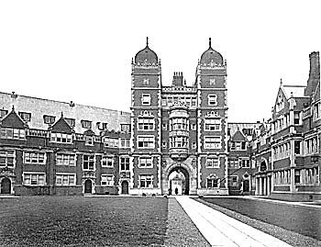
How gladly I would join you there!
What leisure to enjoy, what talks
Strolling along tree-shaded walks
In the umbrageous evening air!

We’d speak in measured, flowing feet
That through the listening conduits glide
Like graceful swans that breast the tide.
For Poetry is God’s helpmeet

Here on the lawns beyond the Wars,
And chiefly of Hallam now she sings,
Bright, haloed Hallam: how his wings
Are light, and woven of the stars;

How in the radiance of your friend
Was shadowed forth a finer life
Destined to rise above the strife
And crown with Peace the latter end.

Look! Punting down the river’s wending
Come Graces, Splendours, Spirits, Glories,
Recounting all of History’s stories
And how they reached this happy ending!
Ah, gentle reconciliation
Of Nature’s ravening tooth and claw
With the Creator’s sacred Law
Through Evolution’s mediation!

Hallam was hallowed by the earth
We shared, knitted as family members.
These halls rang out with laughter; embers
Winked kindly from the homely hearth.

The snide esprit of the cafés
Could not breach such a citadel.—
Your grief was landed, settled well
Into the turf of gentry days.

Still, I recount but half the story:
How oft you wing, from west to east,
On clean, fresh lyric gusts, to feast
On an authentic morning glory!

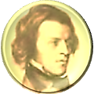
But sometimes, too, there is a taste of
Cold mutton in your funeral baked
Meats, some leftover grief that’s ached
Too long, and thrift has made a waste of.

9.
How without malice you deflate!
A most infuriating gift!
Even as you debase you lift.
Might this explain the special hate

You stirred up with those genial stings? We have something else in common::
It was the honey in your gall we both found the Alps disappointing.
That pained your victims most of all; Elizabeth Browning took you to task for
They envied you your generous wings. lack of cringing awe before the Sublime.

We cannot hold your jests against
You: this, of course, is what we hold
Against you. You are so calmly bold,
You leave us even more incensed. (Said with a smile.)

My levity was tactical,
A dangerous art of levitation.
Ah, with what vengeful gravitation
Things ponderous land when back they fall!

But my dear friend! I am bespoken.
My little children call for me
To help them trim the glittering tree.
And yet, to leave you here, heartbroken…

I bid you stay with us. Take part
In our festivities this Christmas.
There’s room, then, for a ragged Dismas
At the rich table of your heart?
♫

If you speak from mere charity,
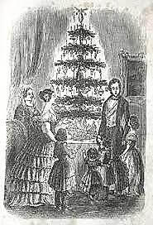
Dear Alfred, ah, I can’t stay here!
Agàpe, Oscar. But I fear
That ends in ‘pay’. Christ’s love is free.

Think not of losses now, nor grieve.
‘Mid glowing lights, and eyes that shine,
Savour the cakes, the goodly wine!
For gaily falls this Christmas-eve.
* T h e A r t h u r C y c l e *

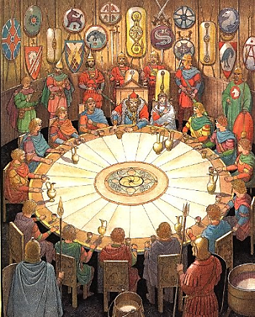

♫

Tennyson and I

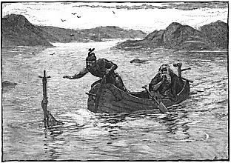
The Arthur Cycle

Tennyson and I again,
haunting Somersby Manor.

1.
Must every male child be named Arthur?
In tribute to that grand Ideal
Whose own wife doubted he was real…
One must not take this any farther!

*

Alfred, my excellent good friend,
Sing me a song of Camelot,
Won’t you? Oh, dear! I’d rather not,
But since you ask: attend, attend!

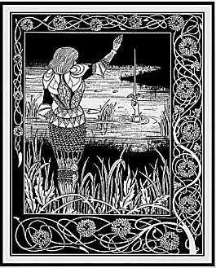
2. King Arthur

O spotless fool, royal cuckold:
The torch, the torch will not be passed!
Why must the lilies fade so fast,
So fast the roses? I am old.

Your knights were many, and true and bold!
Your ladies, they had golden hair.
All that is beautiful and fair
Is as unthreaded cloth of gold.

Thrice must Sir Bedivere be told,
‘Give back the brand Excalibur!’
Ere he relinquish it to her
Who gave it you to have and hold,

The Lady of the Lake, to fold
Into the waters whence it came,
That shining sword of golden flame.
But now ‘tis done, as was foretold.

(Strictly his lot to each is doled.)
Now on a dim and dusky barge
Three queens shall take you in their charge
Wailing and weeping unconsoled

Over your body pale and cold,
And take it to Avilion
Whose other name’s Oblivion.
And the Round Table will be sold
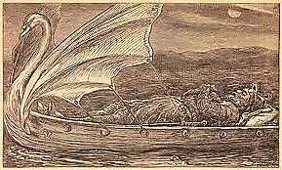
At auction, the silk gown will mould,
A death-moth-eaten souvenir
Of what was once Queen Guinevere.
I weep, but tell what must be told,

The story of this king of old,
King Arthur, and his soul so vast!
And how the torch that was not passed,
On misty evenings, on the wold

That like a tapestry unrolled
Spreads out its endless waste of green,
That fatuous fire by fools is seen,
Sometimes, a Grail of fine fool’s gold,

And how they chase across that wold
A phantom (and to phantoms turn)
That warms them not, although it burn,
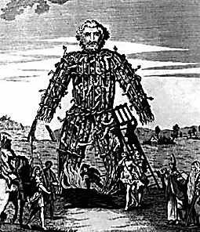
And leaves the ‘nighted world quite cold.

3. The Wicker Man

You brought upon yourself a fate
That you would not have wished upon
Your worst of enemies. It’s done,
Enough! It’s done! It’s far too late

To change what happened. Why tear off
The bandage and the scab beneath
And pull the dagger from the sheath
And stab my heart and make me cough

Up blood again and let out cries
And seep again the morbid fluids?
What, is my soul some sort of Druid’s
Plaything, a hapless sacrifice

In cage of wicker set ablaze
And destroyed so flamboyantly
Pity and terror to ecstasy
Are driven? Through an acrid haze

To see it writhe, that blackening speck,
A small fire lost in a great fire,
The gods of savage men desire,
But spare me, pray, arrah! vos prec.
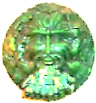
4. The Green Man
♫
You chop him into bits and serve
Him as an archetype-ragout
Or hearty, seething mythic stew,
And in your every vein and nerve

He’ll magically reanimate
And your own inner viridescence
Invigourate. You’ll feel his presence
Within you as an altered gait,

A lighter step, a suppler wrist,
A languid new vitality
With just a soupçon of ennui
To scandalise the moralist.

Two or three inches of transcendence,
That’s all he asks for, from the ground,
That, and a band of angels round
His head to clown, and dance attendance.

Look at his skull! Out of the eye
Sockets, the nostrils, and the mouth
Spring green carnations and the youth
Eternal of regeneracy!

5. Sir Gawain and the Green Knight

He also comes in an edition
De luxe: a Knight, in skin of calf,
Whose head, swung by his hand, will laugh
At you, Sir Gawain, with derision

Quite supernatural, for you
Have severed it with an axe blow.
It says, as it sways to and fro,
That you’ve a debt will soon fall due:

Soon you must offer him your head
In what of course is a Green Chapel.
But first Eve offers you an apple.
Move back a step. You are half-dead

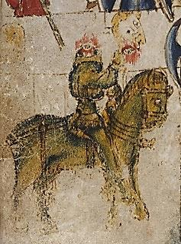
From questing for the giant’s lair
When in a castle you are offered
Harbourage—and much more is proffered:
One Bertilak de Hautdesert

A lovely wife hath; to your bed
She comes, night after night. Her plan?
Seduction! But you, virtuous man,
Preserve your chivalrous maidenhead,

It remains unviolated,
Although not so your sacred vow
To give back the wife’s girdle, now
The talisman that saves your head.

For on the point of hewing you
The Green Knight pauses at the sight
Of it and laughs: ‘twas all a light-
Hearted bit of fun, much ado!

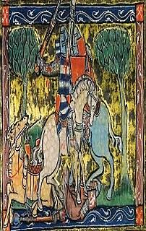
Morgan Le Fay’s behind this jest,
That sometimes devious, sinister
Or merely mischievous half-sister
Of Arthur: it was all a test

Of Gawain’s vaunted chastity,
And of the ideals of the Court,
And withal a malicious sport
Queen Guinevere to terrify.

*

And as the Green Knight doffs his head
To Sir Gawain, for courtaisìe,
I take my hat off to you, Dee-ah,
Who don’t believe a word I’ve said.

6. Merlin and Vivien

The charm you should have kept, that charm
You gave her: ah, she understands!
The woven steps, the waving hands!
The power she has to do you harm

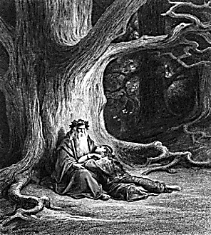
You put into those hands that doom
You to a hollow oak for ever.
You, whom we thought so very clever,
♫
You made the Tree of Life your tomb!

Poor wizard, wizened but not wise,
Who made from music Camelot’s gate
And knew before it came your fate,
And still believed her lying eyes!

You, the wand-waver, a mere tool

O, ay, it is but twenty pages long;
But every page having an ample marge,
And every marge enclosing in the midst
A square of text no larger than the limbs of fleas;
And every square of text an awful charm,
Writ in a language that has long gone by,
* * *
And every margin scribbled, crost, and cramm’d
With comment, densest condensation, hard
For mind and eye; but the long sleepless nights
Of my long life have made it easy to me.
And none can read the text, not even I;
And none can read the comment but myself;
And in the comment did I find the charm.
—Idylls of the King, ‘Merlin and Vivien’

In the hands of one so profoundly
Unworthy! I denounce you roundly,
Hapless magician, gifted fool!

7. Princess Ida and The Lady of Shalott

Your Princess, though: what, from sheer chivalry
She must renounce her independence
And submit to the man’s transcendence,
Foregoing gifts and mental rivalry,

Eunuch self-castrated to flatter
The vanity of the poor male,
The victim, lest his manhood fail?
Must treat her mind as a small matter

Compared with her predestined rôle
As selfless servant wife and doting
Mother—and how he must be gloating,
Your husband who has killed your soul!

Decked out in hollow-clanging blank
Verse and Arthurian trumpery,
Poems of such complacency
Have but Philistia’s Muse to thank.

But Oh! the Lady of Shalott
Whose mirror cracked when she forgot
She must not look on Lancelot,
She drifts down dead to Camelot,

The Lady of Shalott, Elaine!
Her web flown hopeless, floating wide,
What she must do she did, and died:
If love brings death, death ends love’s pain.
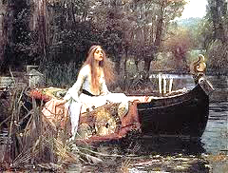
♫
8.
And shall I speak of Galahad
Who perserveres o’er sea and land
♫
Till he alone of all that band
Beholds the Grail, and yet is sad?

For nothing now can be the same.
Ah, back into the world he goes,
And all he knew no longer knows,
And ‘home’ sounds like a foreign name!

All things look skeletal and old
As branches when November winds
Strip their bright leaves away like sins
And leave them purified and cold.

His heart is pure, and so is snow
Unsmutched, a virgin sheet of white.
He prays upon a winter’s night
In his stone chapel, head bowed low.

Infinite Love will ruin Love
Of earthly kind, so dear a waste!
And kisses leave a bitter taste
When human love’s not love enough.

He only wants to die a death
Of his own choosing: he would be
Of flesh entirely, wholly free
And rise toward Heaven like a breath.
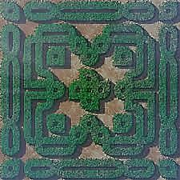

9. The Fairie Queene and the Labyrinth of Allegory

Complexities, in the end, defeat
Design. The maze grows only denser.
Think of those episodes in Spenser
Where plain knights weave in dark conceit

‘Mongst nymphs and wizards and what-not,
Until the allegory spins
So many myths of origins
That Virgil’s oak is overwrought

With Ovid’s ivy. ‘Hard begin’, The Faerie Queene, III, iii, 21.
What is your end? You have too many
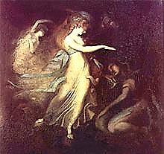
Of these to be said to have any,
And fewer the ways out than in.

So highly charged with gorgeous Eros,
♫
Infected will unwilling serves
Erected wit, and sensory nerves
Are insolent squires to his knight-heroes.

A knight may ‘gainst his interest act,
His better judgment; what he fears he Prince Arthur and the Fairy Queen (Fuseli).
Is overtaken by: his Circe
Turns hoggish mind to bodily fact.

The thread tatters to threads, to broken
Endings leading. But these are new
Beginnings, each a chance to do
It all again, new vows are spoken

In a tempestuous wedding of
The pagan and the mediaeval,
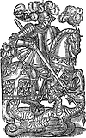
Protestant God and Catholic Devil.
It is the straying that we love.

*

Spenser, you hated us, it’s true. Hated the Irish, that is.
Hysteria mars your fantasy.
But though you fear to set him free,
Eros exuberates from you.

You wrestle to the ground but can’t
Pin down the daemon. He will rise
Again. What spell could exorcise
The Protean from the Protestant?

10. Childe Harold

Childe Harold sings his anxious song
Of influences that make him pine
To go a quest that will, in fine,
At a dark tower, and a throng
Of palely loitering phantoms, end—
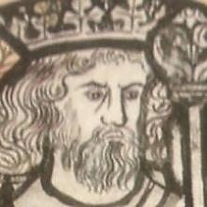
Though first he through a plashed and muddy
Waste, as through a dead scholar’s study
Littered with scribbled leaves, must wend

With steadfast and obdùrate will
Set against Time and its It Was.
But why so hard a quest? Because
Opposed, irreconcilable

Are power and will, good, and the means
Of good? Because triumphant life
Achieved through such a ghastly strife
Might just as well be death? The scenes

Of misty squalour through the which
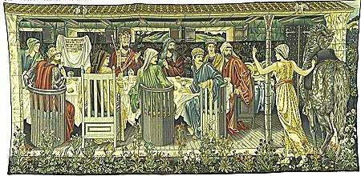
He struggles are composed of naught
But splendid failures, all they wrought
A poverty that makes them rich,

A wealth that leaves them poor indeed.
Who steals my purse, steals trash: how true!
Accumulations vast accrue
Until they bloom into a weed.
♫

11. Arcturus Redux?

Oh once in a blue Cambrian moon,
Perhaps, stray knights will constellate
Into a court, can we but wait!
A king will strike a fork, and tune

Their disparate notes into a Song
Of Solomon uniting God
And Aphrodite. On a broad
Heraldic field that noble throng

Will clash the shield and break the lance,
Before a gateway by a clever
Sorcerer built to last for ever,
Since made of Music and Romance.

A supernatural resource
Endangered, rare, exhaustible
Are the real, loyal, true, frail, spell-
Bound, binding few. But does their force

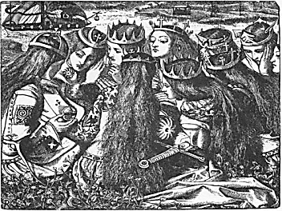
Diminish over time, will jackals
Inherit the high halls, the Round
Table? Merlin’s already bound
Inside an oak, in wooden shackles.

Who shall be judge of Lancelot?
Or so high-minded and severe
As to condemn poor Guinevere?
Yet with their passion comes the rot.

Fear Arthur’s justice! Look and see:
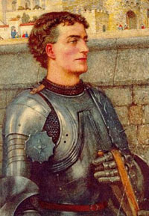
His trusty friend, ah, such a charmer!
Lies dead and crumpled in his armour.
The Queen has joined a nunnery.

*

Some say that he will come again.
Some wounds take centuries to heal,
And many times the earth will reel
And we as blind as drunken men

Will trail a slick of blood behind us
As down the hall of time we stumble,
And many a tower will rise and crumble
Till by the full moon he will find us

Feasting like wolves with small red eyes
And bloody mouths upon each other,
Friend upon friend, brother on brother,
Lips stained with gore and smeared with lies,

And he will have his hands full then,
Assembling once more the knights
He’ll need to set it all to rights:
Why should he ever come again?

♫

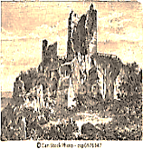

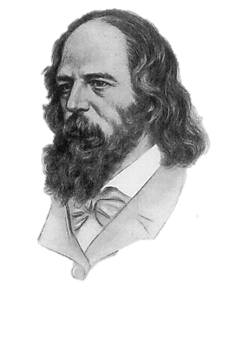
Tennyson and I
By the Ivory Gate

Scene: Somersby Manor.
Still by the Ivory Gate we linger,
On the Astral Plane, in Purgatory,
Or…Ah, where, Alfred, where are we?
In a space thinner than this finger,

Oscar. We are in the in-between
And are the in-between. For we
Are neither here nor there, you see.
Alfred, please tell me, have you seen

Your Arthur? Was yours a true dream?
Do our most-feigning lies become
Realities? Or did doubt numb
The sense that felt the life of him?
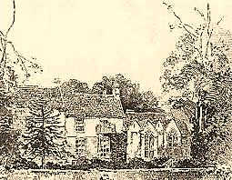
I have not seen him, have not even
Left this old place. No, I remain
Upon the Purgatorial Plane,
Ambiguous between earth and Heaven.

Unfinished business keeps me here.
But you, Alfred, what makes you stay?
Do you not long to see him? Say
What makes you haunt this old house. Fear!

Fear that I will not see him there,
Or will not recognise him. (He
May be much changed.) Ah, will he be
The one who once breathed English air?

And will he wish to see me? Will
He even recognise the face
Of one he loved in bygone days?
Are fleshly memories with him still?

Or what if mere oblivion
Awaits me, and my soul shall die,
Extinguished like a firefly
Within the furnace of the sun?

No, all the Arthurs we have known
Or dreamed: my Goring, Windermere,
Saville, Balfour, Clifton, your dear
Hallam, and he who from a stone
Drew forth a sword, and by that sword
Preserved the Christianity
Of Britain when barbarity
Descended in a ravenous horde:

We’ll see them all, we’ll revel in
A cornucopia of Authors
And Arthurs, like old friends or brothers
They’ll join us in a genial din!

No stern arthuritarian Father
Will we cognise, but pure Arthurity,
Time-mellowed, quick with all futurity,
All excellences Mind can gather.

All will take on one royal Roman
Name, Rex Arcturus, Guardian
Of Ursa Major, a Star Man.
Oscar, Oscar! You’re such a showman!

One Arthur only, and one Author
I long to see. But be at ease,
Enjoy your superfluities.
Arthur’s your Brother, I your Other. Tennyson and Somersby Manor vanish.

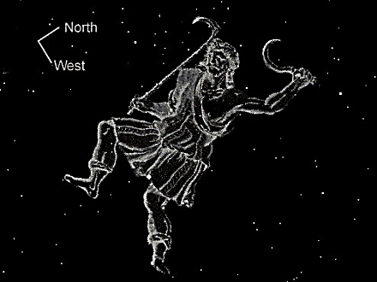

The Ascension of Lord Alfred Tennyson
I knock at the door of Someresby Manor.
Tennyson answers it, breathless with excitement.
It is like In Memoriam!
Like the Commedia, my friend:
Grievous, but cheerful at the end.
Oh what a happy man I am!

I’m leaving Somersby. Tonight
Is our last meeting. Whispers some
Still small voice that the time has come
When I must rise into the Light.

I know I shall see Arthur there,
Though in what shape I know not. Faith
Will bring me past the bar of Death.
The time has come. My earthly share

Goes to the Lady of the Lake.
Excalibur, the appointed sword,
Has been relinquished and restored.
Let Arthur his last journey make.

Am I not Arthur, Arthur I?
Aboard the vessel of our death
We breathe as one the shining breath
Of the new Life that cannot die.

And you must follow where I go.
No more malingering upon
The ‘darkling plain’! There is a dawn
After the darkness here below.

* Vanishes, leaving behind only a
sort of mystical, Arthurian glow.

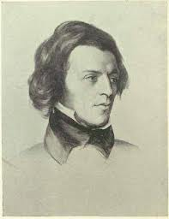
Musical Program
♫

Title Page

Peter Warlock, Balulalow. Setting of an anonymous text from the 16th century.
The Choir of King’s College, Cambridge.

O my dear heart, young Jesu sweit,
Prepare thy creddil in my spreit
And I sall rock thee in my hert,
And never mair from thee depert.
But I shall praise thee evermore
With sangis sweit unto thy gloir.
The knees of my heart shall I bow,
And sing that richt Balulalow.

Page 15, Tennyson and I: In Memoriam A.H.H.

Holst, The Planets, Op. 32. VII: Neptune, the Mystic (excerpt). Chicago Symphony Orchestra, James Levine, conductor.

Page 17, Tennyson and I: In Memoriam A.H.H.

God Rest Ye Merry Gentlemen (trad.) Sung by Annie Lennox.

Page 18, The Arthur Cycle (title page)

Chausson, La légende du roi Arthur avec choeur. La Société Philharmonique de
Mirande, conducted by Max Fouga.

Page 21, The Arthur Cycle

Guillaume de Machaut, Puis qu’en oubli (rondeau). Rogers Covey-Crump, Mark
Padmore and Paul Hillier.
Puis qu'en oubli sui de vous, dous amis,
Vie amoureuse et joie à Dieu commant.
Mar vi le jour que m'amour en vous mis,
Puis qu'en oubli sui de vous, dous amis.
Mais ce tenray que je vous ay promis,
C'est que jamais n'aray nul autre amant.
Puis qu'en oubli sui de vous, dous amis,
Vie amoureuse et joie à Dieu commant.

Since I am forgotten by you, sweet friend,
I bid farewell to a life of love and joy.
Unlucky was the day I placed my love in you;
Since I am forgotten by you, sweet friend.
But what was promised you I will sustain:
That I shall never have any other love.
Since I am forgotten by you, sweet friend,
I bid farewell to a life of love and joy.

Page 23, The Arthur Cycle

Chausson, Viviane, Op. 5. Orchestre Symphonique de Nancy, Jérôme Kaltenbach,
conductor.

Page 24, The Arthur Cycle

Wagner, Tristan und Isolde. Act III: Mild und leise (Isolde’s Liebestod.) Kirsten
Flagstad, soprano, Philharmonia Orchestra, Wilhelm Furtwängler, conductor.

Page 25, The Arthur Cycle
Peter Warlock, Corpus Christi. Text: Anon. carol, ca. 1500. Blossom Street, Hilary
Campbell, conductor.
Lulley, lully, lulley, lully,
The faucon hath born my mak away.
He bare hym up, he bare hym down,
He bare hym into an orchard brown.
In that orchard ther was an hall,
That was hanged with purpill and pall.
And in that hall ther was a bede,
Hit was hangid with gold so rede.
And yn that bede ther lythe a knyght,
His wowndes bledyng day and nyght.
By that bedes side ther kneleth a may,
And she wepeth both nyght and day.
And by that bedes side ther stondith a ston,
Corpus Christi wretyn theron.
“One theory about the meaning of the carol is that it is concerned with the legend of the Holy Grail. In Arthurian traditions of the Grail story, the Fisher King is the knight who is the Grail's protector, and whose legs are perpetually wounded. When he is wounded his kingdom suffers and becomes a wasteland. This would explain the reference to ’an orchard brown.’
“The text may be an allegory in which the crucifixion is described as a wounded knight. The bleeding knight could be Christ who bleeds for the sins of humanity endlessly. Christ is most probably represented as a knight as he is battling sin and evil by his continual pain. The "orchard brown" to which the knight was conveyed becomes, in this reading, the "orchard" of wooden crosses that covered the hill of Golgotha/Calvary where Christ – along with many others – was Crucified, while the "hall... hanged with purpill and pall" could be a representation of the tomb in which Christ was placed after Crucifixion. This allegorical interpretation would tie in with the seven stanzas possibly representing the Seven Deadly Sins. The maiden who is by the knight's side could be Mary. There is religious symbolism throughout the carol. The falcon may have several possible meanings. It may be that, as a bird of prey, it represents those who killed Christ and sent him to heaven. It may also represent a new beginning and freedom, which Christ gained on his death. The colours in the carol are also significant. The purple and gold are signs of wealth, although these were also colours that referred to the Church due to its wealth. The pall (black velvet) probably refers to death. An interpretation of the inscription on the stone may also be that it marks the location of the grail itself, still guarded by the Fisher King.”—From Corpus Christi Carol (Wikipedia),
based on an article in The Independent currrently inaccessible on the Web.

Page 26, The Arthur Cycle

Mendelssohn, A Midsummer Night’s Dream: Scherzo. Mariinsky Theatre Orchestra, Valery Gergiev, conductor.

Page 27, The Arthur Cycle

Wagner, Tristan und Isolde. Act III: Prelude. ORTF Orchestra, Karl Böhm, conductor.

Page 28, The Arthur Cycle

Purcell, King Arthur, Act V, Scene II: Fairest isle, all isles excelling. Barbara Bonney,
soprano. Concentus Musicus, Nikolai Harnancourt, conductor.

VENUS
Fairest isle, all isles excelling,
Seat of pleasure and of love;
Venus here will choose her dwelling,
And forsake her Cyprian grove.
Cupid from his fav'rite nation,
Care and envy will remove;
Jealousy that poisons passion,
And despair that dies for love.
Gentle murmurs, sweet complaining,
Sighs that blow the fire of love;
Soft repulses, Kind disdaining,
Shall be all the pains you prove.
Ev'ry swain shall pay his duty,
Grateful ev'ry nymph shall prove;
And as these excel in beauty,
Those shall be renown'd for love.

Page 32, Tennyson and I: By the Ivory Gate

Schubert, Piano Sonata in B Flat Major, D. 960. II: Andante Sostenuto. Sviatoslav
Richter, piano.

