* Ruskin and I *

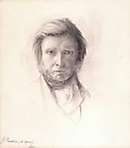

The Storm Cloud
of the Nineteenth Century

Table of Contents

Oxford (In Memoriam C.3.3. II) 3
A Talk with Ruskin and a Friend of His (In Memoriam C.3.3. II) 6
Mr V and I: Astral Travel (Further Revelations I: Dialogues of the Dead) 8
The Storm-Cloud of the Nineteenth Century (In Memoriam C.3.3. III) 10
Doubts of a Soul on Leaving Its Body (In Memoriam C.3.3. III) 12

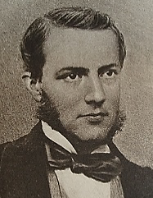
Oxford

O thou idyllic Oxford! Pater!
Ruskin! Max-Müller’s giant Indo-
Europäisch treasure, ah, window
Opening after window! Later

What attitudes would become mine! Ah,
The unfinished watercolour on
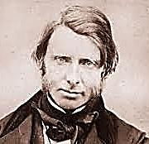
Its easel! Dandyish clothes to don,
Must show a worship of blue china.

In my rooms, punch, tobacco, and, far
Into the night, philosophy
And undergraduate foolery
On equal footing… For such are

The amusements of a young Oxonian.
My friends ‘log-roll’ me down a hill
Till all hit bottom in a spill
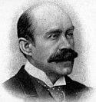
Exhilaratingly Johnsonian!

*

Now this is growing repetitious!
A group of hardies climb the stair
To give the aesthete a good scare:
Down they precipitate. Delicious,

The wine I serve his fellows, (‘game’
They are now!) from the ‘cellar’ of
The inciter whom, with little love,
I have sent tumbling to his shame.

*

Pater’s my mentor and Socrates.
This don who longed to sport with Pan
Once kissed my hand (dear, homely man!),
Semi-recumbent, on his knees.

*

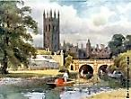

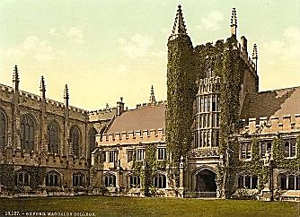
I venerate the eloquence of
John Ruskin and his high ideals,
And pity him the grief he feels
For an unconsummated love.

We help him turn a swampy, narrow
Lane into a paved, proper road
To Ferry Hinksey. (I bear my load
In his especial wheelbarrow.)

*

To Italy and Greece I go,
With Dunskie in Rome seducing me (An Oxford chum, David Hunter Blair.)
To Mother Church, with Mahaffy (John Pentland Mahaffy, my mentor at
Among the ruins in a sunset glow. Trinity. It was he who uttered, ‘In
Ireland the inevitable never happens
* and the unexpected constantly occurs’.)

Sometimes, when I am serious,
Prescience I do not understand
Makes me say, ‘I’ll be famous and,
If not famous, notorious’.

*

Either satirically or as a serious warning,
Now Scaurus was the man of the hour, in view of my reputation in Oxford, my
Famed for quick repartee, though his examiner in Latin asks me to translate a
Nature inclined to laziness. passage concerning M. Aemilius Scaurus.
His speeches had a fiery power

(Though hastily written) to arouse.
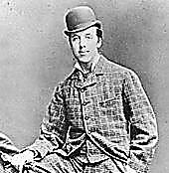
But some of these were deemed to be
So scandalous, they were publicly
Burnt on the orders of the House.

His greatest foe was his own pride.
Rather than bear the humiliation
Of his judicial condemnation
The man committed suicide.

*

My strangest pose is that I am
A poseur—which, true, I may be.
My Double-First’s a jeu d’esprit
Mystical as a Pentagram.

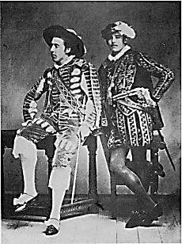
I am proud of my Newdigate,
Dantèan laurels that I won
With my ‘Ravenna’. And Byron
Is in it, too! It is quite great.

*

Fortified am I by deep study
Of the Forty-Nine Articles
(Or is it Thirty-Nine?), and Paul’s
Safe from the storm, though soaked and muddy, The storm that ‘catches him in the Acts’. I
was once punished for arriving late for a viva
‘Tis to be feared. I am so glad voce by being made to copy out this passage.
He didn’t drown! It all turned out
Quite well, and this relieved my doubt:
I resolved never to be bad.

And yet, and yet! I was seduced
By the gods Money and Ambition
And the Madonna of Contrition.
I’m not the holiest man produced

By Oxford, Dears, but I’ve learned oh-
So many things!—And now, go down,
Moses, go down to London Town
To teach the Law Aesthetick. Go!

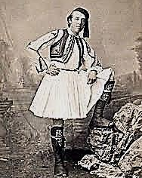
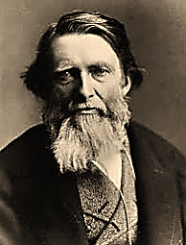
Through the Cracked Looking Glass
A Talk with Ruskin and a Friend of His

I dream I am in the ageing Ruskin’s house in Brantwood, in the Lake
District. He is muttering to himself in his study overlooking Coniston
Water, whilst poring over old drawings and photographs of girls. I
hesitate to interrupt, but how I long to speak with the poor mad genius!

1.
I can no longer see the gleam! See the ‘Intimations Ode’. [Mr V]
This photograph disturbs me. She,
My young Turk, says too much to me.
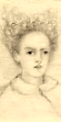
Nature is having a bad dream…

Decomposition rules. No help
For anything from anything
Save Siren-tunes the bank-notes sing
Whilst the stock-market devils yelp!

A cat torments me, and a white
Peacock, whose cries are long and loud!
I live beneath a black storm cloud Rose La Touche
And I lie sleepless through the night! on her deathbed.
Drawing by Ruskin.
Teacher I honour, will you talk
With one whom you must surely loathe?
A morbid love destroyed us both.
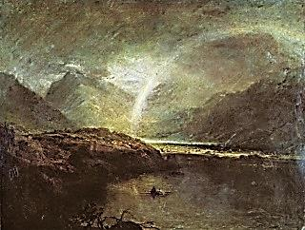
We both have failed… Many a walk

We took together, you and I,
O’er many a silver-misted quad
Talking much nonsense about God
And Tintoretto… Can love die?

Love that can kill can surely die.
You drew her hauntingly on her
Deathbed, your Rose. Ah, do not stir
Those visions in an old man’s eye!

Those little girls of yours, your ‘flirts’:
You never, of course…? The very thought!
Which perish! Still, the matter’s fraught
With ambiguity that hurts

Your reputation. As for mine,
It is past hurting: it is dead.
What I did cannot be unsaid
And all I am is as a sign.
But Child Cults, Cults of Innocence!
What could be more perverse? Come, come! Charles Dodgson alias Lewis Carroll, co-founder
You and Charles Dodgson are a rum of the Society for Psychical Research, appears
Old pair… Yes, Oscar, we’re old f-f-friends. in his astral body as the aura of a migraine.

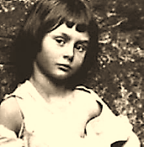
My dear Dodgson, let me ask you:
Those photographs you took of nude
Young girls: how, without seeming rude,
Did you persuade the parents to

Allow you to do such a thing?
It was all innocent, sir, d-d-dirty
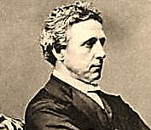
Only to dirty eyes. Quite ‘flirty,’
Those girls? Inclined to worshipping?

We are not given to your s-s-sport,
Oscar. You’ve fallen among Tories,
Violent Tories… But your story’s
Easy to tell. It is a sort

Of Tarot’s Progress mystery
Wherein the Fool becomes the Foul Dodgson plays his ‘Word-
And in the Foul finds his Soul. Ladder’ or ‘Doublet’ game.
In doublets you seek unity.

But isn’t it a bit expensive,
The expense of spirit, wasting time
And money on a sordid crime,
Inflicting damage so extensive

On loved ones for so mean a cause?
It is a waste of shame, good shame.
(For having smirched your parents’ name,
Let’s say—noble, for all their flaws.)

What on earth made you sacrifice
Your fame and social standing for
So vicious a perversion, or,
Vice versa, so perverse a vice?

2.
You should have thought before you spoke, A Transformation Scene: we are now
Measured the sense and weighed the sounds. in a wood in Looking-Glass Land.
For language costs a thousand pounds Charles scolds me mildly like the Red Queen.
A word these days, and one is ‘broke’

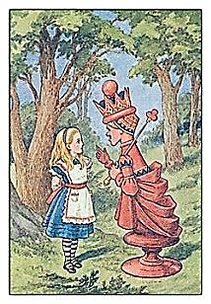
Before one knows it. The bill has
A way of falling due when least
Expected. The watchword is ‘feast
Or famine’. It falls due just as

The crowd’s acclaiming you the Lord
Of Language. Ah, the wreath of laurel
Is snatched from off your head. The moral?
‘Say no more than you can afford

‘To pay for when the check’s presented’.
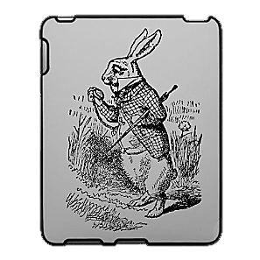
Or is it rather, ‘Pound-wise, penny
Foolish’? (Vice versa?) There are many
More: ‘Soonest said, soonest repented’.

(A variant—this is quite fun!—
On ‘Marry in haste, repent at leisure’.)
You never learned to weigh and measure.
Now, take two eggs, for instance. One

Costs fivepence farthing, two, just twopence.
But one of them is bad. And so
The moral is—oh, I don’t know,
‘One’s sure to meet with one’s comeuppance’.

The Ranee [Lady Brooke] thinks that he has
fallen and cannot rise… I think his fate is
rather like Humpty Dumpty’s, quite as
tragic and quite as impossible to put right.

—Constance Wilde,
letter to her brother Otho
3. An Acrostic Ode

O woe is Oscar, in the snare of
Sin vainly struggling, the law takes
Charge of his body now, it aches
And breaks. Such sins one should beware of!

Ruin they spell; down from the high
Wall Humpty Dumpty falls and shatters
Into his pieces, all in tatters
Lies his good name. Farewell, good-bye,

Dame Luck, a stranger to him now.
England won’t have him back again,
Oscar, whose other name is Pain.
Wild woe to Oscar, Mr OW!

‘Wilde’ is a word. What’s in a word?
Words, words, words, words. A Wilde by any
Other name would be one too many.
Charles, you make me seem so absurd!

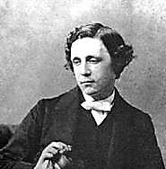
Oscar, you are a man of words,
Not of your word. Ah, we would not
Expect so little of you. What
A waste of time, reducing surds!

5. Oscar, Man of Letters: a Hyper-Anagram

As Oscar rises, so Wilde crawls.
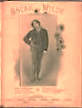
Oscar is solid, Wilde is oil.
Oscar is rose as Wilde is soil.
Oscar sees all, Wilde sees cell walls.

Oscar is cordial, Wilde is coarse.
Social is Oscar, Wilde is low.
Oscar or Wilde, sir? Owl or crow?
Oscar’s radical. Wilde’s a corse.

Oscar’s desire is Wilde’s disease.
Oscar’s so candid. Where Wilde lies,
Oscar swears lies are real. Wilde: Dies
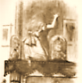
Irae! Oscar we will release.

Mr V and I
Astral Travel

1.
Your absence haunts me. It sounds queer,
I know, but I feel quite chagrined.
You are intangible as the wind!
How strange to switch from there to here

And then to now so quickly in space
And time! Death has its privileges.
We ghosts can move with startling ease
From age to age and place to place.

We fly, as ‘twere, on conscious wings—
Or drift, or float, if minded to.
Still, hawk-like, I return to you.
You must have seen some wondrous things.

2. My Travels

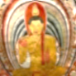
Ah, let me tell you! I have seen
The tawny Ceylonese sunrise
Through a tea-planting girl’s sloe eyes;
Have watched the Nile, swift, emerald-green,

Surge past the ruins of the sacred
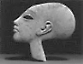
City that Akhenaten built,
Muscling a wealth of fertile silt
Down to the shores where the waves break red

And purple beneath dying suns.
At Alexandria, deep under
The harbour waves, I’ve seen the plunder
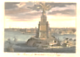
Of time, the great stone blocks that once

Composed the wonder of the Pharos.
On high Mount Ida I have stood
Where Troy’s doom burned in the hot blood
And fateful judgment of young Paris,
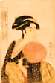
And watched a Geisha girl in Kyoto
With exquisite composure pour
Tea for her warrior paramour
And pluck sad music from a koto.
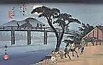
(In a pavilion on the way
Down from Mount Fuji I have seen girls
Make love to girls. This part unfurls
As a print by Hiroshige.)

With the Aborigines I trace
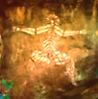
Song-lines, I join them as they sing
Into existence Everything
That IS, and gather it into place.
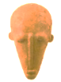
I have seen the Dogon dance delirious
To honour the completed spin
Of its mysterious hidden twin
Around the raging Dog Star, Sirius.

I’ve watched (as strange as this may seem)
From the moon, with these ghostly eyes,
A pearl of calmest blue arise
From darkness like a solid dream,

And only slowly recognised
It as our planet, lone and small
In the void vastness of it all,
A fragile thing ah, to be prized!

As fragile as blue china, and
As rare—which how shall we live up to,
Who drain the tea, and break the cup, too?
Leaving our stain on sea and land.

And sometimes Ruskin joins me there.
Tears fill his eyes, and the earth-light
Trembles in them. The rest is night
And silence, stars and breathless air.

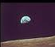
The Storm-Cloud of the Nineteenth Century
Old Ruskin speaks out of the cloud.
His hair and beard are made of fire.

The Cloud comes creeping from the mills.
(We are depraved, we are depraved
And never shall our kind be saved!)
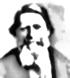
The Cloud hangs heavy o’er the hills.

The wind is weak. The leaves are grey.
(Je ne peut pas toucher la rose!
The lily never will unclose.)
The wind is from the south to-day.

The Cloud is black. Dead souls are in it. The souls of the Crimean War dead
(Sesame seeds explode in fury, he imagined filling that baleful cloud
The End comes, we must hurry, hurry!) when he first noticed it in the 1860’s.
The Cloud grows blacker by the minute.

The Dragon slays Saint George, he fouls
The good green land with blackest gold
Smeared on the valley and the wold
And slips his coils around our souls!

The garden where the coke lies piled
Chokes on the plague, and devils make
Avernus of the clearest lake—
The air, the waters, all defiled!

I cannot tell you what it means.
The earth is swallowed by the world.
Into the future we are hurled
By our intelligent machines.

The Cloud is Hermes, god perverted.
(Erotic drawings, photographs!
It’s wicked how she laughs and laughs,
The little girl with whom I flirted.)

And the wind is the world-wind. Mad
Cassandra’s words will reap no profit.
Hermes rustles us down to Tophet.
Failure! Oh I am sad and bad!

History happens only once
And we shall rue the end of it.
The death-moths through the belfry flit:
Mechanised death to our brave sons!

The Great War comes! The Great War comes!
And after that, the wind, the wind.
Who will dig in the dust to find
The broken jaw of our kingdoms?

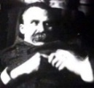
Doubts of a Soul on Leaving its Body
An Exchange Somewhere Above my Bed,
Small Hours of the Morning, 30 November 1900

Ruskin seems to swirl around me as, under the influence of morphine, pain, inflammation and delirium, I seem
to detach myself from my body for indefinite periods, then return to my physical self utterly unsure of where
I am. Swirling with Ruskin is a thickly-mustachioed gentleman, whom I seem to recognise as Nietzsche; both
are in dark frock-coats. We three, it seems, are destined to die ‘together’—to die, that is, in the same year of our
Lord 1900, and we are circling our deaths, our bodies beached—wrecked—on the shore of a new century.

If I may play extemporaneously
On Goethe, the Eternally
Effeminate seduces me
Downwards and upwards simultaneously!

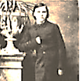
Nietzsche:
No more to walk the streets and grin
At passersby, ‘I am the God
Who drew this cartoon, I, the odd
Clown God who mixes you all in’!

My Will wants deep Eternity!
May things eternally return!
The old grow young. Again they learn
The secret of maturity,

The seriousness they have known
As children playing. Lifetime is
A child, and learning is his bliss.
Friend, when will growing be outgrown?

Indeed. But I am puzzled, sir.
I mean, does not your very presence
Suggest that something of our essence
Survives death? Speak, philosopher

(For atheists have ghosts, I see):
Can a ghost be an atheist?
Do you or do you not exist?
It seems I am born posthumously.

*
Ruskin, gazing on a picture, giggling:
She brings me back my younger days,
This pitty girl, the way she poses
Without any clotheses on but roses!
God wants to be a girl that plays.

