*Rossetti and I *

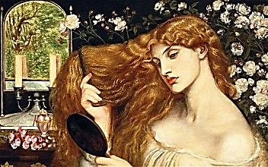

Into the Small Hours

Table of Contents

Into the Small Hours 3

A Moment’s Monument 6

Appendix: Musical Program 15

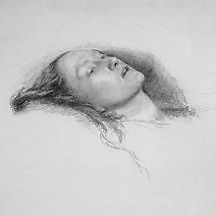
Rossetti and I
Into the Small Hours

His house in Cheyne Walk. We have been drinking.
(Gabriel died 1882, Elizabeth Siddal, 1862—a suicide.)
1.
Has she moved on to the Beyond?
The Afterlife, What’s-Next, the Yonder…
Look at her! Isn’t she a wonder?
Dead, they say. I was rather fond Lizzie Siddal lies on her deathbed. He holds
a feather to her mouth. It does not move.
Of her, my Lizzie. Lizzie Siddal.
Lizzie Rossetti, a good wife.
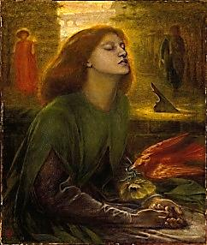
Most brilliant woman in my life.
Look at her. Isn’t she a riddle?

She sleeps! Place on the pillow there
Beside her gold-enhalo’d head
That golden treasury of the dead,
Your Willowwood.—O willow, where?

In the initials of the dead Beata Beatrix, aware of her impending death.
Beloved, the crudely outlined heart A bird, death’s messenger, places a poppy
In the bark, skewered by Cupid’s dart. in her hand. Dante stands in the shadows.
Lean over her and kiss her head.

There. That much, and no more. Now let her,
Like Erda, sleep the deathless sleep
Of Wisdom, doom-drenched, dark, and deep.
Weep, but be calm. This way is better.

2.
Forsake-me-nots I pick to redden
I-care-not-to-rememberries.
Add dominant eau de nil to these,
Than poppies quicker pain to deaden.

Let poppy tears be all I shed,
To harden into what I smoke
To wrap around myself a cloak
Of statuary rapture, dead.

And may I find a guardian Sphinx
That he may endless vigil keep
Over the stone that is my sleep.
Where nothing is, there nothing thinks.
3. Gabriel Whispers in my Ear
PERSONA in a dream came to me
Swiftly, ah, light as any verse,
His whispering, shimmering wing-feathèrs!
He cried, ‘Why do these ghosts pursue me?’

‘Fear not, they are my ghosts’, I said.
‘The ghosts of those I loved and failed’.
I opened up my mouth and wailed
That I, too, was among these dead.

‘You wish to give your Grief a face
And make of me her Mask of Sorrow,
Her thoughts today, her moods tomorrow
You’d have me lend a mystery’s grace.

‘What boots it then to multiply
Her puzzling hurts, as in a hall
Of mirrors, and confound them all
Till you forget the reason why?’

And on His way into the night
He fled, and with one feather brushed
My cheek. Downcast I was, and crushed
To feel a thing so airy-light.

And if my Grief were given voice
How should she speak but as a vapour
Of cries wafting from parchment paper?
A whisper drifting. Insect noise.

4.
I threw my family away!
What stealthy, riotous hours I kept!
Whilst my wife sat at home and wept,
Helplessly waiting for the day

When I would cease to make her suffer,
When I would be myself again.
She thought me mad, and I was, then.
Ah, the excuses that I offer

The face of Conscience in the mirror!
It sounds like ‘Constance’, and resembles
Cyril’s. I stare, the image trembles
Like water, I see nothing clear or
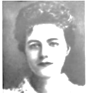
Clean in the rummage of my soul,
It seems so haunted and forsaken.
How long it is, the wrong road taken!
If I could reach out and console

You! But the truth of the sad matter
Is that it is too late, too late,
And it no longer matters. Wait,
Says Hope. Till I completely shatter?
Constance appears. She speaks
* of her first visit to me in prison.
You were behind a screen. I could
Not see you and I could not touch you.
I scarcely spoke. I know how much you
Suffer. Why wouldn’t you be good?
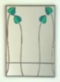
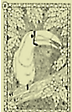
Rossetti and I
A Moment’s Monument

Dinner at his house, 16 Cheyne Walk,
Chelsea. A toucan wearing a tiny cowboy
\ hat is riding a llama around the table.

1.
Ah, Dante Gabriel Rossetti!
What an array of sumptuous dishes!
Everything here looks so delicious…
Anticlerical strozzapreti! Lit., ‘priest-strangler’, a pasta
of unusually large size.—[Mr V]
Your cook can do miraculous things.
A true Artusi, dear, a paragon!
Parsley, sage, rosemary and—tarragon!
I’m a man for all seasonings. The meal finished, we linger over wine. The talk
turns to poetry, how and whether it can preserve
the moment or win it back once gone. He reads the
2. prefatory sonnet to The House of Life. I respond.
‘A moment’s monument’: a moment
Enlarged a little by addition
Of letters? Poetry’s saving vision: Moment becomes mo(nu)ment,
Does it reduce to a smart comment which becomes ‘new’ again.

On language? Say a monument
Composed of letters holds, contains
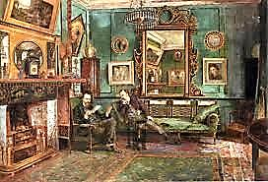
The moment: still, is what remains
More than remains, the life-breath spent?

Ah, we would make the moment new
Again, reborn in naked flesh,
The infant of the instant, fresh
As on the grass the morning dew,

Quivering, beaded, rainbow-coloured, Rossetti and Watts-Dunton.
Cooled by a breeze upon the lawn,
Basks in the keen, sweet smell of dawn!
When time has grown a doting dullard,

And all its tarnished coinage faded,
Can a new currency be minted,
And all things shine that merely glinted
And quicken senses numb and jaded

To eager peaks of ecstasy
And still-more eager expectation?
How to sustain a soul’s elation
In all its natal poetry, A Wordsworthian problem, poetry’s problem.
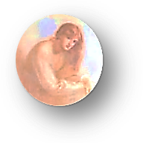
How to perpetuate the minute
In its minutiae, the timbre
Of her low voice, the mellow amber
Of the sunlight, moats floating in it,

As it sifts down upon her hair
And mingles with the red the gold?
Why must light fade and youth grow old?
Why must the leafy trees grow bare? Sighing, I pour us both another glass of wine.
I snub out my cigarette and light another.
Ah, monochronos hedone!
A god can press immortal flowers
Into the yellowing Book of Hours
And timelessness into a day,

And we as well could do the trick,
Though brotoi, dying ones, had we
Time enough for eternity.
But clocks will tock, and tocks will tick. The grandfather clock ticks in the corner; its hands, interestingly, are moving backwards.

3. Rossetti speaks in italics.
Why must the keen sense in the gaze
She gives you as her fingers stroke
Your cheek become a thing of smoke
Viewed through a dim, abstracted haze?

Why must the meaning in a look
That summed up all the Heaven in
The world for you, become as thin
As propositions in a book

Of obsolete theology?
And Beauty, fresh and rose-leaf-lipped,
Illuminate a manuscript
Whose theme is Beauty’s Brevity?

If you could dig it up again,
Love’s body, and amid such bleak
Corruption rescue words that speak
Of Resurrection’s joy, amen!

If joy in flesh proved to be made
Of more than flesh, and Lizzy Siddal
Opened her eyes, and solved the riddle,
Then letter might for spirit trade,

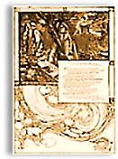
If Willowwood were Willow Is
And Love could make, in the cool mirror
Of Dream Well, a dream-face draw nearer
And greet me with a bubbling kiss!

4.
The inviting smiles the stranger beams
Across the room, the glasses clinking,
The promise in a blue eye’s winking,
Are as a lighted house that gleams

Upon a dim, receding shore.
Absences crowd the cenotaph
Of memory. A Cheshire-laugh
Dies down an empty corridor. The llama stops circling the table. The toucan
flies to a cabinet in the corner. He perches
there, in his cowboy hat, looking depressed.

5.
The moment is a thievish thing.
It pockets all its proffered pelf—
But ah! is not desire itself
Invested in its vanishing,

That one brief pleasure may give way
To others, and variety
Nourish the hunger of the eye?
Sufficient, then, unto the day

The laughter and the lust thereof.
When night comes, and Minerva’s owl
Flits bat-like, time then for the howl
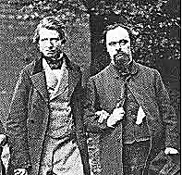
Of Sorrow keening for lost Love,

For ever. I took Sorrow’s bronze
And carved therein, for-evermore,
The Pleasure that Abideth for
A Moment—and awoke in bonds.

In bonds I wake, and having found Ruskin and Rossetti at Oxford.
That Sorrow can in iron shape
Its image, and in chains can scrape
And clank along the frozen ground,

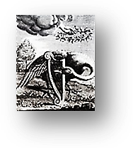
I swivel my tired eyes, I peer
Around at blank and barren walls
Of space, and like a curtain falls
The light, because the drop is sheer.

Sunbeams are rods of bronze in air.
That blinding mirror of my sorrow:
Who will lift it to the sky to-morrow?
Who will hang that heavy pendant there?
♫

What mighty crane will hoist that ball
Of metal aloft? The sky is steep.
The sun would rather fall asleep
And let the shadows cover all.

That burning clock, that tells the same
Old tale from dawn to dusk to dawn
Again, would with a gaping yawn
Sink into darkness, salve its flame

In waters of oblivion,
Scatter in seas and lakes and ponds.
Then who shall tell the tale that once
Upon a time there was a sun?

He who demands of life a true love
Kisses illusion, clasps a ghost,
And weeps to hear time’s heartless toast:
‘Ring out the old, ring in the new love’. ‘New love’, ‘newlove’… Oh yes, Henry
Newlove, one of the ‘perverted telegraph boys’.
Memory still serves. The toucan squawks.

6. The Swan of Tuonela
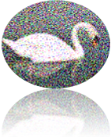
Quite a splendid menagerie!
But why not add a swan to your
Collection? They are going for
A swan song these days. That would be

The mute swan, then, Cygnus olor?
Is that the one you have in mind?
The Agamemnon’s where we find
The first use of the metaphor

Of the swan song, in that scene where
Cassandra, drawing her last breath,
Is likened to the swan whose death
Draws out both soul into the air
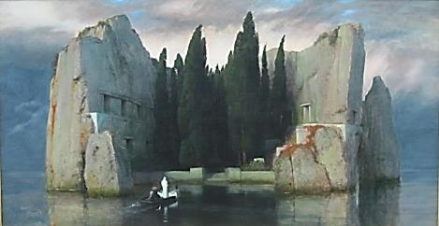
And sad lament. Chaucer writes of
‘The Ialous swan, ayens his deth
That syngeth’. Deep, oh deep beneath
♫
The earth, far from the songs of love,

The shouts of hate, circles a swan
Around the Isle Tuonela, Land
Of Death. Mysterious, pale and grand
Amid the gloom she glides upon

The water. Deathless is her song
As death is endless, and releasing.
Voice of an oboe sadly pleasing, If Rossetti is referring to Sibelius’
She pauses, sings again. Along The Swan of Tuonela, this should
be an English horn, Oscar.—[Mr V]
The shores the shades are listening, listening, A Finnish swan with the voice of an
Startled alive in hearing’s nerve. English horn! Really, Mr V, consider
As graceful as her neck the curve the exigencies of both sound and sense!
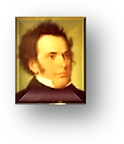
Of melody, and pale and glistening

In the mist is the sombre vision.
The music is a dying fall,
And sweetest at the close of all.
Orphic immortal, death’s musician!

* * *

Schubert’s publisher called his last
♫
Songs Schwanengesang. How could Fate
Rob us so early of so great
A man, of promise still more vast?

His is the Spirit of Water in motion,
Rippling, bubbling, eddying,
But ever a downward-flowing thing
Returning home, to Mother Ocean. His eyes moisten, as do mine. I try to
modulate the discussion to a lighter key.

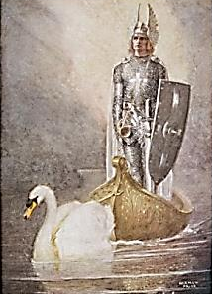
7.
A mute swan is a paradox:
For doesn’t ‘swan’ mean ‘sound’? Her breath
Shapes only hisses, until death
♫
Inspires her: Ah, then she unlocks

Her throat, and pours forth melody!
For when death’s tonic note resolves
Our dissonances, life dissolves
Into the essential poetry

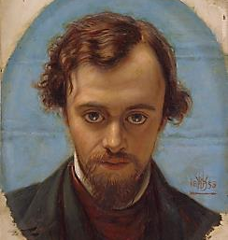
It was. The swan, symbol of faith
In love and God, Lohengrin’s ferry,
Does not invariably marry
For life. Divorce happens (so saith

The ornithologist, and shoots
Down one more beautiful old myth,
A heedless Parsifal armed with
Binoculars, in Wellington boots.)

Sheer Beauty cast in pantomime
Upon the mirror of a stream,
Like the white shadow of a dream
The swan is with herself a rhyme.
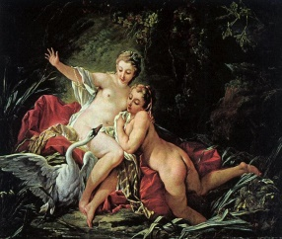
Juvenal calls the virtuous woman
A rara avis, rare as a
Black swan. But in Australia,
I hear, black swans are not uncommon.

Great Zeus preferred to play the swan
In courting Leda. Urgency
Takes on wings, grasping bill, and see!
‘Tis over—ah, much further on

The sequel… Fate can bide its time,
But action in the present moment
Sometimes proceeds too fast for comment.
Back to the sky we watch him climb

On broad but somewhat hurried wings.
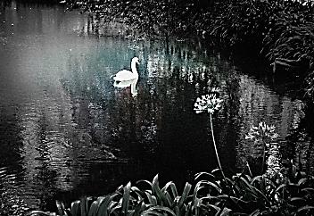
Let politics and history wend
Their slow ways to one tragic end.
Zeus has moved on to other things.

The Trojans’ hecatombs pique not
His nostrils. With his Ganymede
To play with, why should he pay heed?
Let Troy in its charred ruin rot.

(Still, he’s a sentimentalist:
He takes stray stars and makes them spell, in
The sky, a Swan, when born is Helen,
The fateful issue of his tryst.)

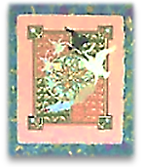
No, it’s a myth, the mute swan’s silence;
It simply has no trumpet call,
No ‘theme song’ for its flight, saves all
For that Grand Tour round mythic islands.

Your Aengus found his love among Caer Ibormeith, beautiful daughter of
The swans, and with her flew away, Prince Ethal Anbuail of Sid Uamuin.
A swan himself. Indeed, they say
There was enchantment in their song.

Let’s not forget the albatross!
Here’s to the floppy, flappy, bloody
Old albatross! Well, in your study
Of Baudelaire you’ve come across,

No doubt, his version of the myth?
Where sailors capture the great bird
And watch him flap about, absurd .
And clumsy; mock his limp, and with ,

A clay pipe tease his beak? Of course. Ah, Coleridge’s admirable
Algernon’s mad about it. Pass nightmare-ballad, with quaint
The wine this way, could you? Alas, annotations somewhat like mine. I believe it should be
I feel its force. I feel its force. the other way around,
Oscar! —[Mr V]
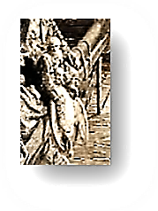
‘The poet is this Prince of Clouds
Who, stranded among earthly things,
Encumbered by his giant wings,
Must limp among the jeering crowds’.

Not bad, my friend, for an impromptu.
Of Baudelidge and Coleraire
Now sing a medley. Fuse the pair.
The toucan or the swan will prompt you.

I am too deeply in my cups.
I am not up to it. You do it,
Oscar, my dreamy Irish poet.
Ah, no. I’ll prompt you with hiccups.
But I am silent, lost in
some wistful thought.

8.
I have forgotten how to paint,
And, oh, I was an amateur.
Chasing the tarts: how that hurt her!
Care for some chloral? (I feel faint.)

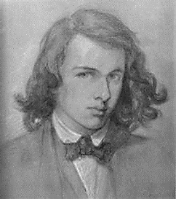
No thank you, for I am in thrall
To the opium-tainted cigarette.
By the last puff one can forget
Everything and imagine all.

I miss her still, that’s what hurts most.
Do you miss Bosie, ever? Always.
On dim side streets. In hotel hallways.
He is, and always was, a ghost.

Better, therefore, to say I’m haunted.
One can’t be disillusioned when
Illusion’s what one craves. Amen.
It was the dream qua dream I wanted.
Suddenly I am very sad.

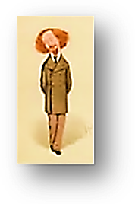
9.
Another glass? Good Lord, is that
A naked Algy sliding down
The staircase banister? The clown!
He’d look good in a cowboy hat.

He keeps babbling about BY-RON
And incest. So he f*cked his sister!
Who cares just where or when he kissed her,
Which breast he lay a hot hand on?

Does Algy want his drinky-tinky,
His boozy-woozy? Ask nice, Algy.
MY EPILEPTICO-NEURALGY!
Now don’t go trying something stinky.

Algy, put your clothes back on! Show a
Bit of restraint! Put on your clothes!
More than a drunk Noah, one loathes
A drunk buck f*cking naked Noah!

10.
The thrush out in the garden! Can
You hear him? As plain as can be .
That little b*stard’s mocking me.
I’d punch him, if he were a man!

He says I that I am a brain-sick
Murderer and a chloral-fiend.
You must feel very much demeaned.
My neighbours taught him this neat trick.

Come, Gabriel: I doubt the bird’s
Remarks have anything to do
With you. Now he’s insulting you!
I think you misconstrue his words.

I’d hate to see you come to blows,
You two. Why not simply agree
To disagree? Let be, let be.
Ah, well: my nerves are raw, God knows.

Recite that poem you’re working on.
Ignore that thrush, the impertinent bird!
I will hang on your every word,
Fitting aubade, for look: the dawn!

♫
Musical Program

Page 9
Saint-Saens, “The Swan,” from Carnival of the Animals. Yo-Yo Ma, cello.

Page 10
Sibelius, The Swan of Tuonela (Four Legends), op. 22. Oslo Philharmonic, Mariss Jansons, conductor.
Schubert, “Liebesbotschaft,” from Schwanengesang. Text by Ludwig Rellstab. Wolfgang Holzmair, tenor, Imogen Cooper, piano.

Rauschendes Bächlein,
So silbern und hell,
Eilst zur Geliebten
So munter und schnell?
Ach, trautes Bächlein,
Mein Bote sei du;
Bringe die Grüße
Des Fernen ihr zu.
All ihre Blumen,
Im Garten gepflegt,
Die sie so lieblich
Am Busen trägt,
Und ihre Rosen
In purpurner Glut,
Bächlein, erquicke
Mit kühlender Flut.

Wenn sie am Ufer,
In Träume versenkt,
Meiner gedenkend
Das Köpfchen hängt,
Tröste die Süße
Mit freundlichem Blick,
Denn der Geliebte
Kehrt bald zurück.
Neigt sich die Sonne
Mit rötlichem Schein,
Wiege das Liebchen
In Schlummer ein.
Rausche sie murmelnd
In süße Ruh,
Flüstre ihr Träume
Der Liebe zu.

Love’s Message

Murmuring brooklet,
So silvery bright,
Hurry to my beloved
So fast and light,
Oh friendly brooklet,
Be my messenger fair,
Bring my distant greetings
to her.
All the flowers
She tends in her garden,
Which she sweetly
Bears on her bosom,
And her roses
In a purple glow,
Brooklet, refresh them
With cooling flow.
When on the bank,
Immersed in dreams,
Remembering me,
She hangs her head,
Comfort my sweetheart
With a friendly glance,
For her beloved
Will soon come back.

When the sun sets
With reddening glow,
Rock my loved one
To slumber,
Murmur for her
Sweet sleep,
And whisper dreams
Of Love to her.

Trans. Richard Morris

Wagner, Lohengrin, Prelude to Act I. Royal Concertgebouw Orchestra, Bernard Haitink, conductor.

Page 14
Ravel, Alborado del Gracioso [Morning Song of the Jester), from Miroirs. Alicia de Larrocha, piano.

