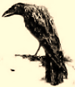
Poe Laureate

A reassessment.
Ah, Poe! In French il est poète;
In English he is merely Poe,
Three-quarters poet merely; so
Baudelaire had to invent him, set

The man aloft as sire and saint
Of Symbolism. Poë-try:
Compound of Gothic gauchery,
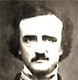
Bad nerves and a dab of grease-paint.

Poetry’s sometimes what we gain
In mistranslation—of a word,
A phrase, a poem. (Pater preferred
Reading you in French.) Then again,

Bad poetry is sometimes lost
In the translation, into prose,
Or prose-poem, for these forms disclose
The Raven’s power, at the cost

Of only that annoying jingling ‘The jingle man,’ Emerson called you.
Which you somewhat naively thought
Sophisticated and well-wrought.
In Baudelaire the uncanny tingling

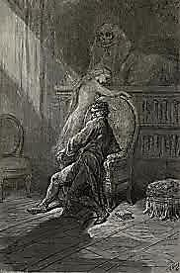
Is felt untrammelled, there is mass
And shadow, pierced by a high flute,
And there is hush, for here fall mute
The tinkling, ornamental brass

Of a pinchbeck musicianship,
The note of terror is allowed
To spread into an inky cloud,
And claws take the heart in their grip.

None of that ponderous Nevermore-ing,
But Jamais plus, the Raven quoth,
A nasal reed-tone piped by Thoth
In a transparent, simple scoring;

Purer the dread in the refrain
For sounding homelier in the ear;
Uncanny are the echoes fear
Makes, pecking thus upon the brain.

