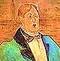
From Père Lachaise
The Critic as Artist as Critic
as Comedian, Confronting a Heckler

I am performing a little tipsy this evening. The time is the late Thirties,
I think. The membrane between the biosphere and the thanatosphere
sometimes grows porous, and psychic leakage may occur. I apologise
for the late-Joycean static that is occasionally audible in the margins.

1.
Purgatory, I’ve decided after
Much back-and-forth with literary
Peers, friends or foes, mixing the merry
Poisoned bowl with good-natured laughter,

Is Criticism: divinatory,
Or, if not, only necessary
In an abstract way, and not very
Thrilling, unless it tells a story.

Yes, autobiographical
Of course, but see that it’s creative
Autobiography. Your native
Wood-notes should be well wrought, and full

Of graces, with the appoggiatura
Of apologia on occasion
Only accented, through sweet suasion
Making your case, with sprezzatura.

De la musique avant tout’ chose!
And there should be a dash of what
The latest slang calls ‘camp’. Thou Slut Perhaps from the French ‘se camper’,
Of Letters, strike a striking pose! ‘to strike a provocative pose’.

Or you will be uninteresting.
What Hell is worse than to be that?
Do not put on the conical hat
Of learnèd Duns, Dears. Be arresting.

Then readers will be interested. One of the group, bearded, tweedy and
And be arrested? You’d know all in his cups, it seems, almost shouts out.
About that. My Dear, don’t be small.
It’s better still to be arrested,

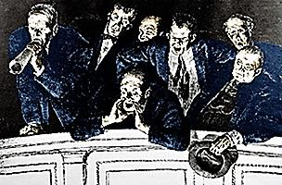
Now and then, than to be arresting.
To rid oneself of a temptation
By yielding to it? Litigation
Is pending, I advise investing

In an attorney’s services,
Because, as all the world should know,
You stole that line from Père Goriot.
What all the world knows now, Dear, is

A pedant is among them. Who
Cares? Why not listen, and learn a little?
No one here wants to watch you whittle
A toothpick from a redwood. True?
The other members of the group
Yes, Oscar, go on. Bob, shut up! pipe up loudly and in unison.
Thank you, my Dears. God knows, though I’m
But an old-fashioned Pierrot mime,
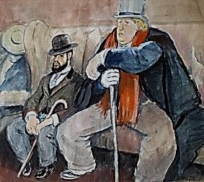
My galops gallantly gallop,

Doing their best to keep up with Youth.
They hate us, do they not, the old
At heart? All gold is but fool’s gold.
Truth is so liable to ‘myth-youth’.

One hath to lithp, and then it’s ‘punny’,
Professor, Dear, so serious-looking.
You are the comic Story Book King
Who doesn’t find the story funny.

The great white caterpillar, bold-
Faced butterfly-imposter-hack!
You steal behind the poet’s back
And grope his person for his gold!

There is no need for iteration,
My dear: by now I think you’ve made your
Point, and the point was hardly major,
Nor has it made your reputation

As a wit or a genius with
Either the ladies or the boys.
All you can do is make more noise
When what you should do is make myth.

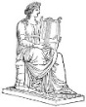
You hide your face behind a beard,
Your fear with a rebarbative
Attitude. That’s no way to live,
Dear. Only fear is to be feared.
The Group Intervenes:

Oscar, forgive us, please, for our
Friend’s horrid manners. Tom will take
Him home to sleep it off. Don’t make
A fuss, Dears. Still, late is the hour…
Bob is firmly escorted
away by the dutiful Tom.

2.
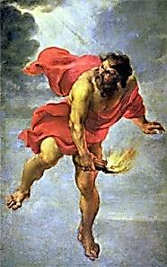
Well, as your friend Bob points out, rightly,
Much that I wrote was a quotation
Without the tedious notation
Of marks; too many look unsightly,

They merely clutter up the page.
Though this may lead to some confusion
‘Twixt plagiarism and allusion,
I brave the pedant’s righteous rage.

What I have borrowed from my brothers
And sisters with such bland élan, ‘Immature poets imitate;
Invisible to some, of an mature poets steal’.
Offensive clarity to others, --T.S. Eliot

Is a closely kept secret open
To ambiguous interpretation
Or to high-toned denunciation
Of one who writes with such a faux pen.

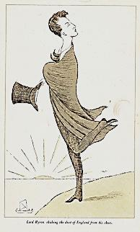
3.
As Byron writes in his Don Juan:
I like so much to quote. Then is it
A fault, so often to revisit,
As one might haunt a Gothic ruin,

Scenes from the glorious high masques
Of yesteryear, to raise the ghosts
Of dead bards, and to them make toasts
With a glass filled at their own casks?

‘As Byron writes in his Don Juan’:
I quote myself now. Well, then, is it
A weakness? Yes, ‘tis an exquisite
Weakness in me, ever to strew an
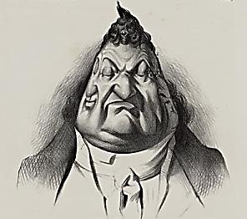
Amusing trail of pilfered flowers
Behind me as I dance along,
Singing another poet’s song
‘Neath a quotation of spring showers.

Snapper-up of considerable
Trifles am I, Autolycus,
Anthologist of genius—
Which, at times, gets me into trouble,

As when my Poems were rejected
By my own alma mater as
Ghost-written by the dead, hélas!
As an eclectically selected

Bower-bird’s cache of plagiaries,
A literary bagnio built on
The bones of Shelley, Keats, and Milton.
My lunar Muse in terms like these

Some still abuse; thus they arraign her
Who glories in her borrowed light
And is the robber’s lamp by night
And makes Parnassus her Lupanar.

(What was my Charmides, Dears, but
Pompeian mural-painting, a
Sort of high-flown erotica
Many condemned as dainty smut?) And so I had to bowdlerise, nay,
geld, almost, that admittedly somewhat
Well, count me one of Plato’s liars excitable young Grecian fetishist.
Who also steal myths others make
According to their mood, and take
All colours, like the hands of dyers. .

And Shakespeare, the nonesuch, the rare
Original, what did he steal?
Deer. But was Shakespeare even real?
Or someone else’s nom de guerre?

4.
There’s a Sublime of plagiary,
And even pastiche can become
Transcendent, when skilled fingers strum
Apollo’s lyre. (It wasn’t he,

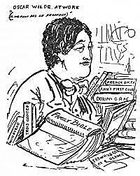
But Hermes, who first fashioned it,
By the way, from a tortoise shell,
Which he then for a flute did sell.)
The allusive tune is infinite,

Whether ‘tis plucked on harp, or fluted;
The poet becomes what he thieves,
And takes up, where another leaves
Off, the great, endless, convoluted

Symphony of one giant Poem,
A vineyard whence ‘tis only fair
To siphon, as the gleaner’s share,
By the glass or the jeroboam,

That which we pant for, like the deer.
With this old Boaz would agree,
Whose sheaves were neither miserly
Nor mean. By now it should be clear

Authors need not originate Auctor in Latin can mean originator or in-
To earn the name, they can improve creaser—that is, augmenter—of a tradition.
What they receive, whether in love
Or rivalry. We all come late

Into the fields, but even unto
This last—especially this last—
As to her firstlings of the past
The Muse gives; what else can she do?
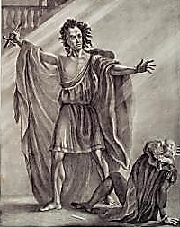
A living bard’s a Frankenstein’s
Monster, composed of parts of dead
Poets, this one’s heart, that one’s head.
Look to th’ arrangement of the lines,

The fresh new use to which they’re put,
Boldly antique, ironical,
Forward-looking, untimely… All Mr Cooke as Frankenstein, at
The difference resides in what the Theatre Royal Covent Garden.

One does with one’s material.
A book made wholly of quotations
In artful, telling collocations:
Would it not be original?

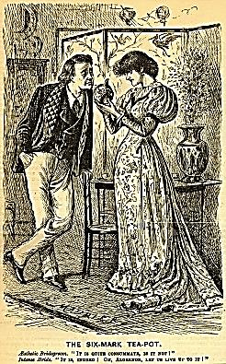
What do prophets do? Plagiarise
There’s no in-here-ain’t
sin in playjeurisnt, is it?
A pelagiarist, beglad,
and all the erse for it!
—Jim
The text of a futurity
Becoming, but not yet to be.
Dears, second-sight has magpie-eyes.

O thou primordial Plagiary
Of Fire, mixed from ingredients
Of revelatory experience
And déjà vu, I sing of thee!

Is not the first bar of the song
Already a refrain, somehow?
The past lives in the here and now.
To beg or borrow may be wrong,

But to steal is a Titan’s act.—
Well, that’s enough on plagiarism.
What can be said in aphorism
Need not be laboured into tract.
But the subject is raised again.

5. Can the Question of Plagiarism
Be Settled Once and for All?
No plagiary-an-sich, only in the mind of
the Created Uncreating? How erigenal! No wonder critics stabbed you with their pens!
—Jim
Originality absolute
Is an illusory ideal.
In truth, to borrow or to steal
Or to allude, these constitute

A literary bodily function.
Whatever may be said of me,
I’m no Sir Fretful Plagiary;
I filch without the least compunction.

Some critics think of literature
As the exercise of a sublime
Ego against the Classics time
Has consecrated as the pure
Mr Terry. Few could find fault with
his performanceas Sir Fretful Plagiary
in Sheridan’s The Critic.

And isolated products of
Genius at war with genius.
By now it should be obvious
This is a cliché, merely a rough

Approximation and reprise
Of the Romantics’ stance, which served,
Once, a real purpose: It unnerved
Their literary enemies,
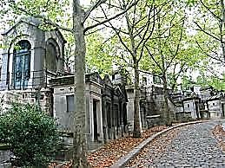
The staid Tory traditionalists,
Guardians of established power.
They fought in a tumultuous hour,
Did the Romantics, with their fists,

At times: The cause was liberation.
The cult of the Original
Was, finally, political.
You can see how exaggeration

And overuse and careless thinking
Have made this worship of the lonely
Genius a vulgar pose, fresh only
To journalists. Thus by a slinking,

Sneaking corruption and inversion,
‘Originality’ is the cry
Of those who least exemplify
That quality: a true perversion!

No great men are original.
The greatest genius is the most
Indebted man, though he may boast
My bold-faced plagiarism of a passage from
Emerson’s essay on Shakespeare (‘No great
men…indebted man’) evokes, or rather,
provokes the shade of Emerson to appear
among us, to set the record straight.

Of being the richest one of all.

6. Emerson’s Genteel Heckle

Sir, you are paying me a great
Tribute, (or is it mere confusion?)
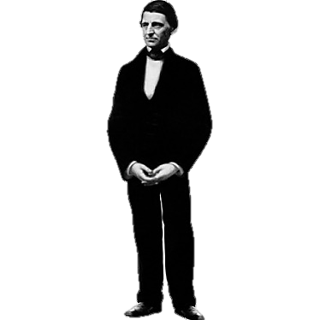
Quoting me without attribution.
Attributed or not, I hate

Quotations. Tell me what you know.
An unattributed quotation
From your own books! Your condemnation
Is wisely inconsistent, though,

With this great truth: that all minds quote.
In alienated majesty
Via your timely plagiary
Return those words I also wrote.

‘I’ that is nothing, and sees all? A bit of stichomythia, anyone?
Self that is only self sees nothing.
Does not self change itself like clothing?
The Veil is torn, and the scales fall.
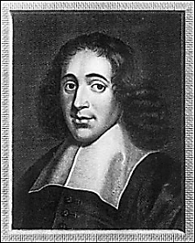
Breathes through us now the Atman’s breath.
When we let go of have and hold,
We are in Everything: Behold
The Substance beyond life and death!

A bit de trop, that sort of thing,
I must say, my dear Emerson.
Yet with Spinoza you are one:
The lecturer, the lens-grinder sing

One sober, mystic Pantheist
Insist upon yourself. Be original.—Emerson
Hymn to a thing not Him or Her.
Well, bless your Substance; I prefer
The attributes. They can be kissed.

Kisses betray. Flesh dies. The Atman
Is the eternal Youth. How broad
Your views are! If your Brahma God
Exists, He is a very Fat Man.

[A Heckling Event appears to be brewing. We can feel the air molecules ironising
all around us. As a broad-comedy front approaches, all shapes and sizes begin
to look ridiculously distorted—widened or elongated. We are about to experience
a massive Caricature, with sarcastic claps of thunder and lightning strikes of wit.]

You are as tall as you are thin,
Thin as the nothing that you are,
Seeing All: the Deep and High, the Far
And Wide, the End and Origin.

By Christopher Cranch.
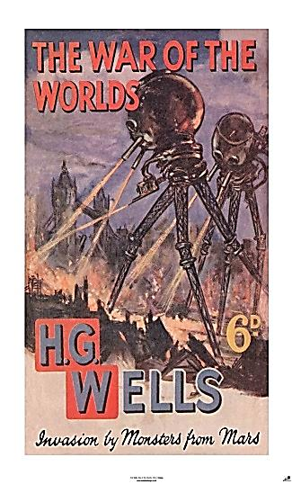
6. Transparent-Eyeball Emerson

From the Red Planet now comes Shiva
To wage a war the world upon!
Transparent-Eyeball Emerson
Is the god’s war-machine, bereaver

Of cities! It shoots rays of Death,
This Cyclops Ralph on Waldo stilts,
And all that stands before it wilts
As down to humankind’s last breath

The impassive Robot takes its toll.
Its gamma-potent pantheist vision
Is that you, Mr Emerson?
Abstracts things without intermission.
And the Overlord of Oversoul,

Who to the transient self is Lord
Of Darkness, threatens now to spread
Worldwide his Empire of the Dead.
But Something somehow steals aboard

The Eyeball-Golem in its stride
Amid the rubble it has made.
The death-ray’s strength begins to fade:
Disease is taking hold inside,

A general, woolly reverie;
An abstraction of an abstraction
Metastasises, rarefaction
Of thoughts breeds growing vacancy

Till with a deafening creak and metal
Groan the great towering Waldo falls
Crashing: acres across it sprawls,
And the contents begin to settle,

Parts with a clatter and deafening clank
Swing on their hinges or fall off
The chassis—for the landing’s rough.
My friends, we have a germ to thank.

