* Oscar at the Movies *

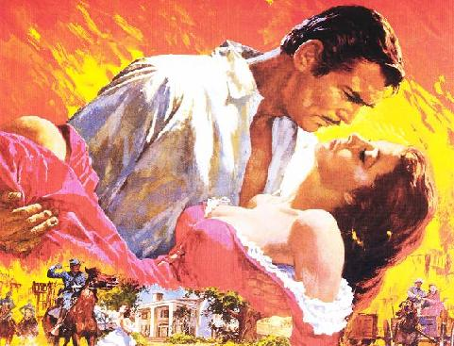

The Vision of Sarah Bernhardt
on the Silver Screen 3
(Cat-Call Music Hell)

On Seeing the Wizard of Oz:
From Hollywood to the Grand Canyon
(The American Tour Revisited) 4

Moving Pictures
(The American Tour Revisited) 7

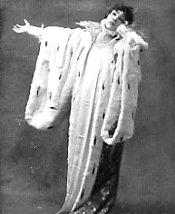
The Vision of Sarah Bernhardt
on the Silver Screen

Sarah, I see you on a wall
Burning, in such a fragile fire!
Your flaring fury, your desire
And fear and grief, I watch them all

Flow through the quick staccato of
The frames. You look a little strange.
You may have undergone a change,
You whom I so admire and love.

But oh, how beautiful you are!
A glow, a beacon beckoning me
To join you in the Mystery
That burns inside us like a star.

You are Elizabeth the Queen, A motion picture made in 1913.
Though you are dressed more like Pierrot Oscar has this vision in C.3.3.—Mr V
In loose gown, billowing sleeves. Your flow
Of gestures must be felt, be seen,

The arms free to protest against
Your fate. (The hands: two fluttering doves.)
Who kills the man she loves, still loves.
You flicker jealously, incensed,

Then passionate, tender, tragic, old…
Old? How could Sarah the Divine
Be anything but young? Your fine
Intensity warms all that’s cold

Into rejuvenated passion.
You would have been my Salomé—
You always will be. Should the day
Arrive when there is no more Fashion,

And every light must dim and die,
Bernhardt promised to help Oscar
financially on his release from Reading
Gaol. Despite repeated reassurances,
the money never materialised.—[Mr V]
In silver gown you will abide
The ebbing of Time’s epic tide,
Still telling your immortal lie.

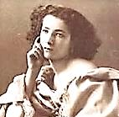
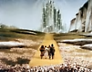
On Seeing ‘The Wizard of Oz’

Present at the Hollywood premiere, Grauman’s Chinese Theatre, 15 Aug, 1939.
1.
I’ve seen Oz, Dears. I’ll give you all
A brief review, or commentary,
Impressions, aperçus… This very
Strange film deserves a small roll-call.

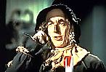
A touch of Kitsch and good homespun
Fantasy landscapes. Winding road
Of yellow brick. Green Witch, of toad
And cauldron, broom et al., quite fun!

O how the Evil are laid low!
Gone is her beautiful wickedness.
Who’ll melt in tears for the ogress
When she succumbs to H₂O?
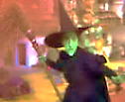
The Tin Man, a mechanical
Old sentimentalist. In God
He rusts when weep he must, this odd
Orphan of the Industrial.

The Emerald City! And that strip
Of gold that curves through all the sets!
That Lion Cowardly, who gets
Biting comeuppance and the lip

Of Dorothy. Nor should we pass
Over that loose and floppy sack
Of fodder who laments the lack
Of that which he already has,

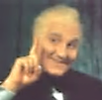
The scarecrow, headpiece filled with straw:
That is, a mind that does not know
It is a mind. And finally: Lo!
THE WIZARD! He who gives the law

In Oz, gold-standard charlatan
Who offers help at such a price
And seems not in the least bit nice,
Proves a most kindly bumbling man

Without the curtains and the smoke:

His promise fattens like the moon
Into a helium balloon
And rescue comes when a knife-stroke

Severs the tether—but, Dears, not
For Dorothy’s Toto, who in toto

The Oscar

Each year the actors celebrate
Their own celebrity, and duly
Award the best, whom else? yours truly!
your Only the great deserve the great.

*

Is left behind as back they go to
Kansas (but, why?) and all for naught

The rescue when her heart is left
Behind there, with the little creature,
For life is not a double-feature,
Ah, no. But as she cries, bereft,

A Happy Ending spell delivers
Her from her dream’s tornado, little
Toto and all, each jot and tittle
Observed of the obscure and divers
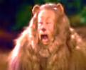
Fulfillment contract Wish makes with
Itself. For one can readily see
In this pure unreality
A most authentic human myth:

That winds may whirl us up, and roam
♫
Into the Strange: away we go
To learn the lesson that there’s no
Place like home… There’s no place like home…

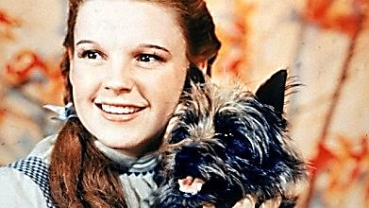
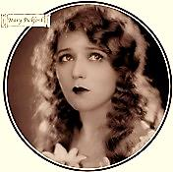
Moving Pictures
For Marcel Proust

The parlours where we do our loving
Are rooms we rest in, yet these places
Are speeding through successive spaces
In time, so they are very moving

Pictures indeed: We laugh and weep.
And one atop the other these
Assemble into memory’s
Fond scrap-book—but how long to keep?

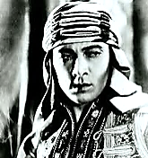
Concatenate the snapshots in
A sequence, till the intervals
Between them blur, embrace the false
And glittering rhinestone and sequin,

Or the impress left by their reflections
Upon a plate of silver thin
As any dream, and enter in
To the Palladium. Our affections

Are bribed by sugar for the eye,
And we, the children of our dreams,
Trade that which is for that which seems,
And take the swindle gratefully.

When the spokes of a wagon wheel
Move in reverse, against the grain
Of physics, what of that? The brain
Ignores the slippage in the real,

Stunned by the fascinating shimmer
Of a perverse, regressive motion.
Who wants the moly for this potion?
Just turn the lights a little dimmer.

Ah, Mary Pickford, there you are!
And smouldering Rudolph Valentino.
Age shall not wither you, we’ll see no
Tarnish upon that silver star.

In quick succession things flash by us.
We give the world its fiat looks
And write about these in our books.
Dears, into these is built a bias

We would not, even if we could,
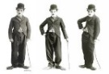
Be rid of. We are prejudiced
Against our passing into mist,
We do not think our death a good,

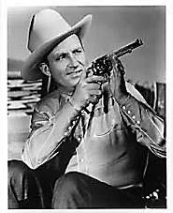
Or dare not think it so. Our lot
Is wept, our lot is coarsely cried—
But Mary Pickford never died.
Though celluloid may singe or rot,

And black holes burn into the tissue,
No, on the eye of God imprinted,
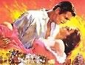
Our images stay freshly-minted
And thence new dreams for-ever issue:

They float upon the Milky Way
Through cycle and through revolution
As in a teardrop’s clear solution,
Film noir to glorious matinee,

Staggered kinetics of the Silence
In which we Charlie-Chaplin walk
Or learn, like toddlers, how to talk.
Gene Autrey six-shoots with mock-violence

Against a Western sky, and scars
Of memory heal themselves alive
Again, again, because they hive
In silver halides of the stars.




