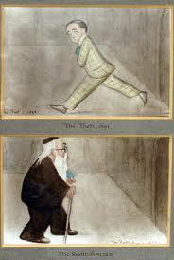 ***The Yellow Book***

***of Max***

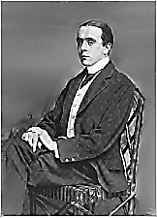***The Visitation of the Max***

*You won’t believe this, Oscar, but:*

*I’m in your dream! I can’t explain*

*How.* Welcome, Max. Your ancient brain *Beerbohm, that is.*

Amuses me. I like the cut—

So slender—of your style. Fine fellow!

Cosmetics cosmic in their periods

Your prose wears: *ennui* toned in myriads

Of masking shades, dominant yellow.

*True, en l’an vingtièsme de mon*

*Maquillage I was wizened as*

*The Sphinx that hath seen all things pass.—*

*Les temps jadis s’en vont, s’en vont…*

You are as old as sand—the sand

Of a resplendent sea-side castle,

Complete with flags of jaunty tassel.

What brings you, though, to Oscar Land?

*Hermes has sent me on a message,*

*Oscar. He wants me to remind you*

*That you are dead.* How droll I find you,

Astral-wing’d, bearing such grim presage!

This ‘death’ of mine: tell me about it.

*You’re sure you want to know? You died*

*In a hotel room. At your side*

*Were Reggie and Robbie.* Who could doubt it?

Such splendid fellows! *An old ear*

*Infection abscesses, with fever*

*In the meninges.* Well, I never!

How clinical it sounds, my dear!

*I fear you make an awful mess.*

*And yet you do not die in sin.*

So I explode, like a myth? *In*

*A ghastly way, you effloresce.*

A most unpleasant way to die! *Max disappears.*

This dream is rather harrowing.

So long since I ate anything…

I feel so flushed…faint…where am I?

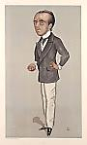***Trial by Caricature***

***The Sphere of Satire***

*Max makes me fatter than I am.*

*The scene is Cat-Call Music Hall.*

[Dante]: *Mind your Ledge!*

1.

Is that you, Max? What brings you here? *Beerbohm, that is. He sees*

Not dead, I hope? *Oh, no. At least that I have gained back the*

*I hope not. I feel like a creased weight I lost in previous tomes.*

*Page in some ancient book. Oh, dear,*

*It must be, yes, I think that I’m*

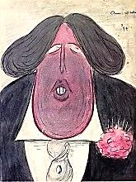 *Dreaming—if old men still can dream.*

Well, welcome to the side, the ‘team’.

You’re on a plane, you see, where time

And space are, well, peculiar.

*I have been drawing you*. Ah, clever

Max! *Hard as I try, I can never*

*Draw you quite as fat as you are.*

*I think I’m going to draw you fatter*

*Than anyone was ever drawn.*

Fatter than Aubrey did me? *(Yawn.)*

*I think I’ll think you as pure matter;*

*Then, Oscar, I propose to blow you*

*Up like a helium balloon.*

Max, don’t be tedious. *As soon*

*As I draw you as so-and-so, you*

*Are what I make you seem. Look! quicker*

*Than V can scribble ‘i.o.u’,*

*The blank your Self reduces to*

*Reforms itself, but as a thicker*

*And grosser Self, and, yes, a fatter.*

*Into an abstract state you fall*

*And simultaneously all-*

*Too-amply incarnate as matter!*

*I sigh as I begin to expand in smirking*

*` Beerbohm-space, self-caricturing.*

*caricature. Ah, well, no small parts…*

2. *On with the Show, then.*

*The grave of Self’s annihilation*

*Gapes thrice as wide for you as for (Something by G&S might be nice here.)*

*The rest.—*A fact which I deplore, —[Mr V]

But losing weight’s a tribulation

*[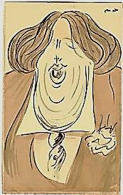](http://inmemoriamc33.com/mikado.mp3)*I am unable to endure,

So I must lug the avoirdupois *Am I the Mikado?*

And pursy bulk of portly *moi*

Like a disease without a cure. *Orchestral tutti. Applause.*

*You’ve taken on a plump rotundity*

*Incredible in its immensity,*

♫

*All-but Teutonic in the density*

*Of its corporeal profundity;*

*Outsized Falstaffian profanity*

*Gives you such ludicrous pomposity*

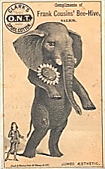 *Of oleaceous adiposity,*

*More than a man, you are a manatee.*

I am become a Schoolman’s quiddity,

*Crassitas*, with a bent for battening

On, of all language, the most fattening,

Larded encomiast’s pinguidity:

I lay upon you, like fantastical

Chintz drapery on an old chair,

The most outrageous flatteries: there!

*The greatest elephant in*

*the world, except himself.*

Upholstered rhetoric, bombastical

Hyperbole and gross exaggeration,

Unctuous, fulsome praise and oily

Compliments greasy as a doily

Soiled to the point of sweaty saturation:

‘Dearest, handsomest Max, ah! you are

The youngest youth I’ve ever seen!’

*Now you are merely being mean*.

‘You are so dapper, so demure!’

3.

*To be so fat suggests depravity, And yet: ‘All the fat is the LORD’S’.*

*It’s true; yet here you are, bereft* Leviticus 3:16

*Of all but your material heft,*

*By now a major source of gravity:*

*In a word, overweight—in fact*

*You have become so nearly spherical*

*It is a harlequinade miracle,*

*Of flesh you are an estate, a tract.*

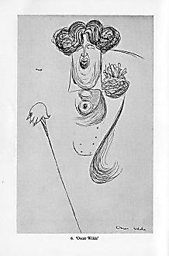*Not one of Dante’s* bolge *holds you.*

*You are outgrowing the entire*

*Depression, rising higher and higher;*

*Like a flesh-flag the wind unfolds you,*

*Or like a sail to the utmost swelling,*

*Like a cloud, like a cloud formation*

*You shadow the globe’s vast curvation*

*And where it ends, there is no telling!*

*So soft, so far-from adamantine,*

*So Tweedledee-and-Tweedledumpy,*

*So Humpty-Dumpty-plump and clumpy—*

***The Tragic Dandy***

*A Dandy, should he live so late,*

*Becomes, not a svelte skeleton,*

*But Falstaff, charm weighed by the ton.*

*How fat was poor Beau Brummel’s fate!*

—[Cancelled stanza]

—Cancelled stanza

*You’re a Gargantuan-elephantine*

*Heavyset, stout, absurdly dense*

*Man who, spectacularly globular,*

*(His thoughts half-nebulous, half-blobular)*

*Lost in his porcine corpulence,*

*Must drag his pudgy, paunchy bulk*

*Along the ground as Sisyphus*

*Uphill his rock, and ponderous*

*The wheezing pace, and a great sulk*

***Another Cancelled Stanza:***

***How Many Tweedles* Are *There?***

*I contain Tweedles Dee and Dum,*

*And several more you’ve never heard of.*

*(Writing in margins is absurd, of*

*Course, a vice I should abstain from.)*

*Exists among your folds of face—*

*Distended, jowly, erythematous,*

*With wattles of which no known limit is;*

*You are a weighty thing that weighs*

*As much as, and in form and feature*

Is *very like a whale whose blubber’s*

*So vast, it seems to mere landlubbers*

*Who’ve never seen quite such a creature*

*Less like a creature than a land.*

*A thing that thinks, ‘Alas, were I a thin*

*Fellow again…!’ No: you are Leviathan.*

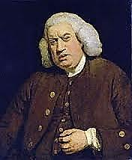*And thus resigned; fat makes you bland.*

*You grow through all the change of weather*

*Till you become (to my dismay!) an*

*Amalgamation Himalayan*

*Of many Oscars heaped together.*

I am become Johnsonian,

Almost. (For a Circumferential

Humanity was the essential

Ingredient of that massive man.)

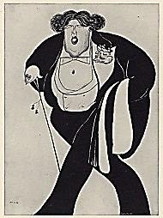Think of me as the Continent.

*The Incontinent, you surely mean?*

There is so much you haven’t seen.

Take the Grand Tour, become a *gent*,

See the Great World of me. Go on,

Round off your education, polish

Your manners, and perhaps demolish

Some *borné* notions, too, my son.

*Ah, it would be a* tour de farce

*Of no small magnitude, if I*

*Could bring it off.* Well, why not try?

It might make you a bit less *sparse*.

***Another Cancelled***

***Brummelian Stanza***

***Beau Brummel, when his slimness fails,***

***Meets an unfashionable end***

***At fences it’s too late mend***

***With his fat friend, the Prince of Whales.***

***.***

*

3.1

*Steatopygic, narcissistic,*

*Multiple-chinned and jowly, fish-*

*Lipped, huge hands moist as you could wish,*

*More than gigantic,* *GIGANTISTIC*,

*So swollen, meaty, over-present*

*In overbearing too-much-of-him,*

*Far too much stuff appears to stuff him.*

*If not bovine, then bovinescent*

*He seems to me in lard and lolling,*

*And, sirs, as far as one can tell he, well, he*

*Has no plans to reduce his jelly-belly,*

*And lately he is prone to rolling,*

*This pound-amassing ball of butter,*

*Nor are there signs he’ll ever cease*

*Becoming ever-more obese*

*And so fat-lipped he can but sputter*

*And thickly slobber forth his muttering*

*Through those reverberant, rubbery slabs*

*Till who knows* what *it is he blabs*

*Through all that noise of spittle sputtering?*

*Not worldly merely: planetary,*

*A gaseous Jupiter whose tactic*

*Is to inflate past the galactic*

*Till ‘mid the supernumerary*

*Vastnesses, with huge creaks and strains*

*He eats the universe entire;*

*Then will his weight and mass be higher*

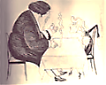*Than everything that he contains*

*(And all is now in him contained)*

*Of substance and of time and space.*

*(What* Grösse *in that fatted face!)*

*Not one more scruple to be gained.*

*What keeps me with a man so sick,*

*So fatuous and outright batty?*

*Love of the Fat Man, Amor Fatty A pun, somewhat* grossier*, on*

*Keeps me with him through thick and—thick. Nietzschean* amor fati.—[Mr V]

Too big I’ve grown for my own trousers.

I must find means to pay the tailor

And to ‘buy off’ a new blackmailer

(The cut of whose trousers arouses).

3.14 (*Enter the Oscar*)

The stage is set: a dull soirée:

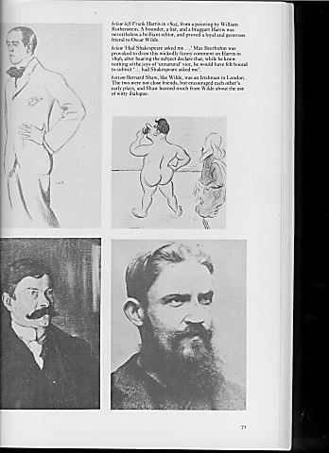 The tepid waltz, the gossiping pairs

Of matrons… Past their frosty stares

I make my slow and shambling way.

My left leg is an epic poem,

My right, a learnèd commentary.

The wit of those whose words I parry

Is pint-sized; mine’s a jeroboam.

*Frank Harris, shameless Bardolater,*

*ready to sacrifice his manhood on*

*the altar of Shakespeare’s Uranian lust.*

My arms are sturdy cylinders

Of gesturing flesh. My lips? Obscenely

Large, said one lady, rather meanly.

I move; my trousers swish; I purse

My monstrous fishy lips, then say

Such wondrous things, as lost in thought,

That soon the miracle is wrought

And all are hooked: I win the day.

*Your lips grew ever fatter, true,*

*And fatter grew your fingers and*

*Your thighs, but your head, vast and grand!*

*Became the fattest part of you.*

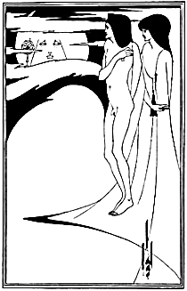3.141

All things want to be round, or rounded,

The Cherokee say: should you sound

*My* roundness I think ‘twould be found

Praise for Earth’s roundness is unfounded.

I am the heavy and the light

Combined: a massive Zeppelin

*‘…gigantic, smooth-shaven and*

*rosy, like a great priest of the moon*

*in the time of Heliogabalus.*

*—*Stuart Merrill

Part helium and part stretched skin.

That’s why I’m almost always right

About, say, Art, Space, Time, and Weather.

I split the difference between

Extremes, attaining, not a mean—

A different difference altogether.

And thus I, with profound resoundings,

A wheel-turned-sphere, blessed by its rondure,

Move smoothly into a Beyondure

Where I’m the ‘round’ in your surroundings,

Modality there is no fleeing;

More, therefore, than a simple ball,

I am the pantheistic All

In which you move and have your being.

Your scheme has failed, Max: though you planned

To make me little by expansion,

(And here I *do* exceed the bounds of scansion)

You’ve made me positively *grand*! *Survival of the fattest?*

You’d make me much more wide than tall,

But I’ve accomplished in my stoutness

A *ne plus ultra* roundabout-ness

There is no getting round at all.

*En gros*, you’ve merely multiplied me,

Not fattened me, by infinite orders

Of magnitude, or greatness. Borders

I’ve none, and nothing stands beside me:

I am God. And you? You are not there:

There simply is no room for you

Save in *me*, as a thought I have too

Long entertained, like an old air.

*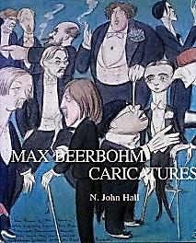Well, as a thought, do I, therefore,*

*Occupy space? If I am ‘there’*

*Inside you, am I ‘in the air’?*

A figure of speech, dear, nothing more.

In fact, I have invented you

As Will invented Enoch Soames.

*Will Rothenstein.*

You are apocryphal as the tomes

You never wrote. You are not true.

3.1415…

*Whilst I am, well, bloviating, hugely, thus, Max has taken from his pocket a small, laqueured box, of Chinese make, it appears. He opens the box, the interior of which is lined with silk, and carefully lifts therefrom, or rather tweezes, a fine silver needle. Remember that I am roughly co-extensive with the Universe at this point—and yet I can somehow make out that the needle is incised with exquisite carvings, made with an even tinier implement, by some very, very small, and I imagine, very thin, presumably Oriental, man. These carvings depict an entire scene: to wit, Angkor Wat, complete with temples, canals, lotus flowers, and monks in saffron-coloured robes with begging bowls. And now I am beginning to worry a bit, for he has casually positioned the needle between the thumb and forefinger of his right hand, and the hand is approaching me very steadily and purposefully, but for what purpose, exactly? I fear the worst: Cosmic Deflation! Whilst all of this is going on, Max’s face wears a look of inscrutable, almost Buddha-like, and at the same time distinctly blasé, detachment. I attempt to dodge the needle, but—there is no room outside me to maneouvre!*

*A small pin-prick can cause a vast*

*Implosion.* No, Max! Not that! NO!

*I (the Universe) deflate catastrophically. An apocalypse of inconceivable proportions, galaxies imploding, planets colliding to form molten lumps, cataclysmic storms and earthquakes and the extinction of life on this planet, of course… Meanwhile Max, who appears remarkably unconcerned as the end of time is taking place deafeningly all around him, appreciatively scrutinises his exquisite needle, occasionally sipping a glass of brandy. Once all the cosmic dust has settled…*

*There! You’re as thin as long ago*

*You were—in youth! Your trial is passed.*

Why, thank you, Max. It *was* a burden,

Being the Being of all beings,

With all the I-ings and the me-ings…

A villanelle shall be your guerdon. *Max looks somewhat alarmed.*

*Oscar, you are wilful, you are whimsical—*

*But I am tired, quite tired. I’m waking up.*

Your image, dear, *has* begun breaking up.

Well, long may you avoid the grim sickle!  *He vanishes, or pretends to.*