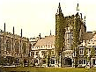
The Lightness of the Light

Am I in Heaven, or Magdalen? With my lovers and disciples (or call them students)
I stroll down the bird-haunted walks of what is actually the Oxford of a dream.
I have been paying more attention to the pre-Socratics in my reading, In their
aphorisms I find my life written and my fate foretold. (‘Character is destiny’.)
I discourse upon them. It is a fine summer day, the Cherwell is our Illisos; we recline
on a shady bank. I am asked to describe the experience of death and the afterlife:
I respond not with a true description so much as an impromptu pre-Socratic fable.

1.
Lightness, once hidden in the bone,
Expands and permeates the flesh.
The body, a thin, loosening mesh,
First feels, then joins, the senseless moan

Of astral breezes as they scatter
The stubborn selfhood like a cloud;
These tatter like an ancient shroud
The boundaries of solid matter

And all that makes it matter: mind
And memory and love and lust.
Soul, bursting into pollen-dust,
Adds bitter fineness to the wind.

It carries weight, this lightness: care
And sorrow, forlorn hope and fear
It holds englobed, a single tear
Evaporating in blue air.

2.
Like atoms of Democritus
We shall disperse and coalesce;
The Whole is neither more nor less
For all that may become of us.

Think that the Heraclitean Flame
Receives us, burning ever-wild
In time’s free play; that time’s a Child,
And we? The pieces in his game.

3.
Earth learns its own unearthliness:
Like an old Gipsy’s crystal ball
It grows transparent to the fall
Of starlight through the emptiness—

Poor Earth, askew, a giddy top
The Aion Child twirled into space
To be the tragic toy he plays
With till he tires, and lets it drop!

Poor Earth, Misfortune’s dizzy wheel,
A sad dream in the mind of God
Who wakes at last and thinks, How odd!
I almost thought the thing was real!

Fear not, my Dears, the encroaching night!
It signals turning and returning.
All that’s heavy is burning, burning
Into the lightness of the light.

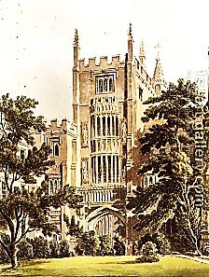
The Gay Science
Time’s Pastimes

I imagine myself as Tutor of Magdalen College,
Oxford, in my old rooms, Kitchen Staircase,
1 Pair Left, overlooking the River Cherwell.
My pupil, a comely youth I shall call H.C.M.

That Time slows as we near the speed
Of lightness (call it inspiration):
The notion merits some dilation.
A sort of Athanasian Creed?

Speaking relatively, of course.
Does ‘athanasia’ signify
A state of immortality?
It almost does. So through sheer force

Of effortlessness we attain
A temporary permanence
That wit indefinitely extends…?
To put it that way doesn’t strain

The meaning. Paradoxically,
As Time speeds up, it seems—to us,
At any rate—to slow down. Thus
It isn’t Time that flies when we

Are having fun, it’s we who fly?
Indeed: we reach the frivolous threshold
Where stale begins to grow fresh, old
Young, what is stale and brittle, spry.

And Time—so mindful of our sins
(You know, that sour Grim Reaper fellow)
At other times—even he grows mellow.
A transient regret begins

To form inside his stringent brain
For what he tramples with his feet:
Apple and golden hair, the sweet,
Small infant smell of ripening grain…

He thinks of Eden days, so rife
With leisure—and so far upstream!
When Time was young, he loved to dream
Beneath the exuberant Tree of Life.

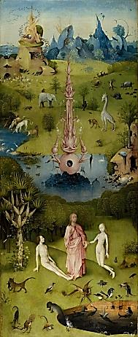
The other Tree is virgin-green,
Time hasn’t learned the sense of time,
Confounds it with the scent of thyme—
Spelt badly, though his nose is keen.

‘Tis these nostalgias that slow
Him down until he almost stands
Still. In the stream of wit his hands
Spread wide, his fingers feel the flow

Of what he is, he grows memorious,
Pleasantly sad. As our eyes twinkle
He starts to yawn like Rip van Winkle—
Then there’s a knock: Conscience, censorious,

Stands in the doorway: Clocks will tick
And clocks will tock. Time starts to notice
That we have spiked his drink with lotus—
And now we answer for the trick.



