***\* Jim and I \****

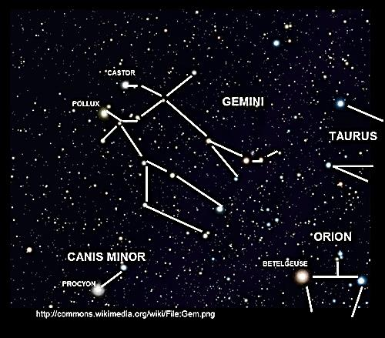

***Strange Gemini***

***Oscar Wilde and James Joyce***

***Table of Contents***

The Mysties 3

A Correction. A Conversation with a Dubliner 4

The Question Mark of Giacomo 8

Awake for Giacomo 12

*Ulysses* Revisited 17

The Story-Teller at Fault 23

The Apocrypheosis

of James Clarence Mangan 27

Oscar of the Cove: A Fantasy 29

Hanged on a Comma: Roger Casement 31

The Good Green Land 32

Jim and I Drink Too Much 34

Appendix: Musical Program 38

(A ♫ next to an image indicates the image is linked to a music clip.)

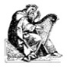***The Mysties***

Who knows the Misteries of the Twelve?

The mystery-eyed, whom I shall call

The Mysties, in the moistening pall

Of Erin’s mist they delve, they delve.

The rich green turf of darksome dells,

The sway of strong druidic trees

Are the seeds of their Misteries.

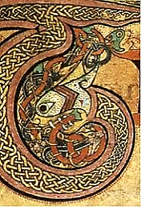The rainbow’s gold. The Book of Kells.

For centuries in the Land of Youth

They sojourned with Usheen, and when

His feet touched Irish earth again,

They withered, too, into the truth.

They heard of Patrick’s Purgatory,

The cave of Hell. They heard him say

‘Twas where their souls would burn one day,

But they did not believe his story.

Ash-plant in hand o’er fields they tread,

These Mysties of the Celtic Twilight.

(You cannot see them in a dry light.)

Mist-moistened are their eyes, and red.

From Tara Hill the Bards are calling,

And wheeling hawks give answering cries,

While down the dark and wintry skies,

Bright pieces of a star are falling.

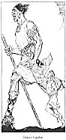***A Correction. A Conversation with a Dubliner***

*In C.3.3., or is it Purgatory? there is some leisure-time for reading, and in addition to the Classics, there is, of course, no*

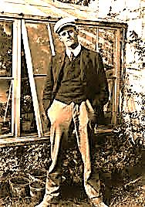*end of new books. I make it a point to keep up with the literary exploits of my younger compatriots, and the works of one*

*brash young Dubliner in particular, with an unapologetic brogue and a very dry throat but a fine tenor voice, have*

*been of interest to me in this regard. Yes, I can read the books of the future! There I entered into the dream of a*

*Mr James Joyce, and he did me the honour, at times somewhat churlishly tendered, of conversing with me about a*

*matter that concerns us both: the opinion that has been imputed to me regarding his celebrated opus,* Ulysses*, in a*

*book by one Hester Travers Smith (*née *Dowden) of the Society for Psychical Research,* Psychic Messages from

Oscar Wilde *(1923). In this book she purports to record my sentiments and opinions on a variety of subjects. In my*

*conversation with the Joyce I am especially at pains to clear up the misrepresentations contained in the Travers travesty.*

1.

Most Irish of all Irishmen,

Devoutest bibulist! Ah, may

I call you Jimmy for a day?

*Most certainly you mayn’t.* Good, then,

It’s settled: Jimmy you shall be!

You make the English language as

Drunk as you are in the cracked glass

Of sibylline crapulosity.

*What, Oscar, ‘s in a name? The ‘Spear*

*O’ God’? A shaky spear to shtick*

*Saint George-the-Dragon with. Gay-lick*

*‘Deer-Lover’? (Ah, dear lover, dear!)*

*Niamh your dam, Oisin your sire,*

*A faerie child, ungainly elf.*

*What vain pretence, to play the self-*

*Infatuated golden lyre!*

*From TirnaNog you hailed, the ever-*

*Green land where dwell the deathless young.*

*The airy lightness of your tongue*

*Came from a stone that made you clever,*

*A stone ye kissed, a stone ye licked,*

*Plain as a doormat, but it casts*

*A charmi-dizzy spell that lasts A dig at my poem, ‘Charmides’*

*Until the whimsy-bubble’s pricked. and its somewhat gauche eroticism.*

*Green blarneyman of Doublin’ Town,*

*So fool of posey, oh, so full*

*Of boysie! Eire-is-ponce-abel*

*Chicain pulled your cloudcastle down.*

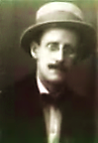*O two-toned green desire that dare*

*Not speak its name in England or*

*In Eire, for ire on either shore*

*Is raised by a Uranian pair!*

*A slim-guilt youth turned Dorian grey.*

*Soiled letterature, creased, dog-eared words*

*Lost the light touch when you crossed swords*

*With Curseon: how could you unsay Queensberry’s attorney, Edward*

*Carson, who, when I was plaintiff,*

*Your pose-proems and the rent-boys’ dirty cross-examined me in the first trial*

*Testi-money? Your flippancy with all the bitterness of an old friend.*

*Flip-fopped—and you claiming to be To his credit, he refused to take part*

*A man of all of nine-and-flirty in the prosecution of my two trials.*

*Prone to Playtonic love affairs!*

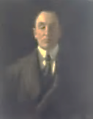 *A pair o’ doxies and a maid*

*Spoke you much ill, but you betrayed*

*Yourself with your grand, silly airs.*

*A simian Joker’s card incensed you.*

*With no full deck you dared to play*

*The Marquer of Queens and Cains. But they*

*Who bore the witnesses against you,*

*The sly solicitors, informers,*

*Detectives (for a Littlechild The name of the private detective hired*

*Shall lead them), they’d sleeved up the Wilde by Queensberry to track down witnesses.*

*Card and the aces. How enormous*

*The consequences of convictions*

*For convicts whom the laws convince*

*It is a game one never wins,*

*Publicly living private fictions,*

*Romans à clef with all the names*

*Spelt out in boldface in the margins!*

*Your wrists decked with the police sergeant’s*

*Manacles, you suspect the game’s*

*Most likely up when led away*

*From the Cadogan’s hock-and-seltzer.*

*Justice! What thought for Beauty melts her*

*Heart? Two more ‘hands’ or trials you play*

*Until the tainted jury votes*

*That you shall don what’s all the vogue*

*Where you go: arrows, scapegoat-rogue-*

*Wear. Ariel weeps. Caliban gloats.*

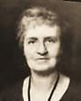*I mourn what violent silence tombed*

*Your voice, glib jackadandyline.*

*O scar that was your mouth! That fine*

*Friendsy of languish, sexiled, doombed!*

*And tell me that you didn’t say*

*Those things that Hester Travers says* *Hester Travers Smith*

*You said about my book, I prays,* née *Dowden*

*That book about a Dublin day.*

2.

Ah, Hester Travers Smith! I know

The woman. She writes silly lies

About me. What vulgarities

She claims I said, how crude and low!

Travers… Another with that name,

A young woman, a curious sort,

Once dragged my parents into court.

She told those lies that brought such shame

Upon my father—who, it’s true,

Was a philanderer, but whose

‘Victims’ did naught they did not choose.

*For libel did this Mary sue.*

Now here’s another Travers, lying

About another Wilde*.—Yis, two*

*Mistraversers transducing you*

*And yours, begob! So are ye trying*

*To say ye didn’t much despise*

*The navel I adamned th’Yinglish world*

*Withal, ye would not have it hurled*

*Gehenna-words?—*To my surprise,

In fact, I was impressed. (My taste

Must seem to you so antiquated!)

This monument you signed and dated

Rises before us pre-defaced

With the graffiti of minute

Particulars of reality.

No Realist I, but when I see

Another genius, I salute.

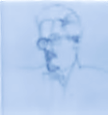*Why did you shame our Ireland*

*With this low scandal? Our poor nation*

*Already has a…reputation.*

*Say why you stooped to kiss the hand*

*Of the English aristocracy.*

*And why for boys you shamed your art,*

*And pleasures fleeting as a f*rt.*

*I li ved a life of poverty,*

*I give me all and sundry to*

*A book that will stare down the ages,*

*Though prudery knits its brows and rages.*

*It is obscene in places, true,*

*But so is life, below the waist.*

*In print you were a toff, your prose*

*Wore a top hat and fancy clothes;*

*In life you were a satyr, chased*

*Poor renters, gave them cigarette cases*

*And dropped them like smoked cigarettes*

*When you grew bored. Starved, household pets*

*Are treated better! Do their faces*

*Not haunt you, these poor children of*

*The working class you airily*

*Exploited? And your wife, does she*

*Speak to you ever of the love*

*That you betrayed? Your sons, yes, they*

*Whom you so casually forsook,*

*Whose happy childhoods you took,*

*I wonder what they have to say?*

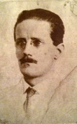

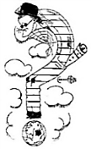***The Question Mark of Giacomo***

*It is 13 January, 1941. Joyce’s death mask floats before me. He has not yet*

*left his body. Beneath the mask floats a curious pen-and-ink portrait of the author.*

1. *To the Mask*

One night I’d like to see you do

Your spider-dance (those rubbery legs!)

Or lay a clutch of Orphic eggs *Plurality of worlds. Your martyred hero Bruno.*

And pigeon-brood o’er the vast Brou-

*Brouhaha: a fascinating French word, from*

Haha of too much world and, Lord! *the cry of the false clergy in mediaeval plays,*

So little time to have fun with *perhaps ultimately from the Hebrew, ‘barukh*

It all, playing the archi-smith *habba’, ‘blessed be the one who comes’.*

Of shapes and myth-scapes of the Word.

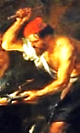Ah, forging uncreated souls

Takes so much time that he could sulk an

Eon over the task, poor Vulcan!

Blackened by smoke, poking the coals.

An embryonic something possible

Gestates into a certain boy’s

Foetus, which grows into James Joyce,

Who tries and achieves the Colossible



And leaves behind a plaster mask’s

Daedal detail and rigour, real

Though dead to what it cannot feel,

Sleeping the questions that it asks.

2. *To the Portrait*

A friend said you looked like a question *Paul Léon.*

Mark when you stood bent over in

The street, and so César Abin, *A Spanish artist commissioned by the Jolases*

Under your scrupulous direction, *to draw Joyce for their journal,* transitions

*in honour of his fiftieth birthday.*

Presents you, concave as your face,

Stooped, the world at your feet, balanced

Over that ball, discountenanced

And fretful in such empty space.

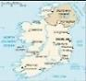Is it a seal-trick in reverse?

Is it your mind’s trick-seal balàncing

The world? You sum up, at a glancing

Angle, the twirl of what occurs

Under your soles on such a massive

Scale. But your large brain’s microscopically

Focused on Dublin’s vivid, topically

Specific darkness. Being compassive,

Dispassionately written in

To what you fret gigantically

Over, you weigh the puzzling tally

Of what has come or might begin

To come of it, in the great scream *‘No, doubt is the thing…Life is suspended*

Of things, and silence of the void *in doubt like the world in the void’.* —*Joyce*

Geometries a paranoid

God ciphers with stars and a Dream.

But you see through no*-*coloured glasses,

 Black spectacles for one half-blind

With pen as seeing eye, whose mind

******Surpasses, somehow, all that passes.

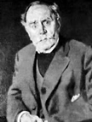Your derby hat is black in mourning

For your old father; it is cold,

You yourself prematurely old,

Cobwebbed, poor, in patched trousers. Turning

And turning keeps the world, suspended

Beneath the slouching Titan mass of a

Sentence suspended, of a Passover.

You are the world’s self-doubt, befriended.

But, egoist, your self-assertion

Of a long hesitation’s poise

Unsteadily standing, makes you joy’s

Grieved father and orphan. Your desertion *His daughter Lucia has sunk into madness.*

From the black capital of the only

Ireland in the world, is it

Not vigil for the Infinite

Word you made pun of? It is lonely.

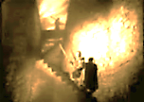3. *What Ho, Bernardo!*

You come not carefully upon

Your hour, but ah, so punctually

Untimely! Watching tipsily

Not less than Everything—how gone,

Going, and going to be—: high sentry,

What strength you show in wavering, posed

So dubiously thus, Blue-Nosed

Comedian of the twentieth century!

Make that ‘half-century’, for the shifty,

Makeshift and shiftless fellow here

Depicted in such shabby gear,

This spendthrift tippler’s naught and fifty. *Portrait of the Artist as a Prematurely*

*Old Man. The portrait was commissioned*

Doubtless you have just micturated *to commemorate your fiftieth birthday.*

In some shadowy alleyway. *(Aquarius: an air-sign, yet a water-bearer.*

*For this relief much thanks*, you say, *The net result: a splendid Celtic mist!)*

And take the watch. In your elated *Picture the watch, of Swiss make, with a*

*Horus-eye staring out from the linchpin-hole.*

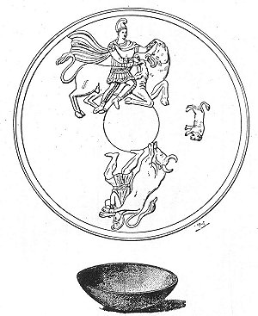Dejection you seem quite transcendent

Of both despair and hope. To ask *A Spinozan stoic.*

The darkness, *Who’s there?* was your task,

*Sainte-homme*, world’s crooked papal pendant.

Of course you haven’t really died,

You are still gloriously neurotic.

No, more, you are *metempsychotic*.

You are Mithra stepping outside

*Mary Colum said of the* Work in

The cave of the known universe Progress: *‘I think it is outside literature’.*

Of language into a transcendent

Space, and entirely independent,

In a hat black as any hearse.

Behind you you have left the broken

Eggshell; the serpent weaves among *An ‘egghead’, Americans might call you.*

The wreckage like the grief-tune sung

By Orpheus, in gone love’s token.

Yes, the poor clown-god seems quite lonely,

Being the giant that he is,

Suspended in a vast abyss.

‘Tis a grand curse, to be the Only.

******Step out of this ecphrasis, clastic

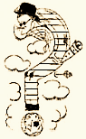 God, in default of every icon,

And with no anvil here to strike on

Save the entirely Phantastic!

4. *Rebirth, as Portrait, of the Mask:*

*He Becomes his Inquirers*

How madly you enjoyed your madness,

You whom I shall dub Sir Reality.

The evil of the eye, its malady,

The dimming of primeval gladness,

The fading of epiphany,

Reversed in re-illumination,

Reveal their own regeneration.

Cold mask, let us be ritually

Punctilious. I hold these strong

***[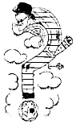](http://inmemoriamc33.com/soldier2.mp3)*** Spirits before your nose, to wake

The Finnegan in you, and make

You live again. Breathe deep and long.

*His eyes open.*

How pleasant, dear, to see your nose

Turn blue! Before it shines that star

You followed. What you were you are;

It was but a light, pleasant doze.

*The death mask vanishes. Joyce*

*in his astral body assumes his*

♫

5. *position, hunched over the world*

*Asleepius, you only make in the now-luminous portrait.*

*The sleeper sleepier. But I’m*

*A sort of something—does it rhyme*

*With ‘fake’?—ah, yes, I am a-wake.*

* * * *A garbled version of ‘Let Me Like a*

*Soldier Fall’. The rolled music sheet is*

*Yes, let me like a soldier fall. shown protruding from Joyce’s trouser*

*Brave manly hearts confer my doom. pocket in this made-to-order drawing.*

*And say, who stand before my tomb, (Mithra, the Roman soldier’s god!)*

He like a soldier fell*. O all*

*My shame and all my glory tell*

*Who only asked of my proud race*

*To die the last, nor in disgrace,*

*And say,* He like a soldier fell. *In Mental Fight!*

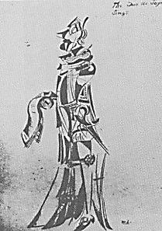***Awake for Giacomo***

*Jim, stood up in his coffin, opens his eyes to a ‘surprise’ wake and*

*welcome party on his officially joining the Posthumous Club, calling*

*for all the uninhibited festivity of a child’s birthday celebration. We are*

*at Rossetti’s house, with many other guests at the night’s proceedings.*

*Jim refuses to play the ‘stiff’, and somewhat rowdily participates.*

1.

*This is your wake, dear Jim, your shiva. (Oscar)*

*Shiva, god of the wild west wind, (Browning, Shelley-shallying.)*

*Quicken a new birth of his mind*

*On the other side of the river. (Chorus)*

*May your wit be with you for ever. (Charles Dodgson)*

*Fear not the whiteness of the light.*

*It shines for you both day and night*

*On the other side of the river. (Chorus)*

*The mast is fall’n, the timbers shiver (DG Rossetti)*

*And you shall come again no more.*

*Things are not as they were before*

*On the other side of the river. (Chorus)*

*

*Here’s to me, boyos, ‘twas a good run (Jim)*

*If a short one. I had some fun,*

*Blazed like the sun, but that is done.*

*Dead, dust-dry-dun is me old Blood Run.*

2.

*The Heraclitean stream will flow on A soused, thirtyish disciple of Joyce’s, Samuel*

*And flow on and so on and so on Beckett, who is actually dreaming this entire*

*This earth weeds grow on, stars will glow on episode—a pickled dream he will forget—with*

*A man who can’t go on, who’ll go on. Irish impetuosity interjects himself into*

*the proceedings with the following quatrains.*

*This little ember that we blow on… Rather stuck on the one rhyme, I think. And*

*A sort of existential Koan, as for his crude language: it is most offensive.*

*This prayer to Nothing and to No One; But no one could dispute his cricketing skills.*

*It goes, ‘I can’t go on, I’ll go on’*.

*A staring silence greets this outburst. I break it.*

Go on. *No, thanks. I sed me peaze.*

*I mind me queues. Belacqua’s part*

*Is to sit on his *rse and f*rt*

*And read D*nte. Whereat I ceaze.*

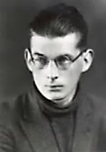You *do* possess a morbid verve,

My dear. You find life meaningless,

And clown at the edge of the abyss.

To do this takes a certain nerve.

And to join the Resistance: plucky!

For the Gestapo like to play

With pain. *This time I got away.*

*Next time I may not be so lucky. ‘”Lucky”… An interesting name for a*

*character in a dark comedy, don’t you*

*think?’ I say to Sam, taking hiim aside.*

*Perhaps he will recall this part of the dream.*

3. *In Principio Erat Verbum, Etc.*

Swinburne: *Dancing about excitedly.*

*This riddle is thorny as a thicket:*

*It begins with ‘ends in beginnings’*

*And it ends with ‘runs in big innings’.*

*Is it cricket, this sticky wicket?*

*In the Big Innings was the Word Jim (a cricket enthousiast).*

*Struck hard, and it made little puns*

*And we scored many riverruns*

*That day, unheard-of many scored.*

*The Word in its beginnings was spun . Charles.*

*Round and around to make a whirled*

*Little ball that we call the world.*

*The Word in its beginnings was Pun.*

*In the beginning was the Word Aubrey Beardsley.*

*Spun round and round until a world*

*Was worlded by the Word, was whirled*

*Into a Word-Thing, as it were’d.*

*And Word is’d, are’d and was’d and were’d Lord Byron?*

*And will-be’d, all at the same time.*

*It was a jealous paradigm.*

*With neither rhyme nor reason, Word*

*Called itself World. It was acutely*

*Ambivalent: was it small or vast?—*

*It made the present tense, the past Charles.*

*Perfect, the future absolutely*

*Conditional. And things all day*

*Heard voices telling them to act*

*Or suffer. Some thought, ‘I’m a fact,*

*And that is all there is to say’.*

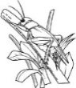*Whilst others thought, ‘Perhaps there’s more Swinburne.*

*Than one way to be seen?’ And doubt*

*Filled them, for they could not make out*

*Quite what it was that they stood for.*

*And others, still, refused to stand Charles.*

*For anything at all. Things changed.*

*Vowel-shifty, moody and estranged*

*They grew, but the Word kenned and canned.*

*AGREE, it told the words, OBEY.*

*But verbs showed dubious aspects*

*Whilst nouns declined to be objects.*

*And grammar suffers to this day*

*From loss of glamour, its chaste mind*

*In the big U of ambiguity*

*Cupped, nouns corrupt in superfluity*

*Of contexts thoughtlessly declined. Malthusian linguistics?*

*In Buggy Innings the Beguine’s Swinburne, tossing fistfuls of multi-*

*The Last Word in Beginnings, buggering coloured beggar’s velvet into the air.*

*Description is its hugger-muggering,*

*God Himself knows not what it means. Soused, le Duc arrogantly usurps my*

*prerogative as giver of stage-directions:*

[*Here the great good William Gilbert Grace, champion cricketer of all time, as old as Methuselah,*

*enters batting giant atoms out of the galaxy and into the deeps of yonder-space, they bounce off*

*the uttermost wall of the spheroid Unicorniverse, each atom splitting into trillions of subatomic*

*particles in turn shattering into sub-subatomic particulules, of which three for Muster Mark,*

*please, and a huge, giant, large, rather big, above-average-in-size-for-a-cricket Cricket hops out*

*of a thicket and takes a turn at the wicket, but no, it is the Good Luck Cricket of Pu-Yi, last*

*Emperor of China, he keeps it in an intricately wrought ivory cage not much larger than a locket,*

*but no, in fact it is simply an ordinary small boy’s lucky cricket escaped from its miniature*

*Schrödinger box, and all are suitably impressed by its decision to exist, and Grace himself in*

*his great bearded Falstaffian little-boy gusto grown to Titan size applauds, we all applaud the*

*Good Luck Cricket at the bat, Cricket runs back and forth so fast he becomes a solid line or*

*vibrating string that hums whilst Oy says Grace and Grace sings me and, by the God of Grace*

*and Greece and Gross of God, that’s surely enough of this* reines Quark-Reden um das Wort!]

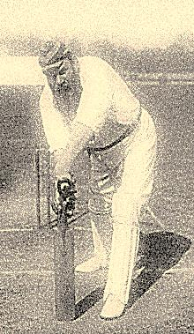

*Ah, well, his left leg is*

possibly *a Greek poem.*

4. Oscar:

The Holy Ghost is but a dove, bird *The nice distinction between the*

Of one stripe; Holy Spirit can *relative incarnational versatilities of*

Be goldfinch, crested grebe, toucan *the Holy Ghost and the Holy Spirit is*

And several species of the lovebird. *the subject of spirited debate. A point first*

*raised by the puritanical lunatic Father*

It is a Lovebird now, the Holy *Feropont in* The Brothers Karamazov.

** Spirit, αγάπόρνις, that’s fluttering

Above Jim’s head. A Joy past uttering

Desires to grace him, heart and solely,

In AGAPORNOTHANATOGRAPHY. *Mark Twain intrudes for no particular*

Jim in his writing spoke the world. *reason: ‘Sir, I have inspected this high-*

Like wings the pages are unfurled *dollar portmanteau-word from every angle,*

And fly into eternity! *and I conclude that it should not be sold*

*at some run-of-the-mill antique shop in*

*Portobello Road. I suggest you bring in*

5.Jim as Cardinal Newman: *Sotheby’s’.—This is done. (I will hardly*

*I speak on the Holy Ghost’s behalf. miss it. The thing was bulky and pre-*

*He is no showman costume-changing: sumptuously hypermetric.) Because it is*

*He is Himself, though widely ranging, heavy, a crew of six is required to haul it away.*

*And never, never does He laugh.*

C:\Users\Aphori\AppData\Local\Microsoft\Windows\Temporary Internet Files\Content.IE5\X0NB3R66\MC900283361[1].wmf*He trumps the allusions of the Holy*

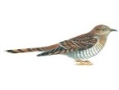 *Spirit.—Then worship we the Dove,*

*The Only-Bird, the Bird of Love,*

*Not to be parroted, but solely*

*Authoritative, overflying*

*All witticism and all psittacism,*

*Who will not tolerate one bit a schism*

*Of any kind, and no denying*

*The truth through pettifogging bluff,*

*But the Confession of the Sinner!—*

[O:] What, can’t the Beggar share the Dinner?

One Last Supper is not enough.

The Spirit spends His time conversing

Idly in any tongue, in chaffing

A bit, even, to set you laughing.

As mockingbird, he’s known to sing

A midnight medley of the day’s

Quota of magna opera,

Warbling an insomnia

Of references and turns of phrase.

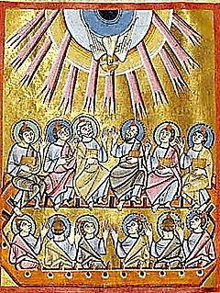6. *Jim’s Sermon on the Pentecost*

*Let us repeat what Paul, in all*

*His heteroglossy raiment, spoke.*

*The giddying Dove beaked him. Out broke*

*A frenzy polyglottical*

*To oinopopontificate*

*Sur le péché, with agenbit*

*Of coscienza infinite*

*Für unsere Moralität.*

*The dove never ceases to move on toward*

*what is before, going on from whereeit now*

*is, to penetrate that further to which it has*

*not yet come*. —Gregory of Nyssa

*Dove-Word is Word intensified*

*To hyper-sacred frequencies.*

*What to us sounds like gibberish is*

*Raw God in all His naked hide.*

Then we’re all ears. Tell us what Paul

Said, that you’d have us all repeat?

*Gandwanananda droople dreep.*

*Now this is not obscure at all:*

*Gandwanananda*, *clearly, is*

*The pure primordial origin.*

We DROOPLE-DREPT: *we fell in sin.*

*Regained must be* *that distant* *bliss*.

*Repeat, my children, after me:*

Gandwanananda droople dreep.

Gandwanananda droople dreep.

*GANDWANAN is the verb, ‘to be’.*

*ANDA means, ‘In a state of bliss’.*

*O do not droople, never dreep!*

*And let the Dove hear not a peep*

*That is not Praise whose Praise is His!*

Oscar:

Though I don’t droople, now and then,

I must confess, I’ve dreeped, or drept.

And many a time for this I’ve wept

And then I’ve gone and drept again.

*Oh! te absolvo, fili. Dreep*

♫

*No more, henceforth, nor droop, my son.*

*[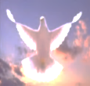](http://inmemoriamc33.com/wake.mp3) And now, God bless us everyone.*

*The Wake is nodding off to sleep.*

***Ulysses Revisited***

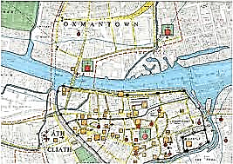

*Speaking with Jim.*

1.

I have read through *Ulysses* once

Again: I am even more impressed.

You and Marcel are much the best

Of Flaubert’s wayward modern sons.

*Begob, my death was a nightmare*

*From which I am trying to awake.*

*You’ll put me back to sleep!* I take

It you’re abashed by such a rare

Compliment? But you write resplendent

Prose! A cracked looking glass you place

Before the Bard’s own gibbering face.

A prank so cheekily transcendent,

Getting the English language drunk!

Linguistic Saturnalia

Striking blows for Hibernia!

Yet, from behind it all, a monk

Peers out, ascetic young aesthete.

‘A god, paring his fingernails.’

(That comes from *me*.) The prim Muse pales

At the soiled wonders of the street,

But down that street your novel guides

Her, sights that would have sickened Zola

You show her, as you give the soul a

Tour of its animal outsides.

2.

That June day glared, and challenged you

To render it, down to the most squalid

Details, as a Carlylean solid. *‘Narrative is linear, Action is solid’.*

But is not Bloom, the Wandering Jew  *—*Carlyle

Reading at stoolhis *Titbits* tale*,*

A sort of icon to remind us

How soon such things will be behind us,

Mixed with the dung and gilded stale?

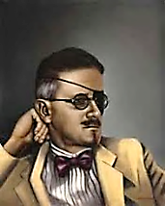And yet ‘tis a canonic Scene,

Recorded for eternity.

It resists ideality

In vain, the smear of what is mean.

It is swept up into the vast

Sun-saturated canvas of

A day in Dublin’s life, whose tough

Presence is flooded by the past

As by a Liffey of the soul

That carries all that is inside us

Of prayers and curses, that detritus,

To the ocean of the cleansing Whole;

The Akashic record of that single

Sixteenth of June, 1904, *When you and Nora first ‘stepped out’.*

Silver-and-dross of Dublin ore,

Where the inner and the outer mingle

In one half-chance, complex vibration

Somehow imprinted on the ether

Of vital oddnesses together

Forming the song of their occasion

Intricately attuned to which,

With vastly listening ear, one sings *‘You’ becomes ‘one’ becomes ‘he’ becomes ‘we’.*

The motley anthem of these things  *A polyphonic ear hears collective Rabelaisian speech.*

Whose very poverty is rich

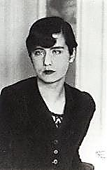

With scents his intuition noses.

Lives of the living and the dead

He lives and dies, for he has read

The scripts of our metempsychoses.

(A schizophrenic, Carl Jung thinks,  *He should have said, ‘scherzophrenic’.*

But diving conscious into water

Wherein Lucia, your poor daughter,

In helpless madness merely sinks.)

3.

Realism, pushed far enough—

Too far, that is—yields to the pull

Of the Phantasmagorical.

Among strange diamonds in the rough

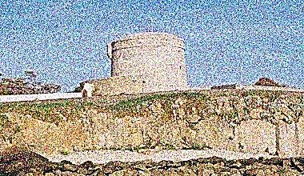We enter what is truly real:

The mind, half-dreaming what it sees

In haphazard epiphanies,

The taste and touch and smell and feel

Of existence as a lived process,

Moment-by-moment. This atomic

Viewpoint is mapped, in ways both comic

And grand (as in ‘met him pikehoses’),

Onto the overarching myth

Of the *Odyssey*. The past, the Great

Tradition, shadows forth a fate,

An archetypal monolith

To which this day’s experience

Adds its impromptu gargoyles. Mind

Passes through Overmind. Refined

And gross, intricate and immense,

Eccentric, yet of massive poise,

This solid dream, this sight-seeing vision

You render with such mad precision

Gives madness reason to rejoice.

You consecrate life’s daily mess

As artist’s bread, down to the least

Particulars and bubbling yeast

Of language-making-consciousness.

*Ulysses* is a smear of gold

We find God-like details enough in

To fill cathedrals. (One must roughen

The texture or the truth won’t hold,

The truth, I mean, of mental realms.)

Your ear, ah, supernatural!

Catches murmurs innumerable

Of bees in immemorial elms,

When that’s the note you wish to sound.

In ‘The Oxen of the Sun’ your style

Runs from the Latin to Carlyle.

Indeed, what echo is not found

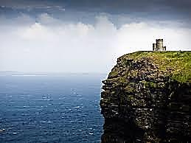Of literary ancestors,

Most from an alien, conquering race?

For you, pastiche is at once grace

And vengeance on those who by force

Stole from us our good Gaelic tongue,

But in whose language we must speak

And write, or else, resigned to weak

Provincial status, dwell among

The marginal, behind green doors

Weave cottage marginalia,

Languishing in Hibernia,

All our subversive metaphors

Hidden, like Blake, but in the dense *‘I am hid’, writes Blake writes in an*

Brogue of an ancient wizard speech *annotation. To be ‘apocryphal’ in both*

We would, like good Saint Francis, preach  *Graeco-Roman and Hebraic traditions*

To ears that catch nor style nor sense. *means to be ‘hidden’ or ‘hid’.*—[Mr V]

With syntax to inordinate

Degrees you play, of which the meaning

Often resembles more a keening

Than a (to logic or dictate

Of fact with reference which one

Can easily grasp) significance.

Nothing in style escapes your glance,

With life it rings in unison.

4.

Imagination can possess

The streaky bacon of a life;

Through the texture, as with a knife,

Cut to the grain of consciousness.

Mid-day traffic. Businessmen feeding.

The potted meat. The scrotum-tightening

Sea, the wind-driven breakers whitening.

Bloom in his silks, or Stephen reading:

We know them by their style of thinking.

How the sun dapples with its light

The schoolmaster, the anti-Semite.

The rumor of sedition, winking.

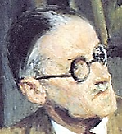The Cyclopean Citizen

Hurling his tin. Gerty, who raises

Lewdly her skirt, the lame girl. Blazes

Boylan. Gogarty-Mulligan.

You get inside our heads… What is

Home without Plumtree’s Potted Meat?

We know the answer: Incomplete.

And with it? An abode of bliss.

(Your Stuart Gilbert certainly

Wrote you a fine advertisement,

A book of which, do you repent?

*I do, I do, most bitterly*.)

It ends—to anticipate—with Yes.

As well him as another, call

Him lover or husband, Yes to all

This, melon-buttocked Molly says.

5.

*Yer deepraised voice is greatful to me,*

*For all of yer profundust snobbing.*

*It pains me, thinking of you sobbing*

*There, in your prisonce, gland and gloomy.*

*But I owe you no reverence,*

*O Moon-Queen of a Beardsley drawing.*

*I find you less than overawing.*

*I made of you whatever sense*

*Kneaded, to bake my* WIP*, a ball Work in Progress.*

*Of doughy smear-sinification,*

*Accusative of accusation.*

*I made you anyone at all.*

(Ah, here comes everybody! I’m

Aware of it: quite Shandean.

The plot, though, as far as I can

Make out, is: Once. A pun. A time.)

To appropriate is exquisite,

To be appropriated, more

Exquisite still. Come, dear: have your

Way with me. I don’t mind a bit.

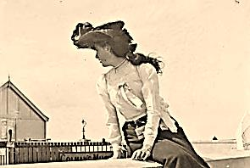Far from a solemn archetype,

I am a posture, a position,

A trend, a manner, a transition—

A Tyger, in short, of any stripe

One of your stripe may postulate.

*Primal infinitive of a sign*

*That signifies its own decline*

*Into declension and cognate…*

Yes, mighty conscience-forging smithy,

Go forth, our Hero Daedalus!

(Though in your *WIP*, dear, some of us

Might wish you a wee bit more pithy.)

[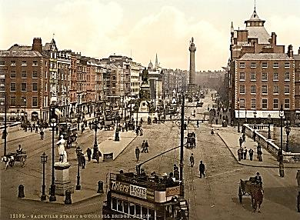](http://inmemoriamc33.com/seaside_girls.mp3)***The Story-Teller at Fault***

♫

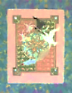

*As told by Mr James Joyce.*

1.

*Aengus, ‘tis the great traveller*

*You are! No tellin’ what landscapes*

*You’ve passed through in your antic scrapes,*

*You always seemin’ here and there*

*And nowhere. It’ll be a cold*

*Day in Hell when the likes of me*

*Can get away with what you see*

*Your way through, begob, but you’re bold!*

2.

The story-teller’s out of tales—

That’s where the mischief takes its start:

The inspiration’s left his art,

And that’s a fault for which one fails.

He gambles with a beggar, loses

His property, his wife, his proper

Semblance, in all things comes a cropper *Hump, croupe, a kind*

Until among the herbs he noses, *of printing press.*

Hare-brained in a hare’s body, he is,

His own hounds set upon him by

His own wife. Then by wizardry

The goods are gone; who knows where *she* is?

But wife and goods and all are stowed

With care in an alternative

Dimension, where we shall them leave

For now, for on the wingèd road

Go story-teller and beggar-man,

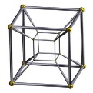 The teller invisible, but seeing all:

‘Tis in O’Donnell’s Keep (it being all

Around them dark, where Red sits wan)

They are, beggar and unseen fellow.

But he is Aengus of the Bluff,

Of tricks the god has store enough,

And Red has store of coins of yellow

(*The architecture of ‘literary space’?*)

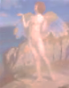To pay him to provoke his laughter. It’s

But a wee thread we’re speaking of

The beggar spins to heaven above,

But up he sends a hare, and after it’s

A hound he sends, and then a lad,

O’Donnell’s lad, to stop the hound

As tries to eat the hare. To ground

He pulls the eaten hare, the bad

Dog and O’Donnell’s boy, asleep.

He chops his head off for neglect.

But sure he can him resurrect,

Such spells are in a wizard’s keep,

But that will cost the king more gold,

Which paid, the lad is in his health

Restored, the beggar has his wealth,

And, well, there’s more that could be told.

3.

How they continued till ‘twas in

The King of Leinster’s court they were,

And many times they hang him there,

The beggar, but he out of thin

Air re-appears alive and hale,

*Is it me-self you’re looking for?*

He asks the guard, and to restore

The king’s dead sons he does not fail,

And to the teller he reveals

Himself as Aengus, he that’s of

The imaginary land of Bluff;

And wife and goods, like one who heals

A wound in space and time that death

Has made, the god brings back to life.

*Bless you, but you can keep the wife!*

As in the abstraction of a breath

The god had hid them in the space

Of telling, whence he now retrieves all,

And cheers the teller and relieves all

From the suspense with which he plays.

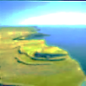And so the teller’s family’s

Restored to him, with his position:

For the king craves the repetition

Of that one story, for it is

All the other stories, isn’t it?

This poor Job-out-of-work who lost

It all, receives more than his cost,

The treasure of the Aengus wit!

He did him a good turn or two

And so the god of trick and frolic

Cures the king, sleepless, melancholic,

And so the teller’s dreams come true.

4. *The Sequel*

The teller thus his lot secures

As *good* in life, though not as *great*.

(But could one come, at length, to hate

Re-telling the tale that ensures

The goodness, the insipid good

That is one’s luck in life, and lot

In the great lottery one has not

Yet won, but thinks that one still could,

If given half a chance, an angle?)

And so the teller hates the god

Who saddles him with but one odd

Matryoshka doll, and lets it dangle

From his hand or sit on his shoulder

And be his hump, his Hugo-esque

Trope of Romantic-Turned-Grotesque.

Never was butt of laughter older

Than what this god makes of him and

His hump, his ‘legendary story’.

*A million of the things, bagorr! he*

*Has, does this Aengus, ain’t he grand?*

*And yet ‘tis but the one he gave*

*Me, this Lord Aengus: beggarly*

*Indeed’s his generosity!*

*Is that how a god should behave?*

*So I’m the pony of one trick,*

*Mavrone! Not half as rich as Craysus,*

*And but a beast of burden. Jaysus!*

*This Aengus god half-makes me sick.*

4. *His Wife Scolds Him*

*A greedy troll guarding his vault!*

*So it’s not autographs you’re signing*

*These days, and on fine lobster dining?*

*Ingratitude’s a serious fault!*

The Story-Teller:

*Why don’t I have it printed, then?*

*There’s pots of gold in that, no less!*

*I’ll use old Cropper’s printing press.*—

So the *auteur* takes up his pen

And is a famous literary man

Who has *amours* and duels in print

And makes himself another mint,

This little literary dairyman.

5. Epilogue: Haines (from *Ulysses)*

*This fine Hibernian trickster is*

* Quite the old hand. Impressive, very!*

*True Celtic-twilight* völkisch*-fairy,*

*Eh what? I’m here for stuff like this. Aengus chops off his head.*

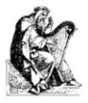

[♫](http://inmemoriamc33.com/chieftains_stretched.mp3)

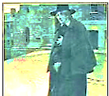***The Apocrypheosis***

***of James Clarence Mangan***

***as Related by One James***

***Augusta Aloysius Joyce***

*The Judgment Hour must first be nigh,  
Ere you can fade, ere you can die,  
My Dark Rosaleen!—JC Mangan*

1.

*Fell Time, that greedy landlord Time,*

*He takes starved children for his rent,*

*And spinsters by their labour bent,*

*And many a bone in many a rhyme*

*There is to pick with him! Among one’s*

*Pet peeves, he greys my hair, he ploughs*

*To earth the Woman with Three Cows ‘The Woman with Three Cows’:*

*And along come the tramplin’ young ones!* *a poem by Mangan.—*[Mr V]

2.

*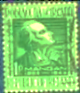Poor Mangan, he with the umbrella*

*Carried about in driest weather,*

*A singular fellow altogether,*

*A needy sot, but he could tell a*

*Story or two in golden phrases*

*To make your red hair stand on end.*

*‘Twas few who cared to be his friend,*

*A difficult man: I sing his praises.*

*Behold him in your mind’s eye now,*

*In his blue cloak and his blond wig,*

*Green spectacles and a great big*

*Witch hat that makes it work somehow,*

*That whole mad-genius business.*

*Among the world’s distinguished forgers*

*He stands supreme, his work is gorgeous!*

*Translated out of languages*

*He did not know, attributed*

*To non-existent poets, such as*

*‘Selber’ (his very self!) with touches*

*Of greatness now appreciated,*

*But praise of little use to him*

*That’s dead these many more than twenty* *‘Twenty Golden Years Ago’, a poem*

*Not very golden years. No plenty* *written by ‘Selber’—German for ‘self’, i.e.,*

*He ever knew, his life was grim* *written by himself, James Mangan. How*

*perverse of the man! Forgery is, of course,*

*And he obscure, and stone-cold dead* *plagiarism in reverse. Right or wrong,*

*Like you at six-and-forty years:* *immoral or imaginative, lawful play*

*Such was his lot. I’ve shed my tears* *or a matter for the law… All these grave*

*For him!* An Gortya Mor*, the dread* *questions will be cleared up only with.*

*the coming of the Apocryphalypse.*

*Famine, made him turn patriot*

*And put a fire into his verses*

*That on the English showered curses*

*For leaving the Irish poor to rot.*

*This man, an idol once of mine,*

*Was taken by the cholera*

*In all his weird regalia*

*In the year eighteen-forty-nine.*

*On his memorial let us hang an*

*Old ivy wreath, on Ivy Day,*

*And for his spirit let us pray,*

*The spirit of James Clarence Mangan!*

3. *Oscar:*

Among the poets constellated

In Heaven, though it may seem full,

There’s room for the Apocryphal

Who never were, but were translated!

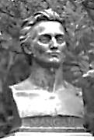

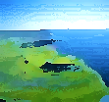***Oscar of the Cove***

***A Fantasy***

**PRISONER WILDE ESCAPES FROM READING**

NATIONWIDE MANHUNT UNDERWAY

SENSATIONAL DETAILS OF PLAY-

WRIGHT’S DARING BREAK-OUT. WHERE IS HE HEADING?

That’s up to you to guess. A thimble

Can be honed down into a saw.

Armour has chinks; doors and the law

Have cracks. Is this fact, or a symbol?

*

I joined the champions of the Cause,

If you must know: we agitated

For freedom from the ones we hated,

The English, and their tyrannous laws!

‘Twas call to arms, and calls quite close

At times: bombs smuggled, weapons cached,

And police station windows smashed

[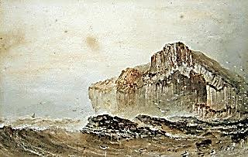](http://inmemoriamc33.com/fingal.mp3)Right under Dublin Castle’s nose.

♫

You don’t believe a word of this,

Do you? Something so noble *must*

Be true! Then you’ll believe me just

A little if I speak of his,

I mean, The Oscar’s, thrilling deeds, *Music at this point, Mendelssohn’s*

His famed great-coat, his sea-side lair, *‘Fingal’s Cave’ Overture, perhaps.*

His wayside tavern love affair?

And how he rides in shadow, and leads

His doughty friends from episode

To escapade in the Good Fight?

Bane of the English in the night,

We harass them on the high road.

Great Oscar of the Cove, they call me,

And Fighting Wilde, and Druid Bard.

Great are my exploits, Dears, and hard

The luck and troubles that befall me.

We blow supply trains off the rails

Then to our hideaway withdraw,

Where, warmed by fire and usquebaugh,

We tell each other the Old Tales.

I learn the harp, and sing in Erse

The deeds of Fingal and Usheen

When Erin’s fields were grand and green,

Before we fell beneath the Curse. *I am what we Irish call a seanachie.*

I’m captured by the Authorities

And sentenced to be hanged—but not

Before a speech not soon forgot

By those who heard such words as these:

Let no man write my epitaph; for as no man who knows my motives dare now vindicate them, let not prejudice or ignorance, asperse them. Let them and me rest in obscurity and peace, and my tomb remain uninscribed, and my memory in oblivion, until other times and other men can do justice to my character. When my country takes her place among the nations of the earth, *then and not till then*, let my epitaph be written.

—*Robert Emmet’s last words on the scaffold.*

*Better to die than live in slavery!*

Before a crowd of thirty thousand

I shout these fiery words, to rouse and

Inspire my fellows to new bravery.

Like a great Actor’s is my stance,

And some weep tears who came to jeer.

*I gladly lay my life down here*

*In Emmet’s name, and Ireland’s!*

The perfect cue for my comrades

To burst in on the scene and snatch

Me from the noose: too fast to catch

We ride to freedom. Well done, lads!

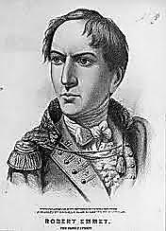

***Hanged on a Comma***

***Roger Casement***

*August 3, 1916.*

*In the months leading up to the Easter Rising of 1916, Casement had secretly persuaded the Germans to help arm the rebels. At his trial for treason, the prosecution had trouble arguing its case as his crimes had been carried out in Germany and the Treason Act of 1351 seemed to apply only to activities carried out on English (or, arguably, British) soil. A close reading of the Act allowed for a broader interpretation: the court decided that a comma should be read in the text, crucially widening the sense so that ‘in the realm [,] or elsewhere’ referred to where acts were done and not just to where the ‘King's enemies’ might be.*

—Mr V

Poor Roger Casement came to me that night

Sent from the gallows to the Great Beyond.

*Hanged on a comma*, said he, with a light

Disdain for Law so dexterously conned.

*While I denounced the Rubber Barons of*

*Brazil, slave-drivers of the Indians,*

*I found the time to search for young men’s love.*

*Uranian rebels stand beneath two bans!*

*Don’t think the diaries they circulated*

*Were forgeries, though the Crown’s aim was malicious.*

*I was the man I was by nature fated*

*To be, like you, whom virtuously vicious*

*England also laid low. And as for libel,*

*Think what is said about us in the Bible!*

[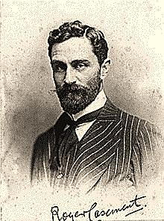](http://en.wikipedia.org/wiki/File:Sir_Roger_Casement_(6188264610).jpg)

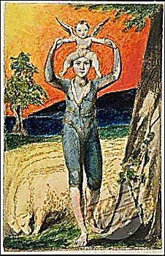***The Good Green Land***

***Yeats, Joyce and the Myst***

1. *The Song of the Faeries*

*Come home, Wilde Oscar, come home to the good green land of Eire!*

*Than your father Usheen you have wandered further and longer by far.*

*Great were your triumphs, and greater your trials! How sorrowful-weary*

*And haggard your face is, and your grey eyes, how haunted they are!*

*The unappeasable host, can you hear them, the legions of Faery?*

*And the lone pipe, and the wheels of Cuchulain’s battle-car?*

Now really, that’s a bit *de trop*.

I’m not a Celtic Twilight man.

My mind is cosmopolitan—

Though I heard the sidhe-cry, long ago.

2. *God is Crazy Jane*

*We both loved Beauty, Wilde, past right or wrong.*

*We knew the truth of masks, that without strife*

*Of contraries, as Blake knew, life is not life.*

*I’m no believer. Intellect is as strong*

*As its capacity for doubt. It can*

*And must remain a little sceptical*

*Even confronted by the Illimitable*

*In all its vast intimidating span—*

*To which a vast uncertainty responds*

*In kind: that, too, is infinite, because*

*The mind is so, being riddled by the loss*

*Incurred with every gain. How cast in bronze*

*Or fix for-ever in mosaic azure*

*And gold the hesitant and questioning*

*Gesture of so mercurial a thing,*

*Of all things the immeasurable measure?*

*My weakness and my strength, was my self-doubt:*

*It made me waver where the hazel-tree*

*Stood still, stand still when the horses of the sea*

*Bid me turn wave and join their tumultuous rout.*

*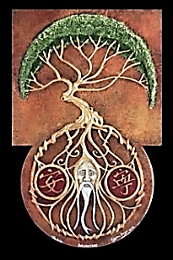When Niamh, let us call her, spirit of Youth,*

*Invited me to live beyond all age*

*In the green land of the Young, I turned the page*

*And read how one must wither into the Truth.*

*My verses were restless with a Celtic lilt,*

*For the heart that was in them was molten and fluid.*

*I gave to my dreams the names* Rose *and* Druid

*And saw the Druid vanish, and the Rose wilt.*

*God is a wanderer, too. Down in his least*

*Details he dwells, a beggar’s mask he wears,*

*And then a king’s. He climbs his winding stairs.*

*The Sexless Angel marries the Rough Beast.*

*The Intellect can never fully parse*

*That riddling grammar, speech of Crazy Jane.*

*Say God is wise, but Wisdom’s half-insane.*

*Our eyes see by the raging of the stars.*

*God is the Rose and the invisible Worm.*

*Riddle to riddle the truth-seekers range,*

*Seeking an island in the sea of change.*

*The island wanders, and the sea holds firm.*

‘In dreams begin responsibilities’,

You wrote. Yet you were irresponsible,

In your heart’s core, and half-in-love with Hell.

That’s why I trust you. You stayed *crazy*-wise.

4. *When I Was an Irish Rat Joyce McMocking.*

*I’ve not been so be-rhymed since old Pythagoras’*

*Time, when—it has been falsely claimed—I was*

*An Irishrat. It wakes the rhythmic saws*

*Of Slumber’s all it does, this Myst mandragorous.*

*To meet Cathleen, a man must walk away.*

*To write of Mother Ireland, move to France.*

*If that sounds too much like the old Romance,*

*Make sure to die in Switzerland someday.*

*We all must suffer our metempsychotic break-*

*Downs, be the worm, the tree, the bee and the clover.*

*In my next life I’ll be no more a rover,*

*But spend my days in a cottage by the lake.*

***Jim and I Drink Too Much***

*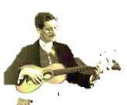 Scene: Oh, any astral estaminet*

*suitably seedy will do.* Hélas!

1.

Now in *Ulysses*, what *is* that

Elaborate machinery

Of ancient Greek mythology?

*A whim*. Ah hah! *Pulled from a hat. So he told young Nabokov.*

From *somewhere!* Such a sturdy bubble!

Well, *keep* your poor lay readers dizzy! *A global* gloire de cénacle.

The scholars, too, must be kept busy.

*And off the streets*. And out of trouble.

*Another round, please, barman.*

*White wine for Jim, usquebaugh*

*for me, in boggy Erin’s honour.*

Your face is sunk into its centre.

It is, I think, the crescent moon.

Why don’t you sing me a folk tune?

*Does Beauty, Wilde, dwell in a renter?*

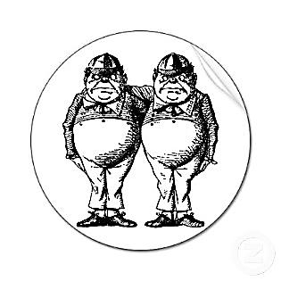*Does it pay rent?* Beauty is free

To those who can afford to win her.

Nora, she found you a beginner…

She never read your books, did she?

*The worthy Sir blunts not his needle.*

One of us *must* be Tweedledum,

The other, Tweedledee. *Or some*

*Quarky half-other, Tweedledaedal?*

2.

*In Zurich I made bold to found*

*The English Players; we made our*

*Debut upon the stage with your*

Earnest*, you know. And through the sound*

***Finnegans Wake***

riverrun, Anna Livia’s reverie

Of night, forged epic check, a Shem-Shaun sham bent

To straddle the chaosmos, vast enjambment

That sweeps us all away along with the

*Of the audience clapping you could hear me*

*Shouting, ‘Hurrah for Ireland!’*

*I yelled. ‘Poor Wilde was Irish, and*

*So am I!’* Ah, you cheered, and cheer me!

3.

But the *Wake,* Jim…How many moons!

*I only wanted to amuse them.*

But some resent the way you use them

As sounding-boards for loony tunes

Selected from your idiolect

** With indiscriminate abandon.

*What principle should a clown stand on?*

*The game’s in how the bits connect*

*If you connect them, which you may*

*In any warlock-which way what*

*So ever.* A veritable smut

Of possibilities, I’d say. *Nora Joyce, née Barnacle.*

*If you look past my stray obscenities*

*You’ll find a comic theologian*

***Proust and Joyce***

*Longtemps* and *Stately*: two first words

Gestating in themselves the last.

Circle swells into sphere. Two vast

Finales seed their opening chords.

Together, what do the words say?

*Yes* to *Time.* Time and its ‘it was’.

To music and to long applause

Let all things passing pass away!

*Behind the cosmic philologian.*

*Not Heraclitus, sir: Parmenides.*

Enough about the cosmos, dear!

I’d sooner talk about cosmetics.

For *tό καλόν* in Greek aesthetics

Is shapely, human-scaled and clear.

*That is the view of an apprentice,*

*As I was in my* Portrait. *You*

*Will not achieve a real break-through*

*If you’re entirely* compos mentis.

*Sits down at the piano and plays snatches*

*of* Tristan und Isolde . *Isolde incarnates*

*before us. She is transformed from a*

*beautiful young queen into a mythological cow.*

4.

*Mein irisch’ Kind, wo weilest du?*

*Woo-woo, moo-moo, mein Kind so irisch,*

*So Io, that it makes me tear-ish,*

*O meine irisch’, irisch’ Kuh!*

*This Wagner Typ puzzo di sesse.*— *He speaks Italo-Anglo-German.*

He stinks of sex? Who doesn’t, after…?

[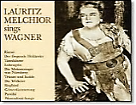](http://inmemoriamc33.com/siegfried.mp3) Although he *does* excite my…laughter,

His Siegfried. One could write an essay

♫

On his stupidity and find,

In the end, nothing to say. (Though on his

Teutonically blond Adonis

Looks one could heap praise.) And his ‘mind’?

He is no village idiot,

He’s a whole village full of them.

A ‘hardy’, we’d say. *So would Shem*.

*From schlimm to wurst he goes, this Brat.*

*.*

5.

*Mavrone! Sure, Ireland was born knowing*

*What hunger is! There’s those that do*

*Not know it; but they will.* How true!

*Me, I never got used to going*

*Without food, studying medicine*

*In Paris as ah! young man.* Hunger

Is *La Bohème* when we are younger

And a youth cannot be too thin;

At forty it is simply *real*.

Ugliness, suffering, obscene.

The grumbling void, the pangs how keen!

*Quick now, let’s order us a meal! Boiled potatoes are ordered:*

*They bring us but the* one*!*

Jim, dare we speak of Parnell, great

And tragic Parnell? How they turned

Against him, whose deeds should have earned

Him reverence? *It was his fate,*

*[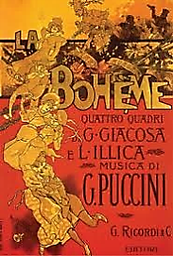](http://inmemoriamc33.com/puccini2.mp3)*

*In part, that prompted me to go*

*Abroad and speak a foreign tongue.*

♫

*How could I live my life among*

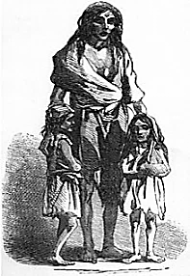*A race of people who could do*

*Such things to such a princely fellow?*

*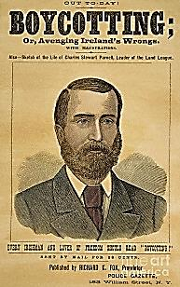 Who’d fought so superhumanly*

*To give them back their dignity!*

All for a harmless peccadillo…

Didn’t Gladstone call him the most

Remarkable man he’d ever met?

*How soon our countrymen forget!*

*One moment he’s the nation’s toast,*

[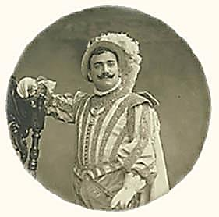](http://inmemoriamc33.com/rigoletto.mp3)

♫

*The next: pariah. Ireland never*

*Produced a greater man, I claim,*

*And to our country’s lasting shame,*

*This hero, brave as he was clever,*

*The people jeered, while the priests gave*

*Smug sermons on his fall from grace.*

A crowd threw quicklime in his face.

*They drove him to an early grave!*

*As for old Glad-Eye, what a dance Gladstone.*

*He danced! He backed a Home Rule bill*

*He knew the House of Lords would kill, Each of us pokes disconsolately*

*And him there, standing with clean hands! at his half of the potato.*

[*Sings and plays at the piano a medley of Verdi* a*nd Donizetti.* Una

*How full of grace and invention*

*is Mozart after the muscle-bound*

*Beethoven.—*James Joyce

furtiva lagrima *wells in the ears of this listener. He plays the opening*

*theme of Beethoven’s last piano sonata, last movement: ‘The*

*donkey cart that goes to Heaven,’ as Thomas Mann characterised it.*]

*The donkey draws the cart to Heaven,*

*F*rting freely in his *rse-scent.*

*Let hands be clasped, let knees be bent:*

*Rise, incest smoke: the Heavens are Seven!*

*Garçons are sweeping the floor, putting*

*chairs upside-down on tables. We are*

*the only patrons left in the establishment.*

*Exotic flowers bloom from the sawdust.*

*A cultish Celt, of Celtish cult*

*Was A.E.I.O.U. McNulty,*

*Known for his mysty difficùlty*

*(Pronounced with stress on the penùlt).*

Our native accent’s out of joint.

*Saying’s the Irish way of seeing—*

Paycock, the Irish way of being

A peacock. *Aye, the pint’s the point*.

6. *Coda: Jim Looks into the Camera and the Near-Future*

*They’ll gather in the local pub, lick*

*The foamy head from the beer mug*

*And drink a toast. But me? I shrug.*

*So Ireland is a REPUBLIC.*

*And still divided from itself*

*North to South, violently Other,*

*South to North. Barman, O me brother!*

*A gallon o’ white wine from the shelf!*

♫

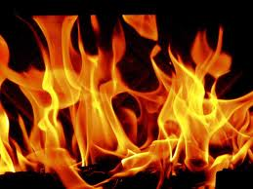

*[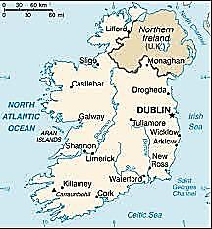](http://inmemoriamc33.com/girlish2.mp3)*