The Phenomenology of Spirits
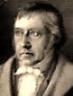
Hegel

1.
Psyche and Soul aren’t quite the same.
Psyche is clear and dry, being Greek,
And conjures cooling breath, whilst bleak
And gnarled, the English soul is game- Und der Geist denkte:

Flavoured, and damp—can even be,
In places, positively muddy;
So much so that linguistic study
Finds no clear etymology,
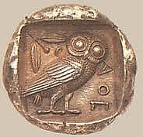
Though some see a root-sense of ‘bind’,
As of the dead in graves, to keep
Their ghosts from troubling our sleep.—
German Geist has three meanings: mind,

Spirit and ghost. Reason dictates
That the late Hegel blend all three
In his Phenomenology
Of Ghost he now instantiates.

2.
Sometimes I see him wandering
The halls of his mind with one shoe on,
One missing—possibly the true one
In his abstracted reasoning.

I say ‘shoe’, and in that negation,
Ghostly and pure, evoke the one shoe
Worn by no foot, not true, not untrue,
Exactly: awaiting realisation.

Each necessarily partial view
Is ghosted by its opposite,
Till both become, in the infinite
Whole, finally reconciled and true.

No, not one single proposition
Of your great Logic is not found
In Heraclitus, though we’re bound
To miss, a little, his…concision

When ploughing through your murky prose
In its Teutonic, ponderous pondering,
Through which the aching mind goes wandering
As through rich thickets of verbose

Magnificence and gothic density,
Or through some never-to-be-finished
Cathedral in which we walk diminished
To dwarf-size ‘neath such vast immensity

Of intellectual ambition.
If even those few who understand
You do not understand you, grand
Indeed must be your towering vision.

3.
You were the rage at Oxford. Jowett
And all his fellow Hellenists
Descried, inside your prosy mists,
Though Philistine minds could not know it,

Platonic truths brought up to date,
Ennobling evolutionary
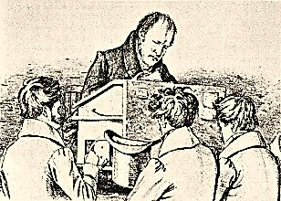
Science’s findings with their very
Essence and human meaning. Late

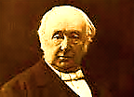
I came upon this scene, and swallowed
Darwin, Hegel, Spencer and Plato
In a mix thought to point the way to
Heaven on earth, if we but followed

The guidance of the Dialectic.
From the mere insect’s chitinous rind
To Plato’s chiton marches Mind,
In a progression slow or hectic,
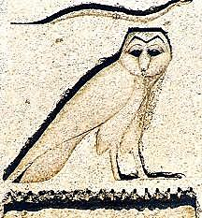
Through violence of tooth and claw
Towards the hard-won apex, Man,
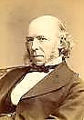
Ex-ape, according to the plan
Of Reason, which is Truth and Law.

Yes, Georg Wilhelm Friedrich Hegel,
Into such views Panglossian
This young and callow Irishman
Deeply, deeply did you inveigle.

You should approve of what I said
When told that my philosophy
Was divorced from the facts. Reply:
‘So much the worse for the facts.’ Dead,

Though, was the sort of lie you told.
It might as well have been a fact,
It was so bloodless and abstract.
Theory’s grey, life’s tree green and gold.

But nothing’s more abstract, you see,
Than the ‘here’ and ‘now’ you hedonists live.
Only the realised Whole can give
These words concrete reality.

Art is doomed by the destiny
Of Reason to slow obsolescence.
Philosophy grasps Reason’s essence
And knows its ruses, too. You try

To stand things on their heads, like thick-
Skinned, elephantine acrobats
(Quibbling with thises and with thats).
Art is much better at the trick.

Untidy history is no thrall
To logic’s a priori grammar.
How many loose ends must you hammer
To make the real look rational

And your own system seem like more
Than a monumental makeshift?
There is more cancel than uplift
In your Aufhebung. What a bore

Is your Minerva, how un-free
Her owl! Art alone has the gift
To cancel the mere fact and lift
It into Ideality.

4.
A mystic of Pure Reason, you
Impatiently leap o’er the line
Kant drew around it to define
What it can reasonably do.

The duty of the rationalist,
It seems, is boldly to bestow
Good conscience on the status quo,
Power’s abstruse apologist.

The contradictions of the Mind
To you are convoluted mysteries
Which only at the end of history’s
Long battle resolution find,

As in those German sentences
Wherein the meaning of the whole,
Like a through-mist-glimpsed, distant goal,
Reached only at the end-verb is.

Reason, on its vast detour, longs
Through all the violent conflicts
To be what nothing contradicts.
In your exalted view, two wrongs

Inevitably make a right.
And what is right? The Prussian State.
What evils Geist will tolerate
To help the contraries unite!

