* Dante *

♫

Master of the Revelations

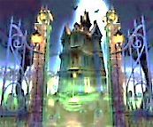
The Dream of the Haunted Mansion
♫

1.
I fell asleep beneath a tree
And dreamed that I was in a great
House, and the hour was very late,
And a great cold came over me.

Down the dark cavernous halls I walked
Past tapestries and many a painting,
When at a strange sound almost fainting
I knew that I was being stalked.
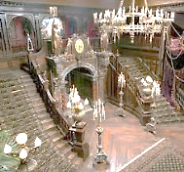
I know he’s here. I can sense him.
It is so dark! What if I bump a knee
Against a ghoul? Ah, monstrous company!
Why must the candles burn so dim?

WHAT ARE YOU DOING IN MY HOUSE
OF MANY MANSIONS, FIEND? GET OUT!
Echo the words. I look about…
The House is haunted. I arouse

The territorial aggression
Of the ghost of the one who built
This Comedy. Mine is the guilt
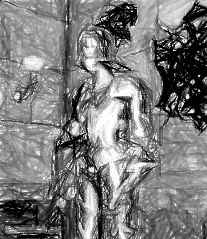
Of trespass; that is my transgression.

Hmm. Should I offer to pay rent?
Charm him with my companionship?
The silence, tense as a tight lip,
Suggests he’d like to make a dent

Deep in my skull with some heirloom
Or other he’s got lying round here.
Mace? Axe? I’m sure they can be found here.
It might be wise to leave this room.

THE POWER OF CHRIST COMPELS THEE, HENCE!
And a huge suit of armour falls
Crashing in front of me, the halls
Ring with the clangour, and I sense

I am not wholly welcome here.
Like mists that gather to a cloud
He manifests himself: that proud,
Implacable face! Something like fear
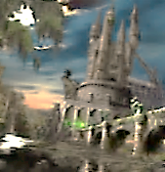
Comes over me, which I dismiss.
What can he do to me that I
Have not done to myself? Then why
Be scared by this wraith-wrath of his,

This hard, high-mediaeval dudgeon?
His house is public property
Given to his posterity
In trust. He is the grim curmudgeon

Who lingers on in his creation
Like an old duke who haunts the estate
Long-since donated to the State,
An august tourist destination.

2.
Scusi, I show discourtesy.
Sometimes I grow so weary of being
The Master, and all that, of seeing
The poets use my Comedy

Not as a temple in which to pray,
But as a template, crude and rough,
To impose upon the chaos of
Their thoughts, knowing no better way

To order their unkempt infinity
Of images and metaphors—
A swamp that seeks a river’s course—
Than to pervert the Holy Trinity

Into a numerological
Prosthesis, or a cripple’s crutch,
And dress up ego’s creaky hutch
As the High Altar of the All.

Yours is no Comedy, but farce
Stuffed with allusions for mere sport.
You serve the Host up like a torte
Topped with a sprinkling of stars!
He is working himself up into a state
of high dudgeon again. I discreetly exit.

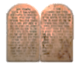
From the Reading Notebook
The Dream of the Terrace of Pride

Dante has heaved the two stone tablets of the Ten Commandments at me. They narrowly
miss my head (the head of my astral body, or in Gnostic-Neo-Platonic terms, my ochema,
Aristotle’s proton organon). So, among the Proud on Mt Purgatory I am to stagger about
the ledge beneath this burden? I think not. (Boccaccio says even women and children feared
the Tuscan might throw stones at them if he believed they had insulted his principles.)

The Ten Commandments? All agog
Am I to read them through again.
Thank you. One does need, now and then,
A hefty dose of Decalogue.

I thought that there were twenty! You
Will read them by their weight upon
Your back. To understand them, one
Must under-walk them through and through.

I note that you are stooping under
A stone. For your pride are you groaning?
Why not for wrath in smoke atoning?
Not yet for you the heavenly thunder. Announcing a soul’s ascension from
Purgatory into Heaven.—[Mr V]

True, I am still in Purgatory.
But I will not be here much longer.
Good. You are not getting any younger. I jest, I jest.
I am shielded by my allegory

Dante doesn’t spend all his time staggering under a rock. There are pauses for meals, and his evenings are generally free. He reads a great deal, keeps abreast of trends, that sort of thing. He has secretly turned into something of an aesthete, surprisingly enough. He is currently reading Hegel on Shakespeare (towards the latter of whom he naturally harbours intense feelings of rivalry). He longs for the light touch and ennobled eroticism of his beloved Troubadours, who so influenced him in his youth. But don’t let on that you know all this, Dears, or he WILL throw stones at you, beginning with the one on his back!

Whose sense, and intellect, is Love.
Soon will a mighty organ note
Signal my rising, like a mote
In sunshine, to my God above.

So glad to hear it. Congratulations.
The fool himself fools, when he mocks.
Salvation lies beneath the rocks.
Get under them. Be strong. Have patience!

You know who I am: I am your Master.
Mind your Hic Labor Est, your Hoc
Opus. Many a jagged rock
Awaits your climb. Come, faster, faster!

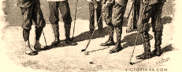
The Refractory Bolgia
♫
[I relate an incident that took place some time ago, in ‘Sweet Worm-
wood’. Dante in golf tweeds threatens me with a huge putting iron.
A reminder of my mendacity in claiming to be on golf outings to
deceive Constance as to my whereabouts and sodomitical doings?]

1.
But what apocalyptic round
Of golf is this, sir? Would you putt me
Into a pocket, Eagle, shut me
In a hole in unholy ground?

You are a Midas in reverse,
Debasing everything you touch.
Foul sodomite, get in this pouch!
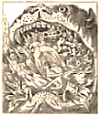
The jostle of clubs shall be your curse.

Really now, Dante, that is quite
Enough! It is uncouth, this show
Of violence every time you grow
Annoyed. You gave me quite a fright!

Who knows what fiery verbal fork
Will dart from that Hell-mouth of yours?
By rubbing salt into my sores
You cure me like a side of pork!

2.
Something in us, despite our lateness,
Still relishes Ruggieri’s head,
Your bloodlust for the damnèd dead,
Your gruesome and atrocious greatness. So Goethe characterised it.

You are the biblical Jehovah,
Old-Testament, uncanny, testy:
One dares not move a muscle, lest He
With Uzzah-lightning knock one over,

This God who tries to kill his Moses,
And leaves him with a Promised Land’s
Pisgah-view, yet with His own hands
Buries him! I suspect psychosis.

One moment you attempt to spill me
Into a ditch, the next you make
A Covenant. For goodness’ sake
Make up your mind and simply kill me!
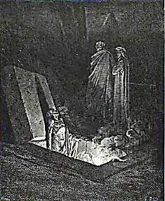
For after all, my fitful guide,
You dwell in Purgatory, too,
As Virgil in Limbo. It is true.
For wrath, for wrath! And ah, for pride!
Dante appears to colour a little.
Have I indeed shamed him, then?

4.
You transformed Christianity
Simply by representing it
So boldly, with such infinite
Attention to detail. We see

The Word grow fleshly. Once you placed
Yourself inside the allegory,
Theology became a story,
And now its casuistry was faced

With characters, and characters
Were given faces, made to speak
As della Vigna, in a weak
And bleeding voice, speaks deathless verse.

Hamlet, the Wife of Bath, Falstaff
Gestate as in a magic womb
In Farinata’s fiery tomb.
This giant figure is but half-

Sepulchred in his sin: the immortal
Vitality of your portraiture
Gives him a life that shall endure.
Even over the Inferno’s portal

I read the word Whim faintly traced,
Graffito of a prophecy
That Art and Personality
Will overwrite and leave effaced

Hope and abandonment together.
Yet hope lies in abandonment:
Of certainties that quell dissent
(Dogmas that turn Thought’s vital weather

Into a frozen climate of
Opinion, fixed and masked as truth);
Of truth to art, of age to youth,
Of self to its temptations, love

To all its many innocent,

I am pleased to report that, since the events related in this chapter, Dante has finally achieved ascension from Purgatory into Heaven, where he is indeed reunited (he writes to me on a postcard) with his
Beatrice. They are expecting a blessèd
event in the spring. I will be sure to drop
a card on them, if I am ever in the vicinity.

Natural and unnatural
Perversities. What you would call
Sin we will call experiment.

Though of its own self-contradictions
Your doctrine died ah, centuries past!
Poetic Genius can outlast
All antiquated science fictions.

Our angels ride in motor cars.
Heaven is but a rocket-trip
Away. How deep the Dippers dip
Into the dark between the stars!

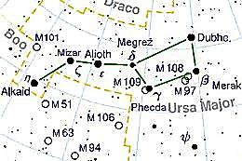
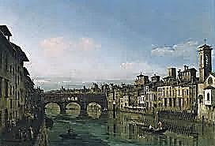
A Conversation with Dante

1.
Dante, you are my ancestor
Upon my mother’s side, or so
She told me: my great-great-great-oh-
How-great grandfather! Ah, before

There came the great Renascence, space
And time were of your architecture,
Souls shaped by you inside the picture,
Sometimes with a distorted face.

You live, you burn at times within
The features of my face, I sense
Your presence in presentiments.
You are my sickness and my sin.

2.
A double exile, I: from Florence,
And the world I imagined, hoped for,
A world no longer even groped for
By your Age—ah, my soul’s abhorrence!

You settle for such a degree
Of blindness and of blandness in
Religious matters! It is SIN.
And what has come of Italy

These days save stylish shoes and portly
Tenors and Carlo Pellegrini? Alias ‘Ape’, society cartoonist. .
(Though I admire noble Mazzini.) And let us not forget Leopardi!
And ah, the love that we called ‘courtly’,

Whose finest, mystic flower was
My Beatrice, lives only in
Pre-Raphaelite paintings (thin
And wan she looks). I have some cause

To speak authoritatively
Of exile, tears, and alienation.
In mutual excommunication
Stand I and your modernity.

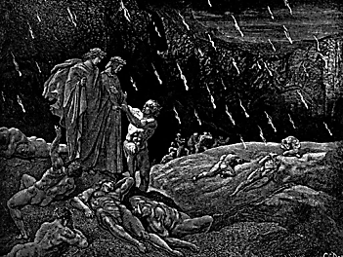
3.
In my Ravenna I spoke half
To you and half to Byron, caught
Between two exiled Kings of Thought.
Florence is its own cenotaph,

Or lives, your thankless mother city,
More fully in your eloquence
Than in its fading monuments.
Sorrow you knew, but no self-pity.

4. Dante

I looked down on no sodomite.
We are all fallen, under a curse.
To try to lift it makes it worse.
Brunetto was to me a light.

To see the place they left him in
Tortured my heart. He was my friend.
So fine a soul, and such an end!
I almost wished it weren’t a sin.

But ‘tis a sin to wish it weren’t,
Impious carping at God’s laws,
Quibbling with codicil and clause.
For lesser things are sinners burnt

At the stake, yes, and rightly so!
Dante, with due respect, that is
Barbaric. In what way is this
Christian, this sadic blow on blow

Of primitive Jehovah justice
Fit for the tribe or for the horde
But by enlightened hearts abhorred?
It is bloodlust, and any lust is

‘Savage, extreme, rude, cruel, not Shakespeare, Sonnet 129.
To trust’, nor scapegoat cults to trust Dante scowls threateningly at
When they proclaim that they are just. the citation, he knits his brows,
Are you evolving toward this thought? growling softly, Malebronchially.

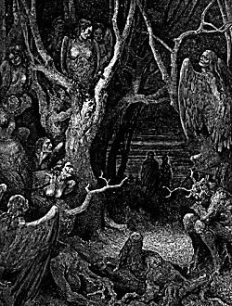
How could you hear the burned cry out
And not think, What if we are wrong?
Have we the right? Your faith was strong
But you shrank from the strength of doubt.

Why should a tragic suicide
Or whore for hearsay flattery
Be placed in lower pouch than he,
Attila in his murderous pride

And millions-slaughtering arrogance?
You sacrifice to an abstract
Casuistry the whole human fact,
The singular, complex romance.

5. Ivan Karamazov Out of nowhere, seemingly.

And what Redemption can be built
On the unexpiated bones
Of one small child whose dying groans
But added savour to the guilt

Of those who persecuted him?
They ate pineapple compote while
They watched him writhe, and with a smile
Saw in his eyes the life grow dim.

When I see God, that tortured child
I’ll show Him, and demand that He
Explain why He lets such things be,
Or we shall not be reconciled.
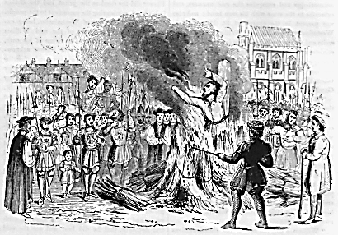
Dante and the Bard

Negotiations
Dante speaks in italics.

The Bard:
‘Twas you who opened this Pandora’s
Box, in despite of (and with prescience)
The cloistered, institutional nescience
Of the Church, and the Gothic horrors

With which it threatened those who dared
To read and reason for themselves.
‘Twas you who scoured the study shelves
And would not let yourself be scared

Away by blind Authority
From the great quest to understand
The world, the work of God’s own hand,
And the Word, from Antiquity

To the summation of St Thomas,
Meant by all people to be read,
Not kept a Secret, dark and dread,
By a cold mummy Priesthood from us.

But the Word points in one direction,
Not all directions, willy-nilly.
(Should I say rather, nilly-Willy?)
We can’t choose this piece, scorn that section,

Picking and choosing what best favours
A momentary use or mood:
That is the very Savage Wood
From which the Word alone can save us.

When all is said and done, to say
‘I do not know’ is not a sin.
Where knowledge ends, must faith begin.
Indeed it must. But my faith may

Well be another’s heresy,
Should I look through that other’s eyes.
How many must we sacrifice
To feed our lust for certainty?

Life wants to be considered curiously.
Let us ask, with Montaigne: Que sais-je?
Those who judge Truth by too-stern measure
See not, because they look too furiously.

O blind Sceptic! Your form shall be
For ever restless and unstable
As Fucci’s. You have set the table
For Circe and her sorcery!

The feast is underway, my friend.
We moderns are to restless change
Committed, and the boundless range
Of possibilities. We mend

Our ways as best we can: the sleeve
Of care grows ever looped and ragged.
The troughs are deep, the crests are jagged,
And all we love we all must leave.

For to the puzzling scheme of things
What is the Plot? We live sub-plots,
Wherein to choose is to draw lots.—
Then Heaven help your reckonings,

Or you will choose yourself a Hell.—
To be or not to be was ever
A riddle hardest to the clever.
Means guess their ends. May all end well!

You find a thousand ways to say
You do not know, when what is asked
Is that you do believe. Unmasked
Will all you revellers be, one day!

Dante storms from the room followed
by his advisors. The next day spokesmen
for both parties characterise the talks
as ‘cordial, wide-ranging, and fruitful’.
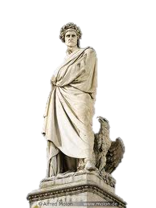
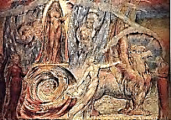
The Latest Pageant

I dream Marcel and I are on the summit of Mount Purgatory,
walking in awe through the Garden of the Earthly Paradise.

1.
How verdant is this Paradise!
To see this place, who would not die?
It has, mon cher, look! its own sky,
A bruised white rose flushed pink at rise

Of day, blood-red at evenfall.
You’d think it was the Tuileries.
Everywhere, roses, peonies,
Azaleas, daffodils, and all
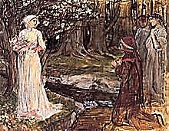
So fragrant! Listen: that sublime
Passage in the Vinteul Septet!
To recall we must first forget.
This is the ambiguous gift of time.

Even for Dante, Paradise
Is the regaining of the past:
Fully remembered, cosmic, vast,
It lives in Beatrice’s eyes.

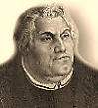
2. The Pageant

Regard, mon cher! It comes. ‘Tis nigh!
The Pageant! It seems barely a moment
Ago that we were passing comment
On the last Pageant that went by.
The Chariot comes to a halt.
[Dante Narrates:]
The monstrous Boor of Germany,
That cowled and costive, choleric
Old Antichrist and Heretic,
Attacks the chariot and tears free

The rear half, and with a strong push
Rolls it into a savage wood
Where muskets bark and men of blood
Lurk behind every tree and bush…

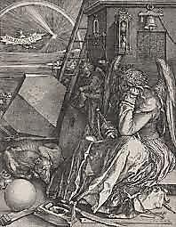
3. A Snide Aside

And next comes antique Allegory,
Dishevelled now, no longer nimble,
Her features vague, scumbled by Symbol,
Disoriented, weak and hoary.

In her right hand she holds a sword,
In her left is an hourglass.
She is a melancholy lass.
She gazes down at a chessboard

On which great birds of prey, the black
And white, are tactically deployed.
She looks down at the sword, annoyed
And puzzled: She thinks back, thinks back

But cannot quite remember where
She got it, what it is, or why
‘Tis in her hand. A tapestry,
Cobwebbed, is floating in the air.

On it are pictures dim and grey,
Images of things dreadfully
Important, one takes them to be,
But what they are one can’t quite say,

They are so dim. But on a table
An astrolabe allays one’s doubt,
It seems so definitely about
Something definite, one’s unable
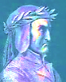
To say exactly what that is,
But one likes how exact it looks.
And there are pentagrams and books,
Flowers, and skulls, and compasses…

Can someone help her, please? Relieve
Her of those objects in her hands,
Whose meaning no one understands,
Or knows too well to well-believe.

Dante’s voice breaks out like thunder overhead.

WHAT, OSCAR, DO YOU THINK ME DEAF?
I HEAR YOUR JESTS. I’VE HALF AN URGE
TO SEND YOU BACK TO SING YOUR DIRGE
DEEP IN THE PITCHY PIT’S BASS CLEF.
(So testy is he, of his art!)
Why, my dear Alighieri, so
Put out by a tall man you know
Is but a foolish child at heart?

Accept what lesser says to Greater:
‘Scusi, senor, la colpa mia,
Uomo della diritta via!
Sono smarrito, gran’ poeta!’

O Highest Meaning of it All,
Which in the eyes of, is the bliss
It is to be a Beatrice!
But all of this begins to pall.
Sudden scene change. We are seated in
the library of my Tite Street home. Brandy
is served. Attired in a smoking jacket,
Dante is casually leafing through
The Importance of Being Earnest.
4. Surprised by Dante

A great bitch-goddess, Lady Bracknell,
An old grotesque raised out of time
By shrewdly marrying the Sublime,
Muffling the funeral bells’ black knell. How flattering, and unexpected:
he has read my play, and likes it!

You should be punished, not seeing how
Much better is The Importance of
Being Earnest than the one you love,
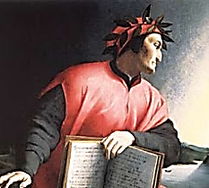
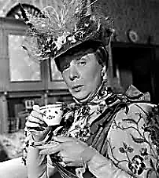
An Ideal Husband, which is now,

Well, something of a period-piece,
Despite its wit, yes, in a way
A middling sort of well-made play,
Whence Ernest is divine Release.

(The Tuscan a theatre critic
Exhorting me, for reasons purely
Aesthetic, to judge more maturely
My own work? He is so acidic,

Yet not unkindly, his advice.)
Perhaps you’re right. Its lightness is
A decorously zany bliss.
An irresponsible Paradise!
I take down a beautiful edition
de luxe of the Divine Comedy,

Perhaps you’d care to have a look
At the engravings of Doré?
They do add something, I must say.
It is a very handsome book.

