Mr V and I
Astral Travel

1.
Your absence haunts me. It sounds queer,
I know, but I feel quite chagrined.
You are intangible as the wind!
How strange to switch from there to here

And then to now so quickly in space
And time! Death has its privileges.
We ghosts can move with startling ease
From age to age and place to place.

We fly, as ‘twere, on conscious wings—
Or drift, or float, if minded to.
Still, hawk-like, I return to you.
You must have seen some wondrous things.

2. My Travels
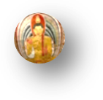
Ah, let me tell you! I have seen
The tawny Ceylonese sunrise
Through a tea-planting girl’s sloe eyes;
Have watched the Nile, swift, emerald-green,

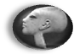
Surge past the ruins of the sacred
City that Akhenaten built,
Muscling a wealth of fertile silt
Down to the shores where the waves break red

And purple beneath dying suns.
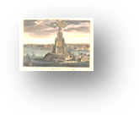
At Alexandria, deep under
The harbour waves, I’ve seen the plunder
Of time, the great stone blocks that once

Composed the wonder of the Pharos.
On high Mount Ida I have stood
Where Troy’s doom burned in the hot blood
And fateful judgment of young Paris,

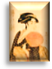
And watched a Geisha girl in Kyoto
With exquisite composure pour
Tea for her warrior paramour
And pluck sad music from a koto.

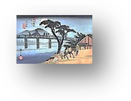
(In a pavilion on the way
Down from Mount Fuji I have seen girls
Make love to girls. This part unfurls
As a print by Hiroshige.)

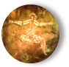
With the Aborigines I trace
Song-lines, I join them as they sing
Into existence Everything
That IS, and gather it into place.
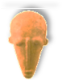
I have seen the Dogon dance delirious
To honour the completed spin
Of its mysterious hidden twin
Around the raging Dog Star, Sirius.

I’ve watched (as strange as this may seem)
From the moon, with these ghostly eyes,
A pearl of calmest blue arise
From darkness like a solid dream,

And only slowly recognised
It as our planet, lone and small
In the void vastness of it all,
A fragile thing ah, to be prized!

As fragile as blue china, and
As rare—which how shall we live up to,
Who drain the tea, and break the cup, too?
Leaving our stain on sea and land.

And sometimes Ruskin joins me there.
Tears fill his eyes, and the earth-light
Trembles in them. The rest is night
And silence, stars and breathless air.

♫

