***Supping with the Dead***

C:\Users\Aphori\AppData\Local\Microsoft\Windows\Temporary Internet Files\Content.IE5\TDAQGTG7\MC910217128[1].wmf*Oscar told us that he had had a hideous dream the previous night—*

*that he had been supping with the dead. Reggie made a very typical re-*

*sponse: ‘My dear Oscar, you were probably the life and soul of the party’.*

—Robbie Ross, Letter to More Adey, 14 December 1900

* * *

*I would like to found an order for those who cannot believe…where…*

*a priest, in whose heart peace had no dwelling, might celebrate with*

*unblessed bread and a chalice empty of wine.—*De Profundis

1.

Not all down there is grief and dole;

The dead will often dine together;

C:\Users\Aphori\AppData\Local\Microsoft\Windows\Temporary Internet Files\Content.IE5\4AX925HK\MC900051004[1].wmf They form a party, in regions nether,

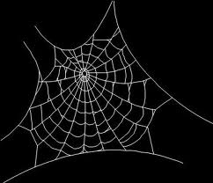And Oscar is its life and soul.

Poised on a cobwebbed candelabra,

One single flame holds back a gloom

That otherwise might fill the room

With spectres *frightfully* macabre.

Droll anecdotes and witty chaffing

Gleam through the shadows candle-brightly:

With dusty top hat tipped just slightly,

Old Oscar has them laughing, laughing.

‘I died, friends, as I lived’, he quips,

‘Beyond my means’—and eyes his glass:

Empty it is indeed, alas!

[](http://inmemoriamc33.com/nachtmusik.mp3)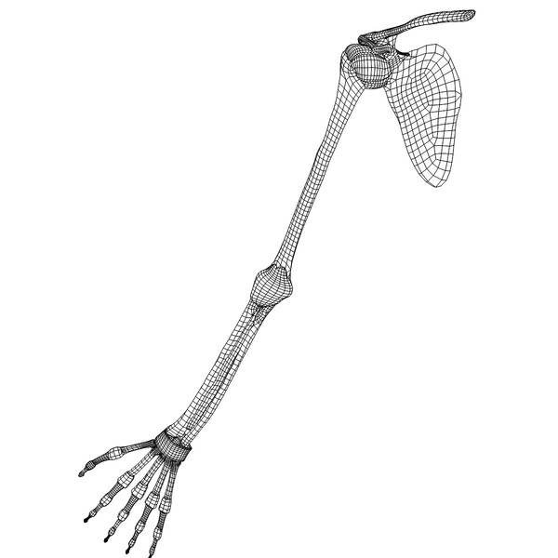And still he lifts it to his lips.



2.

♫

The buttonhole in his lapel,

A green carnation, somewhat sere,

Is redolent still, and of a queer

Radiance rather loud for Hell.

‘Play *Eine Kleine Nachtmusik*,

Please, Aubrey. Let us harrow Hell

With charm! No harm, no harm. All’s well.

Who says it all must be so *bleak*?

‘Like golden lamps in a green night

Let us burn bravely and be seen!

Not all is as it could have been…

Of such dark things let us make light’.

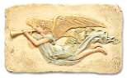3.

Outside, amongst the dark things, grey

And ghastly shapes can hear the the noise,

And they are hissing with one voice:

*You’ll pay for this, come Judgment Day!*

But nothing dims that genial spirit.

He tells his friends, to ease their fears:

‘When the Last Trumpet sounds, my dears,

We shall pretend we do not hear it.

