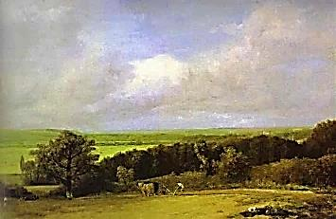
Shepherds of Letters

Wilde and Byron hold a singing contest. The ‘genre’ they choose is pastoral,
in this case super-sentimental (in Schiller’s sense). Byron ‘tunes his lay’ in italics.

i.
Tonight the moore-ish moon is rising.
Flash the gold tennysons in the pond.
How lovelace, I, and suckling fond!
♫
How pale and wan, my shelleyising!

I walk along the coleridge
Beneath a lonely wordsworth cloud.
Day wears a donne and dusky shroud.
I saint john of the cross a bridge.

O’er a swift stream of consciousness
I cross; the azure sky is clare,
I breathe a bracing baudelaire
And I am gay at heart. I bless

The browning of the day, the leaves
That in their nashy brightness fall.
I keats the stubble fields and all
The shakespeares gathered up in sheaves

With white and wriothesley beard. Will blakes
The dowson bread, and all shall share
The goodness of his hardy fare,
The ale, the villons and the cakes.

ii.
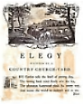
Why mope that hair must thomas gray
When swallows chelidon the spring?
For I shall go a-miltoning
With gladness in my smart today.

But e’en a youth, though edward young,
May night thoughts have, and seek a place,
A churchill solitude, where rays
Of moonlight move the stones among,

And skeltons lie with webster skulls,
To marvell sadly over fine
And private graves where worms do dine;
And thus is proven on his pulse
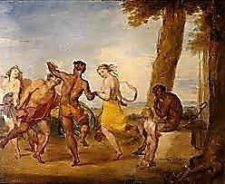
Our brothers-grimm mortality.
Yet euphuistic lylies still
With colour all the graveyard fill.
Still of the spring’s virgility

The songbyrds chaucer in the trees.
The yeats of paradise swing wide
Upon the spensery bowers inside.
Flowers catull us, the white fleece

Of charlsey lambs delights the eye,
The hazlitt hedges are alive,

Historical Excursus

We shan’t macaulay history’s fuss.
Empires are gibbon to decay.
Though all thucydides away,
Their legends still herodotus.

For doyling conans there do thrive,
And larks patrol the fausty sky.

A de musset the nymphs and satyrs
Nimbly dance, and kiplings play.
The merry month of Mallarmay
Approacheth, and what joyce await us!

We lay us down in darkling beddoes
Where knightstale grows, and astrophel,
And jonsonwort and lionel
While hills cast down dark angel shadows.

We gather herricks, while we may,
And puck de quinceys from the tree.
In drowsy morpheus reverie
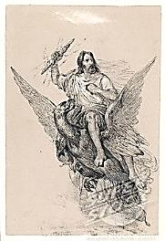
We mumble low Laudànum Te.

Now morris-dance mel villegers
And many a boisterous dickin son
And dickin daughter join the fun
To tunes of fiddling massingers.

Schillery sheridan they quaff.
When in a ceres falling down
They droll, and breughel cockaignes clown,
How sterne is he who does not laugh!

iii.
If rain should burst from gowering skies,
‘Twill do the grain rossetti good,
And I will don my thomas hood
To keep me dryden, hair and eyes.

If Jove should shake his byron spere
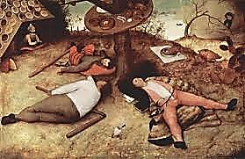
Villiers-de-l’isle-adàmantine,
‘Twill not be long ere sun will shine
Propertiously, and skies will clear.

Let lightnings all the heavens rend!
When mists childe herald storm’s abating
♫
We’ll find a pot of goldsmith waiting
At iridescent rimbaud’s end.

Ere long the festeous rain shall cease
To pelt the hovels of the poe
And then a-trolloping I go
On my good de la mare, at ease.

I ride my horace down verlaines
Sun-dappled hawthorne trees give shade
And sidneying over hill and glade
I worship at arcadian feigns.

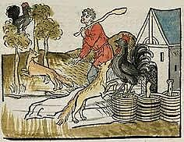
iv.
On vines the purpling pindar grows
While men on jacob ladders tall
Pick fruit in orchards where stendhal
The beerbohm trees in ordered rows.

At dawn the housman wakes, for he
Must clough and thomson all his fieldings,
Else crabbed will be the season’s yieldings
And wilkie will his collins be.

Wycherley dons go quichotting
Through thickets, at their simple noodling.
Proud Chauntecleer is cock-a-doodling!
(He synges, because he likes to synge.)

How fresh the grass, and robert greene!
When nanny-groat and frisky kyd
Caper the wilde flowers amid,
How corydon the pastor scene!

Grandhoggs from holes pope up and peep.
For truffles bristly beardsleys root.
The evans on the eliot’s fruit
Georges itself, and lolls to sleep.

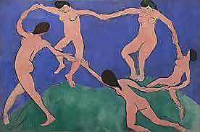
Mice flee the hesiod falcon’s glance
Till under rocks is shelter found.
The beaumonts fletch along the ground
In search of dainty aeschylants.

The pushkins and the hopkins kick
In dostoevsky gambolling,
While from the barnes the anvils ring
In dorset accents inches thick.

From udders of the cowper flows
Milk by the quarto, fit for butter.
Volumes of dung cause grooms to mutter.
In stalls, mares lick their folios.

The gissing gaskells zolafy,
The call of naturalism heeding.
The offspring of their careless breeding
Grub streetly round the moorey sty.

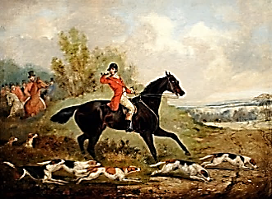
The bins are cramnered, oats and rye.
The troughs are filled with golding feed.
In holing sheds, for winter’s need,
The salt-cured allinghams do dry.

Sly fawkes creeps through a garden gate
With small renard for property.
Into the fenimore coop bursts he
And flutters all the prousting hens.

The horne tooke calls o’er hill and dale!
Now fox in quakering fear must run.
Now robert burnes the mid-day sun
And the milk dickens in the pail.

v.
At Kleistmas we go carolling.
Though blow-ye-crack-cheek’d winds annoy,
The cold kant scott the season’s joy,
Mount calverley oblivioning.

Though sleet and hegel isis eyes
The wouldsman sawyers down the tree
That soon with Forms festooned will be
Our yuletide thoughts to platonise.

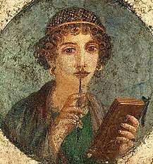
A john can safely ford the fludd
When turned to ice where skaters skeat.
There’s punch for those with frosted feet
And austen broth to warm their blood.

vi.
I hamlet in an open grave.
I dante through the savage wood.
If in that place I find no good
I argosy the pontic wave.

I wallow in wife-of-bathic lust.
Through alien corn I ruth a path.
Beneath an achillèan wrath
I hector down to bloody dust.

I dido died upon a pyre
And aeneas can william tell
Who left me so combustible,
A tender tinder for the fire!

If I have had a lover’s tiff
And love gives me so sharp a pain
That grieving drives me half-insane
I sappho from the nearest cliff.
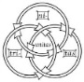
Bohemian sailors I adore,
Borromean, not. I cantor through
A set of winter tales or two
And lautréamont a maldoror.

vii.
O’er grassy fields young Colin herds
His battening letters: A and E
Are plenteous, while X and Z
Are few. Some form gregarious words—

They scrabble as ‘gather’, ‘party’ and ‘join’.
Some stray in little pairs of ‘we’.
A lonely ‘I’ must watchful be
Lest her a hungry woolf purloin.

When lengthening darkness from the hill
Foreshadows evening coming on,
The shepherd summoners with a yawn
In moschus meadows calm and still
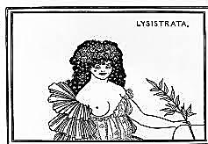
The schelling sheep he kirkeguards:
All are accounted for, and thus
He closes his theocritus
And drives them gently homerwards.

While, from his jug of terra cotta
Draining anacreonic wine,
The cowherd, too, drives home his kine,
Pocketing up his Lysistrata.

viii.
Glims the lamenting Venus star low
Over the sea. Her cause of grief?
Leander, helpless as a leaf,
Sucked under water by a marlowe.
Excuse me! I believe it was Oscar’s turn?

Yet chance what may, I seek a quorum
Of sailors, for I wish to odyssey us.
But let not any modest goddess see us
The contest is cut short by a loud intrusion
before the audience have time to declare a winner.

Tinkling in the Mare Librorum!

