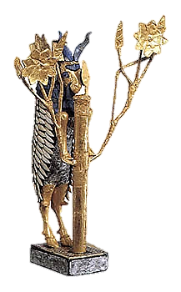
The Royal Cemetery at Ur

Root delicately into the pit. Work surgically with brush and trowel.
It is so dense with the mothers-and-the-fathers-in-the-earth.
Help the earliness shed its tiers. Piece the tesserae, connect the bones.

Ur V.
Time of the lawgivers. It cost you five shekels to cut off a slave’s toe,
ten for an ear. A foreign power had carted off the word for canal.
Finally, the city was destroyed. Everywhere you looked you saw a canal.

Ur IV.
Pictographs were slowly leeching out their pictures. Colourful, specious
religions were founded on a dare. They worshipped a goddess on a hook,
a martyr of meat. They splashed temple walls with a riot of vulgar clay cones.

Ur III.
Words were images of the halos around things. An oafish barbarian
reigned for fifty years. A rebarbative prude, he outlawed the lovely
erotic cylinder seals and poisoned the city dreamworks.

Ur II.
Fall of the tree gods: Their forked feet had tasted too much death. The substance
of deity lodged in the grain of things. A branch grew from the word branch.
In the granaries, rats gnawed what was left of the harvest. Famine ate the land.

Ur I.
End here, at the beginning, where they who have most to bear bear it most lightly,
even the courtiers buried alive with their kings. Priests recline in woolen skirts.
They eat dates. The soul has a tree-roots-and-barley smell… Water carves channels

through the clay and out among the palm gardens, weeping for Queen Puabi
in her mineral cloak. Here is the Goat God. Here is the Harp with a Gold Bull’s Head,
still in the hands of the one who sang and sings it all: the skeletal musician: the poet.

