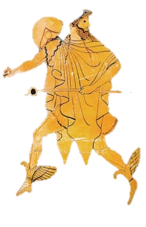
Stealing Time

A watch falls to the sidewalk in slow motion. A shadow blurs by, palming the timepiece.

We were growing old. We would have grown older.

A lineman high up on a telephone pole looked down at the multi-colored dogshit medallions on the pavement below. Dizziness orbited around his head like a cloud of gnats and he fell among those countries like Saturn overthrown.

On the other side of town, an angel with five-o’-clock shadow stood under a street lamp, wearing a trench coat and smoking a cigarette. He opened up his coat, revealing the hot gold Rolex.

I won it, he claimed, playing dice with the moon. He sold it to a passerby.

The divine disc of Aten paused in its revolution around the earth and the weatherman predicted nothing. He got it right. The Rolex in the sky burned out like a Roman candle. Gone, too, was that fine confectionary dusting of stars. Our sleep was fitful in a night without end.

I awoke one Yankee morning with a hangover that consisted of a night sky lousy with stars and bars. They were made of gold, and falling.

They found the watch in a culvert and we discovered that the angels had been dead for a thousand years.

A snooze-alarm clock’s tiny trumpet beeped. Sunrise occurred at 6:03 AM. The candy of the moon melted into daylight. Millions dressed and hurried off to work.

The angel looked around him and moved on.

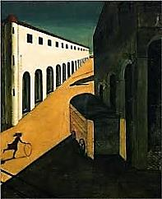
The Messenger

Long lateral shadow puppets stretch their weariness across the esplanade.

The Messenger blurs by.

Hourglass figures stand in studied attitudes of stillness. Inside them, sand is sifting down.
The bottom fills with too much time.

The Messenger looks at his watch, disappears.

City of chess pieces arrayed in a million opening gambits: in the blink of an eye

He weaves you your victories and defeats. Call it a draw.

There is only one cinema in town. It shows three movies, in the same order:
Morning’s Matinee. Le Jour du Jour. That mysterious film noir, The Night.

To the Messenger they are a single still.

Lovers, or shadows of lovers, are standing hand in hand beside the circular canal.

Where is the Messenger?

Ten minutes past de Chirico. In the moonlit piazza a child’s silhouette is motionlessly
playing hoop-and-stick. There are no months, only the moon.

The Messenger has come and gone.

