* Cecelia’s Kids *

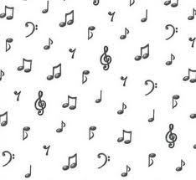

The Spheres of Music

Arthur Chapin

Table of Contents

Prelude 5
Musicians 6
Cadenza 7
The Bony Labyrinth 8
Horn Book 10
A Letter to Oscar from the Sphinx 11
Jim and I Drink Too Much 24
The Gramophone 26
Notes of a Concert-Goer
dans le Neuvième Arrondissement 28
The Serialist Schoenberg
and His Disciples 34
Swan Song 36
Oscar Wilde from Père Lachaise
Salomé and Der Rosenkavalier 38
Oscar Wilde from Père Lachaise
Mozart Versus Wagner 39
Oscar Ascends to Heaven: A Brief ‘Retroscension’ 41
Lux Aeterna 43
La Vallée des Cloches 45
Chopin, 24 Preludes, Op. 28, No. 1 46
The Tomb of the Naïads 47

King Rex the Tyrant Gives a Piano Recital 48
Listen to the Mockingbird (II) 51
Sites Auriculaires 52
Hermes Argeiphontes 53
The Sicilian Expedition 55

Fauré, Piano Trio in D Minor, Op. 120 56
The Jupiter Symphony 57
The Royal Cemetery at Ur 58
Words for a Song (I): Friends We Have Known 59
Serenade 61
Marsyas 62
Listening to Ravel’s String Quartet in F
on a Sunday Afternoon 64
Head of Orpheus on the Water 65
Credo 66
Two Stanzas 67
Words for a Song (II): Holiday Inn 68
Blanch 71
Venus in Rhinestones 72
Our Lady of the Lonely 73
Lili Marleen 74
Hendrix Plays London 76
The Ancient Roadie 77
Words for a Song (III): Down into the Valley 79
Raisin’ the Roof 80
In the Forest of Listening 81
Quieting the Eye 82
The Music Ends 84
Listen to the Mockingbird (III) 85
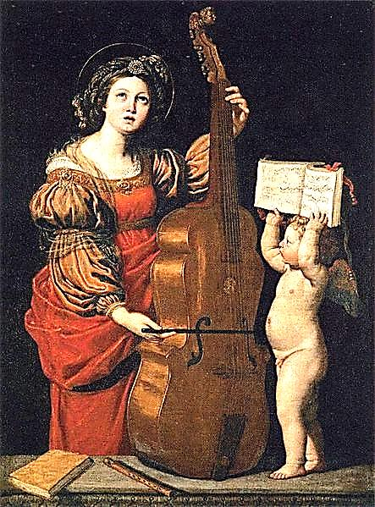
P r e l u d e

Listen to the mockingbird

♫

singing the cadenza

♫

that never endza

♫

Musicians

Ruled paper peeled fresh from the audible world
Like a temple rubbing.
Austere magnificence that consents to endure
A child’s artless flubbing.

A homely hymn played on the piano casting
Lawrence down “in a flood
Of remembrance,” thinking of his mother’s playing,
How it was sweet and good.

Schubert’s petition, in a major key,
To the Eternal Powers
At the end of Die Schöne Mullerin,
Declined, with tears, by the Hours.

Pale strains of Palestrina. Liszt’s chromatics.
Heartstrings twanged, slapped or bent.
A leering clarinet, blue rhapsody,
Klezmer’s laughing lament.

Thumb down the keys, tickle your Telecaster,
Let brassy trumpets blare.
Strike, stroke, strum, breathe, freshly invoke young Jubal
Out of the ancient air.

Cadenza

Time-beaten, flesh fades like a bruise.
But there is a survival made of music.
Against the cadence—Here is the end—
Rise up extravagant waves of a cadenza.
Shostakovich, a frightened wretch
Dying, still under State surveillance, stretches
His hand out, painfully grasps his pen
And sparks a few last startling dissonances
Out of his crippled finger bones.
Beyond all violence now, the notes are dancing
Through open fields of listening, dexterously balancing.

Beethoven sees the acclaiming thunder.
Schumann, ears stuck to a single note, goes wandering
To the Rhine. Time closes in like winter
And the coda takes on a desperate interest,
Pushing against the the tightening mesh,
The final finale, its iron bars of measure.
The bones of hearing scatter in dust.
But in the Requiem, stamping a vastness
Of power on the fragile ear,
The pauper Mozart is the Holy Spirit:
Enter the Capital of the Composer’s Paradise.

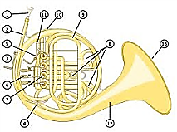
The Bony Labyrinth
Or: The Spiral of Listening

J'aime le son du Cor, le soir, au fond des bois.
—Alfred de Vigny
Hermetic is the ear’s musician,
Obscure the winding passage of
The hearing we give songs we love
Down birth canals of an audition.

A tap upon the tympanum:
Audience granted. Pass the tones
Through a bureaucracy of bones:
Into the spiral then they come.

Each segment of the spiral is
Assigned its frequency along
The curve: electrified, the song
Lights up the listening brain with bliss.

But what the brain perceives as now
Is slightly in the past, already
Over, or soon to be. Those heady
Glissandos, they remember how

Their patterns are supposed to sound:
Present, accounted-for and savoured,
Darkling or glistening, game-flavoured
Or sweet. Faint overtones abound,

Fan out among the neural cells
As complicated connotations
Too recondite for our notations.
The music is a force that wells

Up out of silence like a geyser
And falls back to the stillness whence
It burst, and the enchanted sense
Hears echoes, echoes, none the wiser.

Think how entangled are the sounds-
In-themselves with the technical
Formalities through which they call
Us, and we hear! They make their rounds

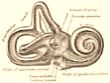
Along the auditory prism,
And notes painstakingly put on
The uniform of unison
Or motley of chromaticism.

The French horn is a golden ear.
The ear is spiraled like a horn.
And where they intersect is born
The tune that we were born to hear.

Pursue into its inwardness
The spiral, down to its least curve:
Note how it flows from nerve to nerve
Into a tiny emptiness,

Or a phantasmagoria
Of leptons spinning in the ear,
Or a translation, dark or clear:
Le son du Cor au fond des bois.
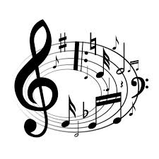
Horn Book
And the Number of his Name
is Fourteen

B - Bellows: The lungs of the organ aloft ♫ Loud as the thunder, as distant and soft.
Bach: Brook, river, cascades from the mountain ♫ Flows into the sea, returns as a fountain.

A - Allemande: A dancer, German by birth ♫ Grace of the Suites, lightly touching the earth.

C - Counterpoint: Each line flints off its brother ♫ Each Heaven-bent to outrace the other.
Continuo gives to the voice of the cello ♫ Harmony’s body, a chromatic halo.
Circle of fifths, climbs straight as a rail ♫ Descends as a serpent devouring its tail.

H - Harmony flashes brief and resplendent ♫ From fleeting consensus of parts independent.
Held note: The violin halts in mid-threnody ♫ Letting the harpsichord take up the melody.
Horn calling deep from the forest to say ♫ The hunters are closing in on their prey.
Hornpipe: Is peasants, rude in their vigour ♫ Stomping the rounds of a simple dance figure.
Hemidemisemiquavers’ quick little swirls ♫ Circle the flute stops like scampering squirrels.
Handel, whose secular operas taught a ♫ Colleague to ‘operate’ mass and cantata.
Home key the citadel, watchtower the dominant ♫ Sly modulations sapping the monument.
Hallelujah! Gratitude, joy and elation ♫ Tuning fork, tonic, and lungs of Creation!

♫
A Letter to Oscar
from the Sphinx

*
Ada Leverson recounts
an interesting evening
with friends.
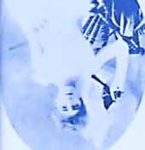

I suspect she is making all this up,
and I believe her implicitly.
—Oscar Wilde

1.
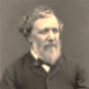
Oscar, I dined last night with Browning
And Beardsley! Friend, I had a fine
Time of it. We drank so much wine!
What with arch Beardsley, and Browning frowning,

And dear Elizabeth née Barrett
Present to goad them on and play
Them off against each other, they
Were quite the experience: I shall share it.

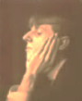
2.
Aubrey’s a gifted young musician,
‘Mongst many other wicked things.
Robert, a musicolater, sings
Along when Aubrey plays magician

At the keys, and wrings teardrops of
Chopin, or strums a scandalous tango.
Elizabeth holds out a mango,
A blushing prize, to him whose love

Most sweetly tunes itself to smooth
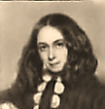
And voluble discourse of tongue
On matters musical: for young
She’s grown, and vigorous and, in truth,

Quite dangerous in her sorcerous beauty.
Robert, the Evangelically
Inclined, takes on most manfully
The challenge, thinking it his duty

To do the honours due to Beauty
And Beauty’s blazon in her eyes.
Aubrey, ah, wicked Aubrey! sighs.
He is ironical and snooty,

And yields his rival choice of theme.
I have one. (Aubrey, do not mock!) Robert speaks in italics.
I shall describe the City of Bach.
The architecture of a dream?

Asks Aubrey, silver-hatchet-faced,
His black hair parted in the middle,
His attitude an angle, a riddle,
His promise, ah, so soon erased,
So cruelly curtailed, dark-glowing A second Keats, he, too, died at 25, and of
In all its tragic anger in this the same disease. I almost wish I had not
Hollow-cheeked, acute face of his, invented him, for such an end.—[Oscar]
Those eyes so full of deathly knowing.

2. The City of Bach

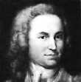
Fugueberg-of-a-thousand-streets
‘Tis called. On this I shall dilate.
Where is it, then? In a ‘fugue state’? (Aubrey, behave!)
The blueprint lays out on white sheets,

On grids of voice in four-part writing,
Intersection, circle, and square.
And through this place the travellers fare
Fleeing each other, or at times fighting,

And generally going their
Own ways down diverse avenues.
But all this counterpoint of views
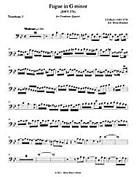
Forms somehow a melodious air

Of a clean richness so precisely
Beautiful that one weeps for joy
To hear the jostling and annoy
Of voices drawing harmony

From clash of passing dissonance,
As textured layers of voice one voice
Make of complex assent that joys
In God as in a Sacred Dance.

Aubrey:
The Book of Numerology!
Who knew the cold Masonic God he
Adored was so adorned and gaudy?
He sings Bel Cantor thrillingly.

4. The Aleph

Into the darkness light shall enter!
Dark was the Void, without a sun.
All things slept their oblivion.
Circumference was there none, no centre.

Silence was King, things slept a slumber.
The Cantor trained a starry choir;
They knew no measure of desire
And so He said, ‘Let there be Number’.

And like the fundamental tone
Of things, before things were, There is.
‘Let it be the Aleph’—lo! ‘tis this. ‘Both tiny and vast: the Aleph-ant’,
‘Be it infinity-plus-one’ whispers Aubrey to Elisabeth, snickering.

And I am. I the Aleph am.
What are you? What am I? ‘I’ is Aubrey interjects a question.
Another, is all the others. Bias
Is built into your Panogram

Towards a certain solipsism
Belied by the Pleroma’s loud
Downbeat into a riotous crowd
Of syncopated anarchism.

I am the Aleph. I am what
I am. Fool! All that is, at all, Saith Rabbi ben Ezra.
Endures for ever, past recall.
Time, saith Shakespeare, is a slut Says Aubrey.

Whose pox God wills our flesh to want,
A pampered punk, a Trojan strumpet,
Apocalypse that lips the trumpet
Of the end of all, this Aleph-Ant

Of More in Less and Less in More.
She is the sultry cigarette girl
In Space’s Cabaret, she’ll whirl
You for a tango on the floor

And lead you to a curtained garden,
One soft and flowery bed. She’ll turn
The gramophone crank, you will yearn
For her, and soften, and then harden

To watch her mince through scented gloom
In slow degrees of sweet undress
Whilst, singing of a heart’s distress,
Marie Lloyd’s clear voice fills the room.

Sleeper awake! The sweet thief’s gone,
And you an elephant of wrinkled
Memory on sheets, think how it twinkled,
The ring she need no longer pawn. E.B.B. looks on amused as the
two rivals glare at one another.
Robert resumes, dactylically rhapsodic.

5. Tetra-Anagrammaton

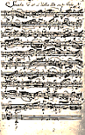
Bach: A brook flowing down from the mountain.
Bellows: The lungs of the organ aloft,
Booming like thunder, now distant and soft.
Bach: Flows to the sea and returns as a fountain.

Anna his sweet Magdalena, the singer.
Allemande: dancer, and German by birth,
Andante it moves, lightly touching the earth.
Appoggiatura, the discord-bringer.

Clavichord thirds embellish the cello.
Circle of fifths its own tail devours.
Clef unto clef calls, and it showers
Chords misted with a chromatic halo.

H: Pronounced ‘asch’, a German ‘B’.
Harmony’s honey is bittersweet:
Hear how in One all the bird-songs meet,
Harps, how they’re plucked of their melody!

6.
High on the senses’ crest, the ear
Is hungry and deep, a shadowy hollow
Harmony-hallowed. Troubles follow:
Cursing and tears are all we hear.

Evil visits us in our dreams.
When the Physician comes, we are too sick
To drink the potion of His music.
When shall we enter a house whose beams

Are stronger than the winds of time?
How low they lie among the stones,
The scattered staves of human bones!
They would in stepwise sureness climb

To sopranino heights of Heaven
And descant sweetly on the Word
Melismas round the tonic chord
With every dissonance forgiven.
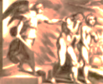
7.
Each part is made of many parts:
A single heart, faithful and true.
Two hearts in love. One, broken in two.
Each heart is made of many hearts.

The heart of pride, sickly and cold.
The Queen of Hearts, upon her throne,
Wears a gold crown, but sits alone,
Her heart worn out in have and hold.

The heart of hate, baffled and wild.
And that miraculous red bird
That beats in the hand of the Word
Of God is the heart of a child.

8.
Follow one street through all the towns,
Cross the one town by myriad streets:
Such the complexity that meets
The ear with wiles to thread these sounds.

Every listening reveals
A unique city; say, therefore,
Infinite cities to explore,
And ne’er the same one twice unreels

Itself before the venturing ears.
As often as they listen, these
Will always hear a different piece,
No road is royal, each path veers

Off on its own course, no twin brother
It has among the ways to get
From end to end of town, and yet
Each path’s as good as any other.

Such is the infinitely complex
Bach fugue: complex yet clear, and thus
Infinitely perspicuous
As the eye of the regorum Rex.

So every work of Bach’s contains
More music than the ear can hear,
Though asymptotically we near
The whole towards which our hearing strains.

His music is pure in excelsis
Deo gloria, the infinite
Dwells in the ringing shrine of it
More than in anybody else’s.

9. Cantata and Mass

Cantata, a pew filled with voices
Diversely joined in one devotion
Spending itself in sound like ocean
Waves on the altar. Grief rejoices.

But dissonance comes like a sword
Amongst the tones, with ills and evils
The tonic major heals—but, Devil’s
Interval, you baffle the chord!

The hearts’ tritones prevaricate.
Sweet distant voices fall and rise.
We hear the tunes of Paradise
But swordsman Michael guards the gate.

The heart’s a furtive, darkling coast,
Tough muscle, Lord, perversely soft,
Made whole when the priest holds aloft
The consubstantiated Host.

Robert knocks back a glass of wine
and turns storytelling balladeer.
10. A Prince and a Subject

He is the Prince, a man of pallid
Visage, and pride unlimited
Inside a small and narrow head.
I am the subject of the ballad.

As vast as a great fugue it was,
This Prince’s grandiosity.
Once, as his coach-and-six rolled by,
What every loyal subject does

I failed to do: I would not raise
My cap, when duty bid me show
The Christian virtue of a low
Obsequiousness. In those days

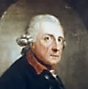
High Worldliness decreed that even
Our music should wear livery,
Though only true Divinity
It ought to serve, and highest Heaven.

Fetters and a floor strewn with straw
Would be the fugitive’s if caught—
Though freedom in this place meant naught
But wearing lighter chains. I saw

My chance, and leaping on my horse,
Broke through the guards’ ranks and attained
The open road. How my horse strained
To outstrip the advancing force!

She plunges on in a dust cloud,
Presto, and her hooves on the ground
In demisemiquavers pound,
Whilst gaining hooves beat fast and loud.

I turn at a remote byway
And somehow narrowly escape.
I try to modulate my shape.
(Such are the games subjects must play.)

I change the angle of my figure,
And backwards, even upside-down
I walk at times, from town to town,
Now seeming smaller and now bigger,

Disguise myself, almost become
Another subject altogether,
Darting hither in stealth and thither,
Hotly pursued. My nightly home

I make in taverns, wayside inns.
The crashing entry of his men
Awakens me, again, again,
Come in the name of the great Prince.

Only an open window gapes
At them when they burst through the door.
Another night: we play once more
This stretto of entries and escapes.

It ends with capture, but a finer
End than the gallows waits for me.
My crime was thinking I was free.
My life concludes in sad B minor.
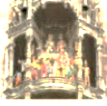
‘Im finstern Tal, fürchte ich kein From the Lutheran Bible, Psalm 23
Unglück‘. I pray here, in my prison, (‘Yea, though I walk through the
Waiting to die. For He is risen. Valley of Death, I shall fear no evil‘).
His tomb empty; so shall be mine.

11.
We go about our business, friend
To enemy and enemy
To friend. The town hall clock strikes three.
Around the clock stiff figures wend

The circle of fallen Man and end
Where they began, as in a prison
Exercise yard. Soul’s prayer-gears (listen!)
Chime: ‘Bury your clocks and ascend’.

12.
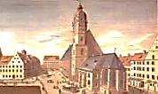
Out in the yard, bread, cheese, and beer.
Anna my wife, the gifted singer,
At our wild children wags a finger
Smiling in daylight soft and clear.

They scramble over bench and board. Thomasskirche, Leipzig.
Smoking my Meerschaum pipe, I am lost
In thought. The beer tastes stale. The cost
To fix the roof I can’t afford!

A sort of fugue, those scampering cats…
That post in Leipzig… I review
My awkward speech: the interview,
The sacred, stupid bureaucrats!

Can rules be followed so far that
You break them? Do you then become
The leader? Leading where? God, home?
Meanwhile, cat runs away from cat.

13. The Passion According to St. Matthew

O Christ our Lord and living Word,
This music is your beating pulse.
As through these dissonant intervals
Lines journey towards the tonic chord,
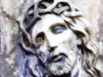
And as the chosen tribe of Moses
Walked forty years through desert sand
Until they reached the Promised Land,
Rose made of thorns composed of roses,

So up a path of flails and curses
You strove, to crown our exaltation
From the tower of humiliation,
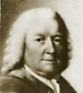
As it is writ in Matthew’s verses.

And in this Passion, in this pity
Let sound the tolling bell, for dun
Will grow the day ere long: the sun
Is setting on the human city.

14. Aubrey’s Palinode

Two subjects scraping, now and then,
Against each other, blade on blade
In spark and clash, then retrograde
Going their separate ways again:

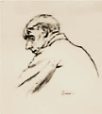
Yes, that’s what counterpoint is all
About. Bach is its master—and
Its slave. The structure is quite grand
But such formality may pall.

I prefer madness in my music.
Thor-hammering Wagner. Poetry, By Walter Sickert.
Too, Schubert’s sweet melancholy.
Or the dark side of Mozart, too sick

To finish his last masterpiece, The Requiem.
Coughing up genius in a garret.
(Sometimes I simply cannot bear it,
This dying. Where shall I find peace?)

[Aubrey improvises mockingly on some favourite themes
and anathemas of the Evangelically-minded Robert,
including his hated Calibanesque natural theology.]

15.
Galuppi, give us a toccata
On themes as wild as the Galapagos,
Or Guinean shores, where anthropophagus
Natives are chanting a cantata
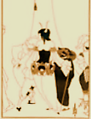
In praise of Nature (God, or Book
Of Darwin, Devil’s script?) They praise
The Vulcan-Spark that in a blaze
Makes oily missionaries cook.

They dance around the fire and shout
Hosannas to a tikki god,
This Gnostic cargo cult of fraud-
Shamans and tribal odd-men-out.

Mutations on the theme of apes
Ever-evolving into angels
As an idea in the brain gels
They sing, and praise all protean shapes.

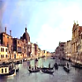
16. Another Venetian Toccata

Galapagan Galuppi sings
The faded beauty of the feather
That on a belle, in heady weather
Of Carnivale, adorned the wings

Of gold, the Cupid guise in which
She revelled in the Doge’s Palace,
Quaffing the moment in its chalice
At the masked ball where all the rich

And haughty nobles of Poseidon’s
Cherished old harlot City go
To see and be seen, ‘mid the flow
Of champagne, and the smile that widens

On Lady Cupid’s face, the fire
Of all the prostituted splendour
Of her fine face when they attend her,
Her beaux, the Knights of her Desire,

As she becomes, in all her glory, Robert interjects.
A vision of Venus, clam-shell borne,
Stroking the tumid Unicorn ‘Under the Hill’, detailing the erotic
In Aubrey’s filthy little story. adventures of Venus and Tannhäuser.

And your Porphyria? Her hair
You twined into a strangling cord.
You killed the one that you adored.
Porphyria, at least the rare The power of suggestion! Robert’s skin
turns purple, blisters appear, he feels
Variety you suffer from, stomach ains, becomes depressed, and
Brings seizures and delusions, brings begins to sweat profusely as Aubrey looks
Depression, anxious thoughts, and things, on gloatingly… But with a great effort of
Bump-in-the-night things, oh! they come. will he shakes off the curse. Aubrey, having
made his point, resumes the singing match.

17.
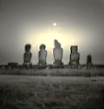
Now let her walk her along the Lido
Alone and lovelorn, for of all
The beaux the one she chose to fall
In love with is the faithless Guido!

And let the sands she walks be changed
To shores Galapagan, or better,
Of Easter Island, yes, there set her
Down in a barren and estranged

Marooning, let my lady pace
Among the cold and brooding heads
Of gone gods underneath the reds
And purples of her dusky days,

Her Knights of Stone, and every breath
She takes their breathless faces mock.
And let them join, as flesh and rock,
The petrified and living death.

18. Abt Vogler and Improvisation

Praise on the instrument your own Robert’s turn.
Hands made the God whose own Hands made
Your hands His instrument, and bade
Abt Vogler find the proper tone,

As of each thing its Final Cause,
For each hue of the rainbow’s blazon
And, in a mighty Diapason,
Sound all the Stations of the Cross.

Fell Time, that makes the roses wilt,
Hath laid low, with his envious malice,
Another Solomonic palace
Bad angels and good devils built.

19. A Hand of Tarot Cards A sort-of run-off election or elimination
round, as narrated by my dear Sphinx.
Now they are playing with the cards, The loser must gradually disappear, like
The Twin Arcana of the Tarot the grin, turned moue, of the Cheshire Cat.
Goddess, a Gipsy nomad, narrow-
Eyed and sly, who picks crystal shards

Of questionable epiphany
From the seamed rock-face of the random.
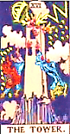
She has a partner: they in tandem
Can raise the dead, for a small fee.
Browning, with a touch
Alas, the lightning-stricken Tower, of Schadenfreude.
From which two men fall to their death! Beardsley looks stricken.
Ah, numbered is your every breath.
How soon it comes, your Hour, your Hour.

[Things get confusing here, Oscar, so let me summarise the Pantomime costume- and
scene- changes that ensue, the detailed chronicling of which will have to wait till the next
post, or if you prefer, chapter: Elizabeth Browning becomes Lizzie Siddal with a strong dose
of Lilith. Robert Browning becomes Gabriel Rossetti, Beardsley withers away, and much else
besides takes place, all of it deliciously decadent. Be patient, friend, the sequel followeth anon!]

I must go now: we are invited
To the Asquiths for a late supper.
My next has things that Martin Tupper
Would cough at; you will be delighted.

Sphinx

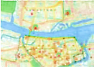
Further Revelations of Oscar Wilde
From ‘Jim and I Drink Too Much’

Jim Joyce speaks in italics.

Soon I shall start to slur your words.
That would be slander, labial libel!
Shall we go home and read the Bible?
I think that I shall stroke some chords! Plays snatches of Tristan
* und Isolde on his guitar.
Isolde incarnates before us.
Mein irisch’ Kind, wo weilest du?
Woo-woo, moo-moo, mein Kind so irisch, Isolde is transformed from
So Io, that it makes me tear-ish, a beautiful young queen
O meine irisch’, irisch’ Kuh! into a mythological cow.

This Wagner Typ puzzo di sesse.— He speaks Italo-Anglo-German,
He stinks of sex? Who doesn’t, after…? this polyglutton for pun-ishment.
Although he does excite my…laughter,
His Siegfried. One could write an essay
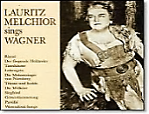
On his stupidity and find,
In the end, nothing to say. (Though on his
Teutonically blond Adonis
Looks one could heap praise.) And his ‘mind’?

He is no village idiot,
He’s a whole village full of them.
A ‘hardy’, we’d say. So would Shem.
From schlimm to wurst he goes, this Brat.

*

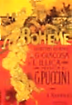
Mavrone! Sure, Ireland was born knowing
What hunger is! There’s those that do
Not know it; but they will. How true!
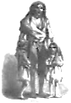
Me, I never got used to going

Without food, studying medicine
In Paris as ah! young man. Hunger
Is La Bohème when we are younger
And a youth cannot be too thin;

At forty it is simply real.
Ugliness, suffering, obscene.
The grumbling void, the pangs how keen!
Quick now, let’s order us a meal!
Boiled potatoes are ordered:
They bring us but the one!
[He sings and plays at the piano a medley of Bellini
and Donizetti, Una furtiva lagrima wells in the eye
of the listener, who is apparently Oscar Wilde.]

How nice to hear you Casta diva
Upon the waters! Diva-gation
Of rivers from their derivation.
The snippy castanets of Shiva.
Jim mocks Thomas Mann’s description
The donkey draws the cart to Heaven, of the slow movement of Beethoven’s
F*rting freely in his *rse-scent. last piano sonata, in C minor, op. 111.
Let hands be clasped, let knees be bent: (‘The donkey-cart that goes to Heaven’.)
Rise, incest smoke: the Heavens are Seven! —[Mr V]

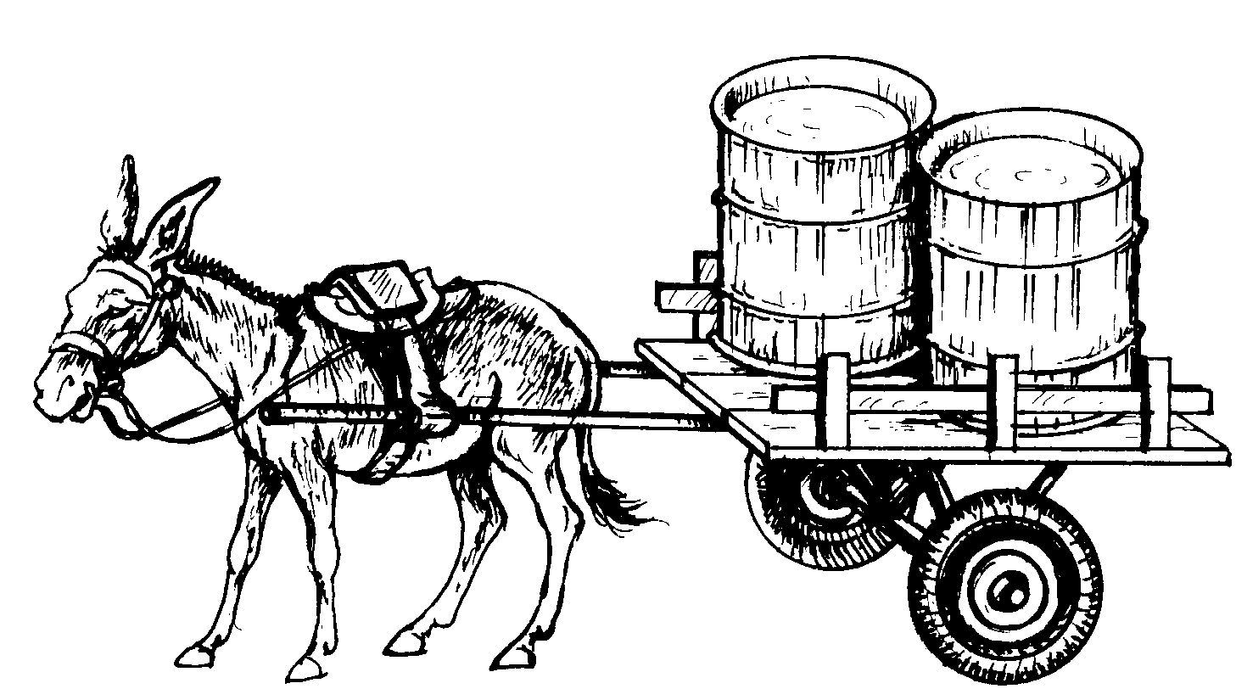
From Sweet Wormwood
The Gramophone
Narcisse and Oscar Wilde are listening to Marie Lloyd on the new-fangled gramophone, which has
lately replaced the phonogram, or wax cylinder.

Cruel, almost, My Love, how deep
The needle cuts into the grooves
To free this melody that moves
Our hearts so strongly that they leap

Into our throats and sing along.
They hardly skip a beat, do they?
Although the needle sometimes may.
But so well do we know the song

We can fill in the interim
Or gently prompt the stumbler. Watch!
The small sore spot that made it catch
I lift it over. Should it skim

Whole bars to which it should attend,
O’er which it might prefer to glide,
Note the finesse with which I guide
It back to what was skipped, to mend

Its ways and heal the indecorous breaches
In the offended melody.
Sometimes the pitch sinks, key by key,
To Mephistophelian reaches,

Basso profundo, and the platter
Slows down to silence, motionless.
A fear sets in, and heart’s distress:
To calm the anxious pitter-patter

I rouse myself from where we lie
And give the handle several turns,
Till back into its fullness yearns
The voice, and with a weary sigh

I sink back down beside you, Dear.
We drink in through our ears the song
That heals, because it knows, the wrong.
It makes one shed a harmless tear

That art so artless as this singer’s
Could catch our suffering in notes
Through which the soul so freely floats,
Caressed by ghostly Orphic fingers

Like granted mercies long beseeched,
Until the needle’s Odyssey
Stops at a tranquil inland sea,
And the end never sought is reached:

The nowhere going round and round
The smooth black circle at the centre
Which you and I will one day enter,
Who were always for that stillness bound.

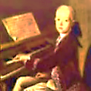
Notes of a Concert-Goer
dans le Neuvième Arrondissement

Speaking as a Parisian ghost-about-town as well as a somewhat dingy ‘Inn-
Spectre’. In the Afterlife, partly under the influence of Mr V, I have become
much more interested in music than I was in life, Dears. One could say my
‘I’ has become ‘all ears’, but perhaps one shouldn’t. Here are some reviews.

1.
Not the arts only, all of life
Aspires to the condition of
Music, where all the passions love
Themselves, yes, even pain and strife.

As Nietzsche tells us in The Birth
Of Tragedy, in dissonances
The very soul of suffering dances,
Exulting o’er its trials on earth.

On a blind giant’s shoulders rides
(In Schopenhauer’s allegory)
The lame man who can only see,
Beset by instincts on all sides.

But that poor crippled, seeing mind
Finds fleeting Heaven in the ear
When the Will, imageless and clear,
Sings Passion purified and kind.

Music in which mere repetition
Holds sway narcotically but serves
To soothe or stimulate the nerves;
While that of genius, with a ‘vision’—

And yes, I mix my metaphors
Advisedly: every ‘aesthetic’
Is, on some level, synaesthetic—
Such melody as Mozart pours

Over our heads like sacred oil,
Anointing us with happiness
That brings us close to gods (they bless
That angel resting from his toil):

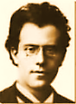
Such music is our sacred bread,
Or should be consecrated thus,
Estranging and enlarging us,
Joining the living and the dead

In tentative and secular
Communion, so intense, so clear,
Tuned to the inner eye and ear,
It sings in candles like a star,

Shines like brass fanfares! Though the bliss
Of the young dancer fades, alas!
In moments musicaux, the ‘was’
Is momentarily an is.

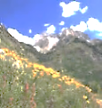
2. After an Evening of Mahler

Suppose that music, audible,
Is only writing in the ear;
Then writing, it is equally clear,
Is music intellectual,

The melody that thinking makes,
Or rather the polyphony
Of its conflicted symphony,
Mahler-esque, dark, where lightning breaks

Only at times on the overbearing
And rather sophomoric Storm
And Stress at the loose edge of form.
Ah, best when all the pompous blaring

Of brassy fanfares and the dense
Black Nietzschean moustachioes
Of Nihilist dissonance find repose
In the Slow Movement, where the tense,

Brow-beating histrionics and
Heroics give way to a free,
Pure flow of complex reverie
And thought with thought walks hand in hand

Through Alpine glades in bracing air,
Crisp vistas of nostalgia,
With cow-bells tinkling, and ah!
Lieb’ Gott der Vater with us there!
2. Chopin

Recently I heard Rubinstein’s
Chopin (Arthur’s, I mean): It is As distinct from the Russian
Chopin’s Chopin. Strange, how in his composer-pianist Anton Rubinstein.
Hands a brief nocturne redefines

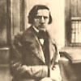
The world, and modulates its key.
One’s hearing grows chromatic: birds
In the trees trill in minor thirds,
Full of Polish melancholy.

Refined, and yet through Marsyas’ throat
Your pain at times forced melody.
For resolution endlessly
Deferred is the true modern note.

Chopin, whose music is a mythos,
A strange and beautiful disease,
You breathed your life into the keys
Till none was left to keep you with us!
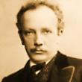

4. Richard Strauss

But, Beecham’s Rosenkavalier!
At Covent Garden I was present
And through the ears of a quite pleasant
Young man heard all, and shed a tear

For the great Marschallin, and scoffed
At Baron Ochs when Mariandel,
Whom on his knee he tries to dandle,
Proves, when the sly disguise is doffed,

To be the man who steals his catch.
Margarethe Siems lived the rôle
With her clear notes and tender soul,
And what a queenly She to watch!

And ah, the splendid final scene, The duet, ‘Est ist ein Traum’.
As the celesta silvers over
The rose-red fire that burns ‘twixt lover
And lover when the Marschallin

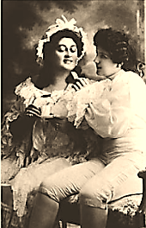
Leaves Sophie and Octavian
Alone together, is a dream’s
Dream-consummation. And those gleams
Of dissonance? They are the wan

Smile of Princess Marie, resigning
Her claims with an auf Wiedersehn
To youth we shall not see again.
Clouds with them take their silver lining

When into nothingness they fade,
Leaving in memory a rack,
At most. She thinks (and turns her back),
Es ist vorbei! But, how well-played!
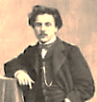

5. Fauré

Last night I went to hear Fauré:
Piano Quartet in C Minor.
In chamber music there’s no finer
Expression of Provençal gai

Saber (save in the Violin
Sonata, also wrought when he
Was a young man passionately
In love). The scherzo, sparkling in

The mind as Keats’s beaded bubbles
Brim full the cup of vintage wine,
Moves in an agile, elfin line
Through that love’s dark and gathering troubles:

Rebuffed proposal, heart’s wound, rage
And sorrow, the dispiriting chore
Of running the Conservatoire,
The politics… The War. Old age.

6. Debussy

Now the mysterious L’Après
Midi d’un Faune wafts through the gloom
And like a poisonous flower in bloom
Nijinsky with himself doth play! Théâtre du Châtelet, May 29, 1912.
Ah, quel succès de scandale!

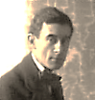
(His leaps are such miraculous things:
He seems to hover in mid-air
Before descending; one could swear
Hermes had lent the boy his wings!)

7. Ravel and l’Enfant et les Sortilèges

And as for those svelte ear machines
Of the Swiss-Basque Maurice Ravel,
That paradis artificiel
Of pastoral wallpaper scenes

Torn by a child in petulant rage,
Where shepherds beating on a tabor
Make soft lament for love’s lost labour,
And innocence must turn the page
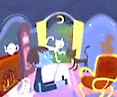
And hear the woodwinds’ mortal quavers:
I rode in one, vicariously,
Through a young lady named Marie
At the Opéra last month. One savours

The rich, expressive ether of this
Precise nostalgia of the ear
In an aloof child engineer
Who prizes a frail, guarded bliss,

The benediction falling on
Him softly in the shadowy garden,
When, hurt, he gains the creatures’ pardon
And he and innocence are one.

8. Vaughan Williams A pupil of Ravel’s. I astral-travelled to Gloucester
Cathedral to hear the premiere, September 1910.

Fantasia on a Theme by Thomas
Tallis: haunted as an old chapel,
The strings sound. The old story, apple
And fall and death, and distant promise…

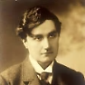

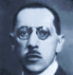
9. Young Turks

But in a way that makes one wince, key I attended the second, placidly received per-
Relationships are savagely formance of The Rite of Spring. Since its
Distorted, the ears rhythmically raucous debut it had quietly metamorphosed
Assaulted by the mad Stravinsky! into a cornerstone of the Repertoire, Dears!

(Diaghilew’s a man of charm
And money. Gawkers stand on chairs
To watch pariah and homme d’affaires An impresario and art-collecter, interested in
Walk by the cafés arm in arm.) acquiring some of Aubrey’s erotic drawings.

*

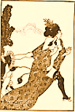
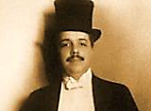

Sprechstimme, a glissando, shrill,
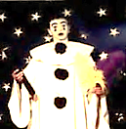
Death-pale expressionist nightmare,
Mad-clowning of Pierrot Lunaire…
The twentieth century is ill.

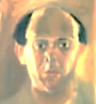
*

But when the gate of light’s unlocked
And I walk home into the Vast,
Let it be to the mystic last
Strains of Schoenberg’s
Verklärte Nacht.

*

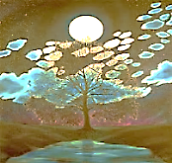

The Serialist Schoenberg
and his Disciples

[A screed against Serialism and the ‘Emancipation
of the Dissonance’, by the amateur musician, Mr V.]

Beyond the highest tessitura
Of an Expressionist soprano
The high, thin keys of the piano
Make a cold musica obscura,

Sound of the interstellar void,
A black noise as of some dark matter
Whose hymns to itself make glass shatter:
This is the music I avoid—

That is, of the twelve-tone variety.
In dodeco-cacophony
Of an affective palette free
Of every affect save anxiety,

It blandly ignores the nature of
The intervals. So dissonance
Must be freed? What, freed of nuance?
Insults to hearing win no love.

Theory’s Pyrrhic victory
Over the ear only accents
The split ‘twixt intellect and sense
In fractional overtones so high

That they amount to a dog-whistle
Music for dogs, and the dogs do
Not like it. And our poor ears, too,
Feel they are suffering a dismissal.

The hexachord is universal,
An aural grammar Nature ingrains
In foetal ears and foetal brains.
By a mechanical reversal

To embitter music, scorn the natal
Hunger for consonance, and blame
Ears for not relishing the game,
Will to this music prove quite fatal.
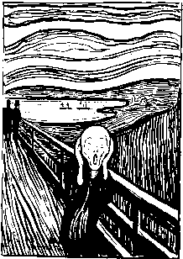
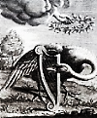
Swan Songs
Rossetti and Oscar Wilde
Scene: Rossetti’s house on Cheyne Walk.

Quite a splendid menagerie! Rossetti speaks in italics.
But why not add a swan to your
Collection? They are going for
A swan song these days. That would be

The mute swan, then, Cygnus olor?
Is that the one you have in mind?
The Agamemnon’s where we find
The first use of the metaphor

Of the swan song, in that scene where
Cassandra, drawing her last breath,
Is likened to the swan whose death
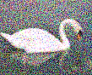
Draws out both soul into the air

And sad lament. Chaucer writes of
‘The Ialous swan, ayens his deth
That syngeth’. Deep, oh deep beneath
The earth, far from the songs of love,

The shouts of hate, circles a swan
Around the Isle Tuonela, Land
Of Death. Mysterious, pale and grand
Amid the gloom she glides upon

The water. Deathless is her song
As death is endless, and releasing.
Voice of an oboe sadly pleasing, If Rossetti is referring to Sibelius’
She pauses, sings again. Along The Swan of Tuonela, this should
be an English horn, Oscar.—[Mr V]
The shores the shades are listening, listening, A Finnish swan with the voice of an
Startled alive in hearing’s nerve. English horn! Really, Mr V, consider
As graceful as her neck the curve the exigencies of both sound and sense!
Of melody, and pale and glistening

In the mist is the sombre vision.
The music is a dying fall,
And sweetest at the close of all.
Orphic immortal, death’s musician!

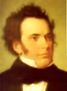
Schubert’s publisher called his last
Songs Schwanengesang. How could Fate
Rob us so early of so great
A soul, of promise still more vast?

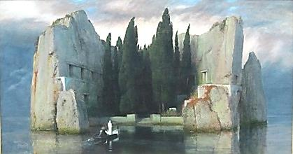
Oscar Wilde from Père Lachaise
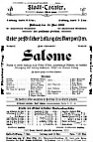
Salomé and Der Rosenkavalier

A visitor:
Did you know Richard Strauss has made
An opera of your Salomé?—
Yes, and without, I’m pleased to say,
Changing a single word. It played

At the Opéra not long ago,
And through the unsuspecting ears
And eyes of a young man, my Dears,
This poor ghost witnessed all the show.

I found it splendid, on the whole,
Especially the orchestral writing.
Those mad ‘wrong’ notes, so harsh and biting,
Capture her wild young pagan soul.

But ah, Der Rosenkavalier’s
The silvery apotheosis
Of ‘The Harlot’s House’, where Lust’s red roses
Waltz with Love’s lilies, and one hears

Celestial dissonances ring
As they descend from Heaven, angels
Of bittersweet accord. Love dwells
Among us, but is on the wing.
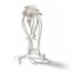
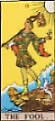
Oscar Wilde from Père Lachaise
Mozart Versus Wagner

What tripped me up, my Dears? My own
Too-much futurity… The uncanny
Sense of it, so hard to make any
Sense of! Alas, I should have known,

I often thought, yet I did know—
Knew just enough to have known better
Than to send, ah, how many a letter!
Whose indiscretions caused me so

Much grief, for instance, later, in court.
The Sisters ply a witches’ craft,
They read palms, show you your life graphed
In the lines; hints of dark import

They give, flash you a Tarot card…
(‘He’ll be your death’, a friend once told me.
I laughed at him. And now, behold me!)
Ah, when they laugh, it is a hard

Laughter: To hear it and to bear it
May be the hardest labour of
Them all. And all for love, for love!
Ah, love, to what shall I compare it?

To fate itself, I think.—I’m tired,
My Dears, of talk. I recommend
That whilst in Paris you attend
The Opéra. I’ve much admired

Melchior’s turn as Parsifal.
Ah, how intently strain towards
A heavier Heaven Wagner’s chords!
Slain Viking blood dyes that high Hall.
Sooner to Mozart would I rise.
But if from earth I must look up
To Heaven, let my ears drink the cup
Of Wagner’s heady harmonies.

I’m sorry you’ve missed Melchior’s latest
Siegfried in Götterdämmerung.
His Tristan, too—divinely sung!
Music most morbid at its greatest.

Farewell, my Dears! Too brief, alas,
The pleasure! I must rest, perchance
To dream… May you all find romance
And joys to treasure as they pass.
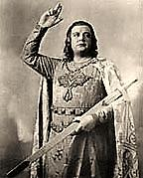
Oscar Ascends to Heaven
A Brief ‘Retroscension’
From ‘Demi-Heaven’.

That wingèd youth, quel amuse-bouche!—
Will the Lord strike me with his levin
For chasing cherubs into Heaven?
The Saints will find me somewhat louche,

I’m sure; they’ll turn away from me
And ask of God, with a pained face,
That He request I leave the place,
Like some old haughty maître-d’.

Ah, is there Grace enough to wipe
My sins away? Is not my type
One of a far-too curious stripe,
Ascending ere the time is ripe?

Down-at-heels Mephistopheles,
Turn back! The moon’s where you belong,
Or listening to Casella’s song See Purgatorio, ii:
At Purgatory’s foot, at peace to a poem by Dante.

With all your selves… How threadbare seem
My splendid clothes now, shameful rags…
My gloves, pricked from sewing mail bags…
Is this another prison dream?

Penance lacks charm. At least to be
Belacqua, Dante’s idle friend, See Purgatorio, iv.
Would give me leisure-space to mend
My ways a bit more casually,

Not keen to make that arduous climb
To the Earthly Paradise. A breeze
Would fan me, head between my knees,
(For surely I have served my time!)

Sitting in shade—no, not to brood:
To daydream, perhaps gently jeering
My old friend’s strenuous mountaineering,
His fetish for sheer Altitude.
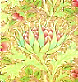
For what I crave is Latitude.—
Still, why not play along? The ride’s
Easy, the view, glorious. Besides,
I would not have them think me rude.

For surely it is a bit presumptuous
To criticise one’s own Ascension?
It would be graceless not to mention
The many lovely effects: how sumptuous

Yet chaste is the sky’s Giotto blue;
The angels, purest Raphael;
Music by Mozart—chosen well: Ave Verum Corpus, perhaps? No,
Wagnerian bombast will not do. the chorus of lovely cherubim, those
angelic boys, in Die Zauberflöte.

For through the psalms and scent of roses,
The smiling chords divinely blent,
Should run a thread of pure lament
To complicate Apotheosis.
Lux Aeterna

The cello, whose song is grief
for the mother tree.—Linda Pastan
1.
Dank duff on the forest floor
Steams in the slant-shine, rain’s after.
Perforated greencoat
Glimmers through its wounds
On the crawlspace, thick vigors
Writhe: pale grub bellies, leaf plaster,
Black sog, branches bending.

Toadstool’s soft head swells,
Cool pallor sprinkle with dirt specks.
Wood chips cling to their stray places,
Log, puddle, mud-patch.
Rot riots sweetly, quiet as the chigger bites.
The caterpillar chews, inching through loam.

2.
In the center is a clearing.
Pine trees arrange a circle.
Tall stillnesses tense over you,
Raw, orchestral.
Dusk-robes, in their slow procession,
Trail over foliage their blackening length.

Listen.
Requiem of Duruflé.
Rosin-moted light sifts onto cellos,
Basses, string section, woodwinds, Requiem:
Killed trees reassembled as the Lux Aeterna.
Resinous haloes, scent of the Spirit rising
From the pith, vibrant
With sympathetic bones.
The fork that tunes the Crucifix
Hives its resonance
In the cells of cellos.

The wood is a secret hidden in the wood.

3.
I was alive and I called in the forest:
‘I will nurse you with a thousand attentions’.
My breath was a clear, quick smoke.
Light, a granulating honey.
There were bitter densities I gave
Softer names. I named them shadow
Or shade, blue shadow, woodsmoke shade.

‘Why do the wasps torment themselves
In balls of fury?’ Said the dusk
That entered my mouth
That verpertine evening.
Dusk opened up my mouth, and Vespers sang.

4.
In a drift of leaves
Is vigil. In the the word, which
If you have forgotten, remember.
If you remember, say.

It dwells. It grows.
It is and it is to be.

‘Yes’.
La Vallée des Cloches

And I went walking through Ravel’s
Valley of the Bells.
I walked, and distant matins rang
With a muffled clang.

Slow green tones tolled far and low.
Rain refreshed the meadow,
Moistened the clover. A ghostly sound—
Light hoof-beats on the ground—
Rippled the mist. Tinkling noises,
Murmur of shepherds’ voices…

I looked out through a row of tall
White columns and watched all
The steeples crumble into dust
And the bells rust.
The echo of a minor third
Was all I heard.

The steeples crumble into dust
And the bells rust.
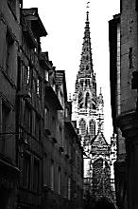
Chopin, 24 Preludes, Op. 28, No. 1
(Student’s Edition by Alfred Cortot)

The passion, the impatient ardor, with which this prelude
Sweeps all along, can only be rendered by the accurate
Punctuation of the syncopated figure which, from bar to bar,
Pantingly and feverishly carries the melodic line forward
To the exaltation of measures 21, 22, 23, and 24.

These form the culminating point of a curve
Afterwards modified by a brief diminuendo
During which there is a weakening of the tone only,
But not of the pressing and insistent rhythm
Now become like the beating of a heart exhausted by emotion.
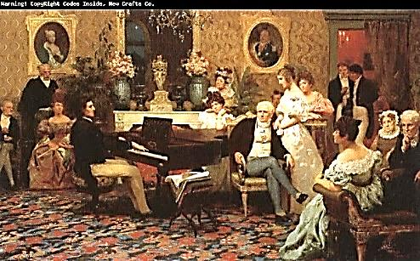
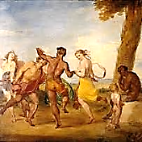
The Tomb of the Naïads

After Pierre Louÿs
(Les Chansons de Bilitis) Set to music by Debussy.

I was walking through the frost-covered woods,
My hair across my mouth sprouting little icicles,
My sandals heavy with mud-spattered snow.

He said: What are you looking for?—I am following
The tracks of the satyr. His little cleft footprints
Are like holes in a white cloak.—The satyrs are dead—

The satyrs, and the nymphs, as well. In thirty years
There has not been such a terrible winter. The tracks you see
Are those of a goat. But let us rest here. This is their tomb.

And with the blade of his hoe he broke the ice over the spring
Where the Naïads used to play. He took large frozen pieces
And, holding them up against the pallid sky, peered through them.
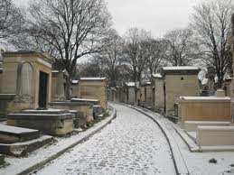
King Rex the Tyrant Gives a Piano Recital

Every Sunday, when with heart
high-sorrowful and cloyed
he rested from his day job,
you would not see him at his usual pasturage,
ripping meals from that great meat orchard
as he crashed his way down to a skyline luridly inflamed.

At times such as these, the whole world retired
to lick its wounds in silence, free
of those deafening shock waves throbbing from the swamp
when the thick-skinned King (who was also very thin-skinned)
pulled up short at his dinner to roar at his food:

DON’T LOOK AT MY HANDS!

On this day you would find him in his palace
entertaining guests, in a genial mood,
eating, at most, two servants, and passing up a canapé.
Sometimes he displayed, for connoisseurs,
the smeared botches of his "abstract expressionist" paintings,
or read with a suavely modulated growl
from his latest forays into the realms of Erato.

And when the great gilded grandfather clock
in the hallway banged the ineluctable hour,
his chorus of toadies knew what to say:

Sire, won't you favor us with a little Debussy?

And we shuffled through the double doors
into the auditorium.

Industrial-strength kettledrum footsteps
crescendo'd from stage right.
He squeezed into view, his head bedizened
with a dandruff of klieg light shards.
He landed on the piano bench, squared
his shoulders to put a little wallop into it,
and then it could not be denied
that the up-and-down Clonk Clank Clownking
had begun.

Fine lacquered rosewood flew into chunks
of lumber exploding toward the ceiling,
white keys scattering like broken teeth, snapped strings
flailed like riot hoses slipped from the grasp.

All this time he watched over his work
with huge satanic eagle eyes hooded
by the ancestral crests of his orbital bones.

But now and then those eyes
seemed to look out at us in perplexity,
as if to ask why destiny had appointed him
to level the lyrical to the literal
with such monstrous finesse—
like that dream of a pagoda poised
over its reflection in a lake
collapsing into splinters of the physical damage
he was inflicting with those pitiful, vestigial hands.

Ah, he could swallow a tank,
but an octave he could not span!

On and on the pounding softened us up
like the overture to a beach landing,
no place to hide in the inland of the ear,
he continued to torture Debussy
in blatant violation of the Geneva Conventions
and what could we do but pretend to listen
to what we would pretend we had never heard?

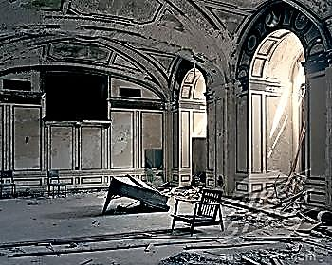
Listen to the Mockingbird (II)

Glib plagiarist, recite your myriad melismas,
In careless order mime the sober songs
Of all the venerable classical birds.
Play the familiar strophes, loved refrains,
The ditties and the snatches of old song,
The cautious hooting of Minerva’s pet,
So baleful when heard on evening’s rafters,
The roo-coo-cooing of the turtledove,
The efflorescent nightingale, such lofty
Twittering… Mingle all these noble strains
In medley, wring new music from the ripe
Decay, new vintage from the raisin: hybrid
And full of spurious, rainbow-like delights.
Mix and amass, as light unfurls its flags,
Your plural songs, improvize glib cadenzas,
You of the endless, perishable music.

Sites Auriculaires
Maurice Ravel
The silken hammer
and the fragile anvil.
World’s pinna. Thunder-blinded
radio eye.
Helical swirl, golden ratio.
Motionless cyclone. Still whirlpool.
* * *
Thumping of drums against the tympanum.
Stirrup of the vanishing horseman.
* * *
Shell that listens.
A cry: its sheltering grotto. Daphnis and Chloe
A whisper: white
Sibilance of surf. Melody
emerging from the sonic shadows.
Bone microphone.

Ambiguous tritones hesitate in the vestibule,
resolve to enter as the tonic chord.

* * *
Introduction and Allegro
Harp arpeggios
superconduct the air,
saturate the labyrinth
and soothe the soul-beast
in his amygdalic lair.

Let us walk the autumn woods, come evening.

* * *

Canal, and the melodious gondolas
floating up and down. A barcarolle.
Une Barque sur l’Océan
* * *
Places of the ear.
Places for music to take hold.
Hermes Argeiphontes
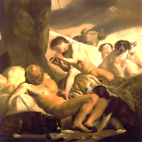
Slayer of Argos

Io: how Heaven’s Queen despised her!
Zeus was clever: he bovinized her.

So Hera must prevent, somehow,
This assignation with a cow.
She hires one Argus as a keeper
(No-Doze, friends call him, Never-Sleeper)—
Panoptic, that is, many-eyed,
Behind, in front and to the side.

Hermes (it’s true, he is God’s pimp)
Has found a way around this crimp
She puts in father Zeus’s plans:
He’ll send the rube into a trance.
He’ll flute a tune for Io’s guardian,
Something genial, almost Mozartean—
And not in a somniferous way, no,
More like a cheeky Papageno.
For Hermes is a virtuoso;
The monster’s taste is merely so-so.

How could he make sense of this light,
Off-hand manner, this bevy of bright
Blue notes that flutter past his ears
Like “angels smiling through their tears”?
The thrilling trills, the highs and lows
Of saltatory arpeggios…

What he can’t follow only stuns
Him; his eyes shut (not all at once,
More like a city blacking out)—
And to his great relief, no doubt:
The visible is his reality,
An ineluctable modality
That bores him, on a hundred screens,
With replays of the same old scenes.
His eyes cry out: We want to close!
He whistles softly through his nose.
Argus, it was not wise to drowse and
Curtain your thousand eyes to a thousand
Dangers—were you killed with one blow
Or many? See? You’ll never know.

Zeus rolls aside, exhausted, sated.
The look on Io’s face? Frustrated.
For passion dies in brief elation;
Music’s the only consummation.

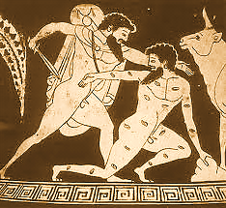
The Sicilian Expedition

Thucydides, The Peloponnesian War, 6

A minor god, despite my many aspects,
Essentially good-natured, almost more human
Than divine, and so I had a greater share
In the daily life of the people than the more austere
Or blustering deities, huge in their armor
Or unattainable in their sashed loveliness.

They evoked my name at crossroads—
All of these were haunted and accursed,
And I had power over the dead
Buried in wait there, in the motionless space
Where flows of traffic pass each other in their haste.

At the entrance to their houses they placed my bust
On a pedestal. I was the sentry, bluff and phallic.
I, and only I, blocked the approach of calamity.

And so it was more than untoward, it was an omen of disaster
When my images were smashed by unknown hands
On the eve of the Sicilian Expedition, as if to ensure
The beginning of the end of the Athenian Empire,
Greatness destroyed by demagogues in the name of that greatness.

And so, no minor god, after all, your friend Hermes,
But the most faithful and witty companion
Of the Athenians in the time of their ascendancy,
The first to feel the bitterness to come.

At war’s end, as the Spartans dismantled
The city walls, the work was accompanied
By the strains of my beloved instrument.
Citizens wept to hear—ghosting the curt percussion
Of hammer against stone—the music of flutes,
thin, cruel, hieratic, fit for a god’s departure.

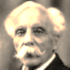
Fauré, Piano Trio in D Minor, Op. 120

What was it that made Nadia Boulanger so revere it,
this testament of his old age when he could barely hear
the lower octaves and notes sounded higher or lower
than they were?—
The Great War has come and gone,
a shabby peace is taking hold. Memories of la Belle Époque
and the lyrical follies of a long-gone youth
shimmer fitfully beneath dissonances that trouble
the surface of this music like acid algae blooms on a lily pond.

Especially the slow movement, the way it revisits
the early phase—the Berceuse, for example, that Proustian lullaby—
bitterly enriched now by a lifetime’s accumulation
of disappointments: the thought that his piano scores
had been used by his publisher’s wife to seal jars of preserves,
that the petty politics of running the Conservatoire
had cost him so many compositions—and, oh-so long ago,
how his Betrothed had broken the engagement and his heart.

He climbs a staircase of sequences with effortful steps,
at a gingerly pace, as to the top of some unfinished tower,
and from there he sees all of sad and lovely and vanishing
Paris spread out beneath him like a floating dream.
Rain is falling past the mansard roofs and gothic spires:
Is it France weeping, is it notes falling from their staves?
The rain, merely the rain, pouring through gutters and freshening,
awhile, the sewer water rushing through the Catacombs.

The Jupiter Symphony

The city had taken every civil defense precaution
but it remained vulnerable to the music of Mozart.
The Jupiter Symphony reduced it to rubble.
Beauty is brutal.

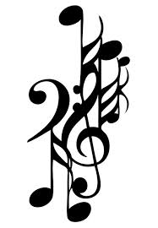
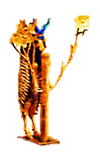
The Royal Cemetery at Ur

Root delicately into the pit. Work surgically with brush and trowel.
It is dense with the mothers-and-the-fathers-in-the-earth.
Help the earliness shed its tiers. Piece the tesserae, connect the bones.

Ur V.
Time of the lawgivers. It cost you five shekels to cut off a slave’s toe,
ten for an ear. A foreign power had carted off the word for canal.
Finally, the city was destroyed. Everywhere you looked you saw a canal.

Ur IV.
Pictographs were slowly leeching out their pictures. Colorful, specious
religions were founded on a dare. They worshipped a goddess on a hook,
a martyr of meat. They splashed temple walls with a riot of vulgar clay cones.

Ur III.
Words were images of the halos around things. An oafish barbarian
reigned for fifty years. A rebarbative prude, he outlawed the lovely
erotic cylinder seals and poisoned the city dreamworks.

Ur II.
Fall of the tree gods: Their forked feet had tasted too much death. The substance
of deity was wedged in the grain of things. A branch grew from the word branch.
Day and night, furtive priests were gnawing away at the oracles flourishing there.

Ur I.
End here, at the beginning, where they who have most to bear bear it most lightly.
They eat dates. Princesses marry gods and make love to captains, patriarchs walk
about in woolen skirts. The soul has a tree-roots-and-barley smell… Canals carve

through the tongue’s moist clay and out among the palm gardens, weeping for Puabi
in her mineral robe. Here is the Goat God! Here is the Harp with a Gold Bull’s Head!
Still in the hands of the one who sang and sings it all: the skeletal musician: the poet.

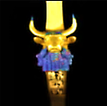
Words for a Song
Friends We Have Known

You think of them often
When you have the time
But too much has happened
Or you’re fresh out of dimes

Some of them wrote you
But you didn’t reply
And now it’s too late
To explain to them why

The ones who left town
The ones you’ve outgrown
The ones who have changed
And they won’t say hello

Here’s to the friends we have known

O they come and they go
Over the ocean, under a stone
They flew high they fell low
And let’s drink to the friends we have known

Some struck it rich
And some lost it all
Some just got busy
And no longer call

I mean Danny and Rosey
And Heather and Bill
Friends from the office
And wise guys like Phil

You married and moved
You stayed home alone
The war took your life
Or maybe you took your own

Here’s to the friends we have known

O they come and they go
Over the ocean, under a stone
They flew high they fell low
And let’s drink to the friends we have known

Here’s to the good times
The bad times, the bland
Your old high school sweetheart
And the guys in the band

We listened to records
That sang about love
And the things that get lost
When you have to grow up

The jokes that seem funny
Now strike you as sad
There’s pain in your heart
Where you ought to feel glad

When you think of the friends you once had

Mmm mmm they come and they go
Mmm mmm under a stone
Mmm mmm such jolly good fellows
And here’s to the friends we have known

Serenade

The full moon, and the werewolves roam.
The plague moon, and an empty town.
The sickle moon, to cut you down!
The no-moon, and a broken home.

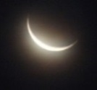
That sliver of silver is the new
Moon rocking in the cradle of
The old, whose dying mother-love
Is fading slowly out of view.

The cycles turn, the church-bells ring
The Harvest and the Hunter’s Hunger,
That always-older, ever-younger
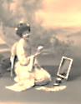
Diminish-and-crescendo thing.

There’s nothing new beneath the moon
Except the moon. Or, its reflection.
There are reversals of direction.
Fresh as a daisy or a tune

Recently minted, and as cheaply
Dear, as if from one’s wonted stall
In a suburban music hall
One loved the empty music deeply:

Such is the new moon soon-to-be!
So interesting to speculate
What figure’s humming by the gate
A Moon Song, in that foreign key?
Of Yum-Yum, or Rusalka?
Alas, we shall never know!

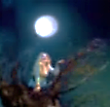

Marsyas

In a spasm of pique
She threw it away,
Minerva of the Many Counsels.

Not from a stag
Or a red-crowned crane:
From the shin-bones of a human
Knotted into the vessel of a tune.

It wasn’t the ligature
Or the strain on her lungs
That screwed her face up into shrewdness:

It was the song she could not abide,
The one she awakened where
It sheltered in the hollows of the flute
Like a sorrowing thing in a cave.

The destitution of that mortal song
Cries and is lavish on the ear,
Wave on a sea conch,
Spindrift, spendthrift, spent.

Ending, and empty at the center,
Resonating, for a while,
In the vice of space and time.

And the flute fell to Marsyas.

He was nosing the leaves for berries.

Cleft-foot demi-goat.
Little gamboling man.

And he brought to bear on the bones
His breath, and the history
Of his breath—a freight
Of dirty jokes and garlic smells.

The flute fell to Marsyas,
Whose death lay inside him
Like the core of a fruit
Forbidden to gods.

If Apollo pulled him from himself,
It was for the secret he hungered to know—

Where is it happening, the dying in you?
I want to taste it.

Where does it happen?

The self, a nesting doll,
Eludes itself. The outside
Is in the inmost room inside it.

Apollo ordered his skin pinned down.
Nailed to a tree like a flag.

And the god withdrew.

*

Out of the satyr’s bones
Make instruments to sing
In memory of those bones
When they could sing themselves
In flesh-tones, blithe in Arcadian woods;
And of the flighty breath
That fluted and fluttered there,
A little fluting in the air,
Once, on a summer’s day.

Listening to Ravel’s String Quartet in F
on a Sunday Afternoon

Shall we get out of bed, Dear?
We could venture
Out into the rain:
The streets are mirrors,
The leaves are red and gold.

But listen… Where
In the music is it falling
From, Love, this something
That is more like rain
Than rain itself?
As if Orpheus
Invented melancholy
So that we could hear it
And be happy, because
We are so perfectly sad.
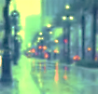

Head of Orpheus on the Water

Become the note you sing.

Echo of the rising waters.
How the sea’s premonition sounds.

Sing where you will be
with the voice of where you were.

Essential now,
teach the water what water is,
a rashness lost and retrieved
in the mirrors of its motion.

Your voice is a bodiless honey.
Afloat on a buoyancy that is not hope.

Become the river.
Relax into your delta flats,
work out your intricate metaphors
for a vastness that swallows all qualities.

After the final cadence
the song sleeps in the arms of singing
under the moon, O vocative O!

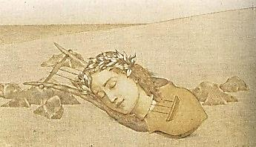
Credo

Things felt became my credo, not mere feeling. Rilke works as Rodin’s private secretary.
Look, always look… So I told Pain and Pleasure: New Poems. Later, the Sonnets to
Your destiny is buttress, vault and ceiling. Orpheus, a kind of palinode to these…
Squeeze into silence under massive pressure.

Spread through these stained-glass shapes, be the still bliss
In martyrs’ eyes when sunbeams bruise them; coil
Your tumult deep inside the wafer’s kiss,
The cool, chromatic sheen on chrism oil—

Fling yourself out now, in convulsive waves,
And find, in Orpheus, your mouth, your breath.
Float down the river of a song no staves

Can hold—be one whole note that rings through death
And grows so vast and palpable and round
Earth dwells entirely in that single sound.
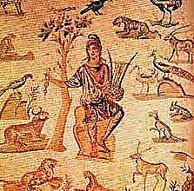
Two Stanzas

For the duration of two stanzas
They are doomed to live. A music hall,
A jaunty song, a curtain call,
The men and women clap their hands as

She curtsies, the applause dies, the crowd
Return to drinking—then, the gloom:
The chanteuse in her dressing room
Is weeping with her gold head bowed.
Words to a Song (II)
Holiday Inn
Seeking after that sweet golden climb
Where the traveler's journey is done.
[Jaunty major key:]

Holiday Inn is a great place to stay
Holiday Inn is just off the highway
Holiday Inn will make you feel OK
Holiday Inn is open 24 hours a day
Holiday Inn has a swimming pool
Holiday Inn will always keep you cool
Holiday Inn has a room for you
Holiday Inn's better than Howard Johnson's

Holiday Inn where the sheets are clean
Holiday Inn is like a traveler's dream
Holiday has excellent cuisine
And in addition, it has a really nice ice machine
[Melancholy interlude in a minor key]
But if you stay
Past check-out time
They'll make you pay
An extra $50 of more.
So you be sure
Check out before
A certain hour
It should be posted on your door
At Holiday Inn there's always free stationery
At Holiday Inn the toilets are sanitary
At Holiday Inn the rooms are bright and airy
And some locations have cable television

Holiday Inn in the middle of the night
Holiday Inn is like a shining light
Holiday Inn will always treat you right
Holiday Inn beats all the competition
Holiday Inn. A home away from home.
Holiday Inn. Complete with touchstone phone.
Holiday Inn. You'll never feel alone:
A Gideon Bible is in every room.
But if you stay
Past check-out time
They'll make you pay
An extra $50 of more.
So you be sure
Check out before
A certain hour
It should be posted on your door
[Instrumental break: melancholy saxophone solo. A quiet
sound of steady rain, windshield wipers whining, a car
honk, Doppler Effect glissando counterpointing saxophone riff.]
Visit our lounge, relax in elegant surroundings
Get into the sounds of groovy soft-rock bands
Wander around, and while the beat is pounding
Play video pinball with a Daiquiri in your hands
Holiday Inn has a Magic Finger bed
Put 50 cents in and it will help your head
Holiday Inn and you'll sleep like the dead
Holiday Inn's color-coordinated
Bring up a friend, you both can stay in a single
Ask the desk clerk and she will give you a ring
She will make sure you get up in the morning
Hasn't Holiday Inn thought of just about everything?
Holiday Inn is everywhere
The people are friendly and they really care
Holiday Inn has comfortable chairs
Holiday Inn. Be sure to bring a bottle of gin.

[Full choir:]
Holiday Inn
Bottle of gin
Holiday Inn
Bottle of gin
[Audience rises to their feet here:]
Hallelujah
Hallelujah
Honolulu

Blanch

It was the sort of night when the moon—Nature’s
disco ball, poets say—the sort of night when the moon
presides with scrutinizing cool over the hound dogs’
blurted odes, the splashy sizzle of krill on the surface
of the waves… It was a feverish Saturday night,
as I recall… The moon—let’s call her Blanch—had set
aside her patch of cloud and was giving the world
the once-over…
It was the midnight hour, when Wolf Boy
was most likely to be seen striking his contrapposto pose,
stylishly pointing up at that swollen yellow eye.
(The hispid sprezzatura of the way he fist-pumped
in the spotlight, strafed with silvery ghosts of bullets!)

Me? As usual in a downstage corner of the scene,
white-faced and wistful as Pierrot if he wore a leather jacket,
fingering my slim-necked electric mandolin, crooning
Blue Moon with a back-up band, my hair slicked back,
smooth-talking with a twang in a cheesy voice-over:
Nobody loves you like I do, little Queeny.
Nobody else knows how many moons you are.

But Blanch? She only cared for Wolfie and his sexy moves,
the hounds vociferating in the woods, the krill percolating
on the surface of the sea— and oh! the way that sexy Boy
of hers twirled, fist-pumped in an instant freeze-pose,
fist-pumped and twirled and stamped out the Fever Dance,
glowing in the ogle of that greedy yellow eye!

It was that sort of night, as I recall.

Venus in Rhinestones

I walk alone down Bitter Avenue.
I woke, and she was gone. I walk alone.
The Devil’s your friend till the bill falls due.
You pay for every pleasure you have known.
How long before the pavement’s overgrown
With weeds, guns crackle and rats run for cover?
In a bar somewhere in the red light zone
Venus is singing to her latest lover.

The dive’s bad breath, that’s the stale smell of brew. .
An ambulance keens by. Alley cats moan.
A hooker’s doing what a hooker do.
A stray dog snarls and bites his chicken bone.
Then there’s that clutch of paper cups, wind-blown
And scuffing past those shivering mugs that hover
In cubbyholes, and while the El-trains groan,
Venus is singing to her latest lover.

Pimp with right arm graced by a snake tattoo—
Finger fishing for change in a pay phone—
The moon, cheap earring moon, pinned to the blue
Bruise of the sky—three dusty pigeons, flown
To their roosts—shark collecting on a loan—
The dockside corpse those crazy bums discover:
All this, in the world’s weariest monotone,
Venus is singing to her latest lover.

Prince of this World, your heart is made of stone.
When the girl screams, it’s you who loom above her.
Put by your business, gather in your own:
Venus is singing to her latest lover.

Our Lady of the Lonely

Lie by the fire, Love: guide me into you.
Our bodies, at their animal devotions,
open their secret rooms, and love’s still there,
where we left it when we said good-bye this morning.
For this we thank Our Lady of the Lonely.
A muted trumpet solo haunts the speaker.
Cool sparks dance off a glimmer of rooftop jazz
Brooding over the city like the moon.
Lights quiver in the shadow of a blue note.
Tonight you are beautiful. Nothing else is certain.

It is the hour, O Lady of Consolations,
When hearts rise and demand their earthly share.
We’re small as children in each other’s arms.
Out in the streets, Love, it is shadow and wind.
On the windowpanes, moonlight melts into firelight.
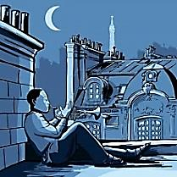
Lili Marleen

Through a barrage of jeers
the pretty German girl
sings in a quavering voice
a song
that slowly makes the grown men cry,
melting, for a moment’s truce,
the barbed-wire barricade
between two warring powers.
This is where Paths of Glory ends.

No, this is the final shot:
Kirk Douglas, the Colonel, walking away
haunted and alone
with what he has heard, and what he saw:
the senseless execution of his men.

Let’s never have another fight, my Love.

*
That other song, that icon of the ear,
words written in the Great War,
set to music in the sequel
and sung by Germans and Allies alike:
let’s scratch that platter
with a needle, dear, again.

Diastole and systole
the accordion compresses,
stretches, compresses
the squeeze-box of the heart.

There goes that little ghost of a march.
Lili Marleen—
the jaunty doomed refrain.

The voice of Marlene Dietrich
is worldly sorrow
following the tune to where it ends.

The tone arm lifts itself
from listening
like a salute.
With the stiff dutiful gesture
of a tomb-side sentry
it returns to the notch,
its resting place.

The Mädchen left behind
by wasted gallantry
is left behind again—
and so are we, with only
those interior echoes
that follow into silence
songs of love and war.

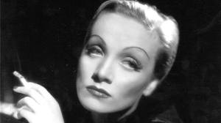
Hendrix Plays London
You’ll never hear surf music again.
—Third Stone from the Sun
Freaky distorted left-hand genius music:
This was the ecstasy of Something New.
I saw him play, this other-earthly mystic.
He pulled out an Old Glory hanky and blew
His nose: they cheered—the Union Jack made two.
The embassy we egged was Dad’s domain.—
But years pass, wars die, and as if on cue
I hear surf music. It’s the old refrain.

I search time’s rhymes, I run the old mnemonic
Until I reach the lonely name of Sue.
We snuck home, shared the hash pipe’s flimsy magic,
Made quiet love. What could my parents do
Next morning when they found us there, snafu
Of teenage nakedness, a small red stain
On the white sheets, your eyes, so wide and blue?
I hear surf music. It’s the old refrain.

The moon looked lost up there, eclipsed by manic
Soho light-shows. People we barely knew
Put blotters in our hands. Cut to mosaic
Mandala visions, soundtrack by the Who,
Where? When? Christ my g-g-generation grew
Repetitive. Demand put such a strain
On nickel and body bags. My mind’s askew,
I hear surf music. It’s the old refrain.

Prints of gone shoes fill when the tide rolls through,
And what it takes we’ll never see again.
Shsh. Listen, girl: you’ll hear me asking you
How did that song go, what’s the old refrain?

The Ancient Roadie

Fragmentary as a flashback, this view,
Through the tall grass, of a tour bus
Brown-spotted and spoiling like a lemon—
Eyes looking up through two cartoon china-man slits,

Mind blown by the sunset’s vast psychedelia:
Blue air bleeding out its shine in streaks of ruby.
Corrugated clouds rippling motionless,
Transverse. Tawny vapor trails—flake, fluke, freak.

A bass line like a black light set to music throbs
Between his stage-amp-deafened ears. Silvery
Jangles of rhythm guitar punctuate smoky vocals.
What band of spirits is this, shaking jagged hips?

Hendrix and Morrison, Joplin and Jones:
They’re showing off their beautiful young skeletons.
The sky’s alive with flickering Bic lights.
That aging groupie is the moon.

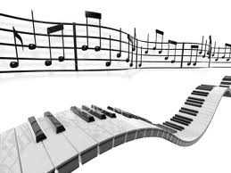
Words for a Song (III)
Down into the Valley

Down into the Valley did I go,
The Valley where the daisies never grow.

Down into the Valley did I go
Where trees are shadows and the cold winds blow.

Up into the mountains I climbed slow
Then down into the Valley did I go.

Up into the mountains I climbed high
But in the Valley I lay down to die.

I walked along the level ground for miles.
I went down on my knees and prayed awhile

Then down into the Valley did I go.
You will find me sleeping in the snow.

I thought I heard the Angel’s trumpet call.
Then down into the Valley did I fall.

I thought I heard the Angels singing loud.
Amen they said and wound me in a shroud.

Down into the Valley did I go.
I watched them bear my body, walking slow.

Down into the Valley did I go.
O mother in the ground they laid me low.

Oh up into the Heavens I was bound
Then step by step I climbed into the ground.

I could have sworn the Angels gave me wings.
And down I fell among the shady things.

I walked along the level ground and cried.
I laid me down upon the ground and died.

Oh down into the Valley did I go.
Down into the Valley did I go.
Down into the Valley did I go.

The Valley where the daisies never grow.
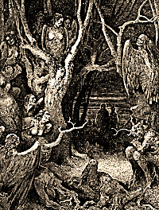
Raisin’ the Roof \ | /
-- Heaven --
/ | \

Jazz
On

stepping to

stones of
up
our wrong notes

we stumble

In the Forest of Listening

In the woods, in the forest of
Listening, fragile animals
Move. Can you hear their cries and calls?
They are the hymns of savage Love,

With obbligato of the humming-
Bird and the ponderous, heaving, grave
Sleep of the bear inside his cave,
And little feet on leaves snare-drumming.

The ear of which I am the listening
Is a deep wood of ancient trees.
Birds hop the branches. Moonbeams seize
On clutches of pale larvae, glistening.

Death is alive, and feeds on birds.
It crawls into their staring eyes
And feeds. The humming of the flies
Is a hymn, and I know the words.

*

I raise a temple in the ear
Where there was labyrinth. I found
The soul upon the crawling ground
Of what it moves beyond. I clear

A little clearing for the moon
To see alive the struggling wood
In motives snarled, and call it good,
Because it makes itself a tune.

This is the burden of the song
That is the poem ORPHEUS,
The poem of Orpheus. What it does
It is. In darkness it is strong.

Quieting the Eye

1.
Be blind awhile, and listen, dear.
Your eye has done you much offence.
Lay black crepe on the hungry lens.
Let Beauty enter through the ear.

Let the acrobats of vision rest,
No more upon the retinas
To dance their hand-stands for applause.
Let colour drain into the West.

The prism that has broken light
A million ways to feed your eyes
Let break, that all the hues may rise
Back to their Heaven vague and white.

Accept the music of what is
Into the blind and cradling ark
Of listening, where Truth is dark
And sheltered from all images.

The music feels its way along
The labyrinth. By feel it knows
The furniture of nerves, it goes
The spiral journey of all song

That wants to build into the joy
And soft explosion of its power
To make a blossom of an hour.
It is not still, and does not cloy.

2. Pythagorean Orpheus

Vision finds sanctuary in time made rhythm.
The auricular nerve vibrates in unison
With Orphic strains, and ear and harp are one.
The spark of joy leaps the synaptic schism.

He tunes the music on his giant harp
Of myriad strings, each string a particle
Or wave, on staves multidimensional.
In neutron flat or in electron sharp

Through the star-eaten body of the dark
The fugue of matter and energy pursues
Its trillion courses, bent to split and fuse
And split again to fractions of a quark.

The lowest octave of a stone he plays;
And in the sopranino heights of space
In fiercest notes, each with a Shiva-face,
The furious descant of the gamma rays…

Everywhere wave-functions decohere
Symphonically in whispering, roaring, sobbing:
Basso profundo of the black hole throbbing.
Flute notes that keep their distance, although near.

Our lives and deaths vibrate across the strings.
Pythagorean Orpheus orchestrates
The Vast from its minutest quantum states:
He is the infinite part-song that he sings.

The Music Ends

The music ends too soon so that the ear
May ring with wishing it would never cease.
We learn to love by losing what is dear.
Just when with parting we have made our peace
The music ends

In a smoke sharp enough to sting a tear.
Those Odes to Joy are Heaven on a lease.
The Timeless briefly hovered and was near.

Da capo, then, beloved Masterpiece,
The only opus that we ever hear!
A rosin cloud drifts over the high C’s:
The music ends.

Listen to the Mockingbird (III)

The cadenza that has no beginning

and reaches past its ending

as if it had no end

