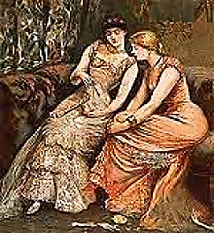
Iris of the Eye
(A Collabourative
Novella-in-Progress)
♫
Cyril and Vyvyan (in italics).

1. An Evening at the Baron’s

In Manchester’s Victoria Mills
The children slave, they learn no Latin.
But Iris, ah! she laughs in satin,
The curtains shudder to her trills.

Fine Japanese and Flemish prints
Hang on the Morris-papered wall.
A chair speaks to her soul with all
The flowery eloquence of chintz.

(As for Japan: it is a myth. See ‘The Decay of Lying’.—[Mr V]
There’s no such place. There are no such people.)
A smokestack is the Devil’s steeple.
The older man she’s flirting with

Notes her eyes noting someone younger
Whose wife notes this, and in a flounce
Exits the room, and in the towns
Of England, children sleep in hunger.

But in his country house, the Baron
Is giving a soirée. The poor
Factory children cross the moor,
Builders of wealth they have no share in.

Here is Clitandre, here Cecelia,
Here grave Diana. That pale, thin,
Aethereal vision is Gwendolyn.
And here comes sprightly young Coppelia,

The Princess of the Grand Ballet!
(A sorcerer’s handiwork, or daughter);
Ondine, who lures men to the water;
And Columbine, as fresh as May,

Who cuts Pierrot, for she would fain
Kiss Harlequin, the masked valet.
The Duchess brings her daughters: they
Are puritanical and plain.

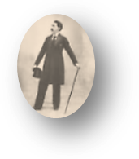
And many more that I could name
Grace with their company his house.
Slim, handsome dandies make their bows
With an arch smile, keen for the game.

Each youth, a worldly Parsifal,
Intends to yield to every charm
These Flower-Maidens wield: bare arm,
Flushed cheek, or silent Siren call
♫
Of parted lips that mouth a gasp.
If Ondine makes a pure fool of him,
Clitandre’s eyes hint she could love him.
But one flower is beyond his grasp:

Iris the Queen, whose charms bewilder an
Avid eye. And the feast, the glow
Of candelabras…! No, there are no
Such children, there are no such children!

Look on those braids of golden hair!
The beaux are whispering, ‘What a stunner!’
Who does not have designs upon her?
The power loom in the corner there

Is rather big to fit the space.
She’s no Penelope, though she
Plays the piano skillfully.
Ah, power looms in every place!

Into the night the guests carouse
In decorous patterns ‘neath a blaze
Of chandeliers, as the band plays
The Treues Liebes Herz of Strauss.

(The police have just seized the man
Who killed three pheasants in the woods
And almost made off with the goods
But they ran faster than he ran.)

2. The Anatomy of a Sphinx

Of all eyes cynosure, this Iris;
Her face turns every head her way—
To the chagrin of Amadée,
The tragic tribade. (To admire is

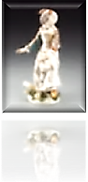
Exquisite, but, ah, to possess

Exceeds the powers of this grey-
Eyed Artemisian femme damnée,
♫
So she selects a watercress

Sandwich with a disconsolate moue.)
Iris moves past her in a shimmer
That changes as the lights grow dimmer
To a mirage of gold and blue.

But now the brittle windows tremble
In neurasthenic rhythm to
The coal train that comes rumbling through
The garden, where the flowers resemble

Their shades in Hades, they are so
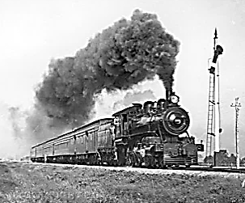
Black with the dust the iron beast scatters.
Iris is heedless of such matters.
Desire is her domain. The glow

Upon her silks blinds every eye
To the grim business without,
Though guests must strain to hear, and shout
To be heard over the shrill cry

Of the steel whistle as the steam-
Powered hulking demon shambles by.
But shimmering in her vibrancy
Is Iris, lambent and a-gleam,

A glow-worm in the hearts of men,
Bait to capture a lingering stare.
In the fireplace the embers glare
At her sullenly now and then.

Has Iris any depths to sound?
A Sphinx without a secret, she!
A superficiality
So pure it is, indeed, profound:

A lateral profundity
Of surface into surface woven,
Like the rich fabric her limbs move in,
Whose sheen a craftsman knows to be

The effect of empty spaces, ‘floats’
Where the threads do not interlace.
But ah, the glamour of that face
In whose eyes Aphrodite gloats
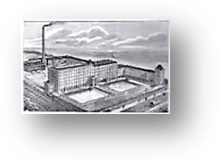
Is as a Symbol on which dotes
The weightiest mind in helpless wonder!
The urchin-children huddle under
The bridge. It’s cold. They have no coats.

(Not now! I’m working on my next
Novella, Iris of the Eye,
An iridescent fantasy.
Realist details would mar the text.)

3. An Unfortunate Incident

The older man, the Baron, is
Being questioned by two constables,
Causing cessation in the pulse
Of waltzing: something is amiss.

‘The poacher’s daughter, sir, has filed,
Sir, a complaint that you have, er,
Behaved indecently with her,
Used force, and she is now with child’.

That iron loom has spun the lord
A sticky web of legal troubles.
Dom Perignon expels his bubbles
As peu à peu, without a word,

The guests leave, singly or in pairs—
Except for two: for Amadée
Is wrapt in passionate Sapphic play
Sequestered in a room upstairs:

At last, her lovelorn heart’s desire is
Hers by a most perverse plot twist
I weave into the tale: a tryst
With aureate-haired and lustrous Iris!

How frail a thing is a good name!
The lady of the house walks in
Upon the couple whilst the sin
Is burning—burning now with shame!

Writ in the book of infamy,
Wide-eyed and scarlet-cheeked, with hands
Clapped to their mouths, they hold their stance
Like figures in a tapestry.
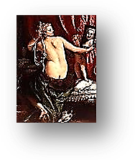
4. The Sequel:
Another Victim of the Labouchère Amendment

The Baron pays for wicked bliss
When others come forth with their tale.
Behold him in his cell in gaol,
With not a girl around to kiss.

And Iris? On her feet she lands,
Her small white feet, in Paris, an
Accomplished actress-courtesan
Who has them eating from her hands

Upon the boards, whereon she dies
In many rôles, and lives again,
Idol of women and of men
Who dream in French of those blue eyes.

5. The Moral

Of course, the moral of the fable’s—
Do what you will, not what you ought?
A child is to be loved, not bought.
Morality is a game of labels.
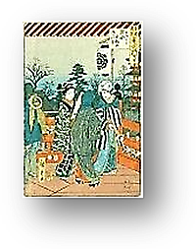
Iris in Paris
♫

Scene: cabaret somewhere in Montmartre. Iris and her lover perform on a revolving platform that wheels them
past successive instruments of execution and the interior of a galley-slave ship. ‘Iris’ is pronounced ‘ear-ease’.
She is the Sphinx, with a touch of Manon. But most of all her performance alludes to ‘la Comtesse’ Jeanne de
Saint-Rémy de Valois of the notorious Affair of the Necklace. (Jeanne de Valois was sentenced to prison but
escaped disguised a boy. In her absence, her husband was sent to the galleys for life. I play the husband.)

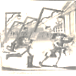
Justice, like love, alas, is blind.
I had such fun with you in Berne,
But now, my dear, à la lanterne! A street-lamp with noose attached.
Although my heart revolts, my mind

Believes in Violent Revolution.
Ah, what sweet moments to recall!
Darling, when up against the wall, The Communards’ Wall,
Be sure of my undying devotion. Pére Lachaise, May 28, 1871.

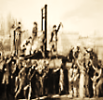
Sharp faction, and the worn-out tread
Of Fortune’s Wheel leave one in need.
‘Twas you or I. (How sad, to feed A guillotine.
The basket such a handsome head!)
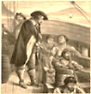
Sometimes Fate leads us into alleys
Shadowy: we must take our chances
Between the murderers and romancers.
For you, I fear, it is the galleys. Slave galley ship,
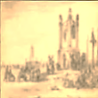
benches, oars, chains, etc.

Dear, never for a moment doubt
The pain it costs to watch you mount A gallows.
The scaffold! But a girl’s debts count,
And so I had to sell you out.

Ah, do not think I shall forget!
I loved you madly, darling—past words!
All I can give you is your last words,
A blindfold, and a cigarette.

What’s that? The word that rhymes with ‘rich’?
Oh how you wound me, dear! That curse,
You cruel man, hurts me far worse
Than it will hurt to watch you twitch.

Musical Program

Page 1
Poulenc, L’Invitation au château. Mouvement de valse. Oleg Gunko clarinet, Olena Kharambura violin and Olga Lysa piano.

Page 2
Ravel, Valses nobles et sentimentales. VII: Moins vif. Krystian Zimerman, piano.

Page 3

Johann Strauss, Jr., Die Fledermaus. Act II Ensemble (“Champagne Song”). Metropolitan Opera Orchestra, Adam Fischer, conductor.

Page 5

Ravel, La Valse. City of Birmingham Symphony Orchestra, Simon Rattle, conductor.

