* Caduceus *
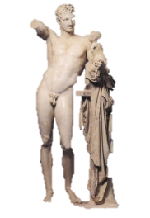

Poems for Hermes

Arthur Chapin

Muse, sing of Hermes, son of Zeus and Maia…
—Homeric Hymn IV

Mercuri, facunde nepos Atlantis…
—Horace

The sons of Hermes love to play
And only do their best when they
Are told they oughtn’t…
—Auden, Under Which Lyre

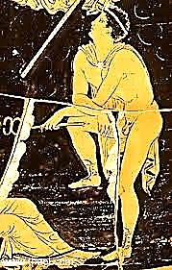
Table of Contents

FTD® 5
Kletic Inventory 6
Priority Mail 7
Hermetic Fib 8
Those Little Reversals 9
On Behalf of the Gods 10
Priam 11
Semele 12
Calypso 13
Caduceus 14
Theseus 15
Marketplace Oracle 16
Stealing Time 17
The Messenger 18
The New Elysian Fields 19
Instant Myth 21
Hermes Psychopompos 22
Orpheus Insufferable 23
Euryidice Incensed 24
Hermaphroditus 25
Orpheus in the City of Dis 26
The Orphan in the Dark 27
His Grand Recital on the Harp 28
The Song of Orpheus 30
Head of Orpheus on the Water 31
Daphne 32
Marsyas 33
The Fortunes of Phaëton 36
The Planet Mercury 38
Antique Mercury 39
Hg 40
Candygram 41
Dr. Hermes 42
Hermes Argeiphontes 43
Atlas 45
Proteus, Menelaus 48
Poem—Tmesis!—of Odysseus 49
Odysseus 50
Epyllia 51
Strange Gods
1. Ye Shall Have Other Gods Before Me 52
2. The God Who Was Bored 53
3. Heliogabalus 56
Hermes on a Plinth 59
Gnomics 65
Hermes Trismegistus 66
Liminalia 67
The Sicilian Expedition 69
Constellations 71
The Epilog 72

FTD®

Stealing through unsuspecting psyches—
This sprinter in wingèd Nikes—
This highly superior
Courier:

How does he carry with such rapid, airy
Gestures things so lapidary
Over this granite
Planet?

If he won’t sell the shoes (coquettish,
He’ll tease, Is that your fetish?)
The thing to get is his
Pètasus—

The woolen cap or doughboy helmet
(Oh-so hail-fellow-wèll-met!)—
And if you see his
Caduceus,

We’d like that too.—Look for an angle.—

Whatever you can’t wangle

From old Quicksilver
Pilfer.

Kletic Inventory
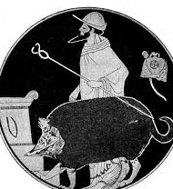
Thief-god, famous in hermeneutic circles,
Inventor of the lyre and father of liars,
Patron of gamblers, travelers, flash-powder miracles—
Smuggler-of-Priam past the Greek watch fires—

You with the mythic, mythopoeic look—
Startling, to see your lithe caduceus morph
Into a simple tool, the honest crook
With which you nudge us toward that Stygian wharf

Where Charon rubs three bony digits, frowning—
Conner of texts—wave-skimmer—angel and grifter—
Joke-god—god-in-the-back-of-the-room, class-clowning—

The crux of speech—crepuscular shape-shifter—

The writing and the poem and the reading—
The dreams of sleepers and the quick of metal—
A flowing into quivering solid beading—
Unsettling wherever you may settle—

Teacher—bamboozler—anything—nothing—mist—
Glib nephew of Atlas—Zeus’s hustler-and-bustler—
Concealer—Revealer—and—topping the list—
Poet. Musician. Magus. Cattle-rustler.

Priority Mail

Before the mind’s eye even opens,
Before the telegraph boys stir,
The sudden inkling Messenger
Brings you the news before it happens.

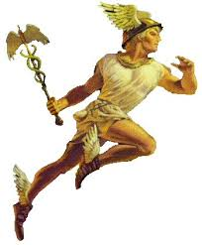
Hermetic Fib

I
Did
Not steal
Your cattle
Or your sheep, Phoebus.
I was at home with my mother.

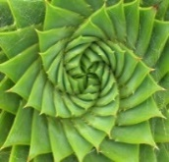
Those Little Reversals

As a baby I made the gods a fine burnt offering.
I wanted to play with fire; piety was my excuse.
I taught your cows to walk backwards, Phoebus. Why accuse
Me of stealing what I was just discreetly borrowing?

In brotherly blood feuds, prophecy foretells a rehearsal.
Atreus will be king when the sun sets in the east.
Zeus, at my urging, made that happen. Then came the feast…
To advance the plot of the play, introduce a reversal.

I went to the trouble of starting a war of immortal pathos
For gallantry’s sake: introducing three beautiful goddesses
To a handsome shepherd-prince named Paris… As odd as this
May seem, Eros is older than Death, loveless child of Night.

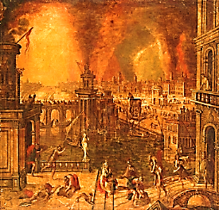
On Behalf of the Gods

Don’t shoot the messenger, I like to joke
When bringing bad news. You, of course, can’t hurt us—
You’re passing shadows, you go up in smoke.
(Whatever shall we do if you desert us?)

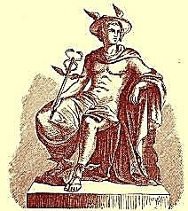
Priam
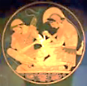
I came suddenly to Troy
and found him riding in a wagon
filled with ransom.
He was heading for the enemy’s camp
to beg the body of his son
from the man who had dragged it for hours through the dust.

It was nighttime when I appeared before him
in likeness of a young man with new-grown beard.

The Greeks not far in the distance
were rubbing their hands over watch fires.
I cloaked him in darkness
and no one saw us pass.

Priam clasped the knees
of his son’s astonished killer,
the hero, who uttered threatening words
at first, but finally saw, in the old man’s grief,
the image of his own—
and together they wept.

The body passed through the Scaean gates.
They performed the rightful obsequies
and the king bade his son farewell.
Hector, tamer of horses, burned on the pyre.
And it would not be long before his father joined him
in the place where the dead forget their dead.

Semele
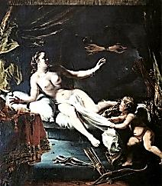
Ecstatically she burns alive.
Something survives
in the womb of the Thunderer’s thigh:
A fetal deity.

Expect blood-thrilling wine, the brandished

Thyrsis, anguished
intensities on crests and peaks—
dangerous secrets.

This One for whom the women burn—
Twice-Born
to spark violence of the senses
in the rites of dance:

Hermes presents him freshly swaddled
yo the stern god:
Father, from mortal Immortal rises:
It is Dionysus.

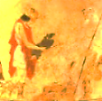
Calypso

Skimming the waves
light as a bird
in my golden sandles

A blur in the mirror
of the sea, I convey
the will of the gods

To Calypso on her island:
Must a goddess so lovely
stay here for ever lonely?—

His wife, his son his home.—
The message is: this will be torn
so that that may heal.

So I weave among you,
leaving each a piece
of Fate’s enormous news.

Caduceus

The kerykeion, or caduceus,
In ancient times was wielded by the herald
Ushering in the honey-tongued, fresh-faced drug
Rep from, say, far-flung Glaxos, neatly appareled,
With powdered horn from a young, lusty goat;
Or when, at the symposium, courteous
And tactful, he clinked on the libation jug
While the after-dinner speaker cleared his throat.
Theseus
Look closely at your thread,
Theseus: it, too, is a labyrinth.
Enter the Labyrinth once more:
Take up the thread, the rescue mission.
(Why would she let you lose your way?)
These torch-lit halls are echoing
With cries: follow the sounds to where
A carnivore with hornèd head

Lives at the center of the myth

By grazing on the virgin dead.

A swooping blade, a glassy stare:
You saved the young ones, hero! Bring
Them back into the light of day.
But the myth wills its repetition:
Enter the Labyrinth once more.

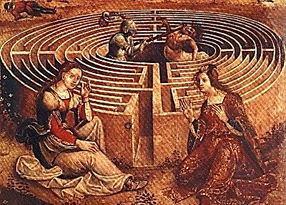
Marketplace Oracle
Only a single oracle is recorded for Hermes… The inquirer…
placed a coin in the right hand of the god; he then whispered his
question into the ear of the statue, and, stopping his own ears,
left the market place. The first sound he heard outside was an omen.
—Andrew Lang, Myth, Ritual and Religion

Words file across the architrave like stock quotes
On a Dow Jones TV crawl. PRACTICAL OMENS
FOR BUSY PEOPLE. BUY ONE, GET ONE FREE.
(So truth obeys economies of scale?)
You slip the god a drachma and some change.

Hands to your ears, arms bent like amphora handles,
You’re primed for wisdom now. You leave the temple,
You hurry past the stalls, the slaves decrying
The price of olives and libation bowls:
The Stoa shrinks behind you and is gone.

Two men walk by, austere, with chiseled features:
This must be Aristotle; that’s his mentor,
Plato. The former’s pointing to the earth,
The latter to the sky. Unstop your ears:
Buy low, says one. The other says, Sell high.

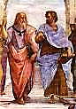
Stealing Time
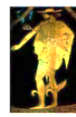
A watch falls to the sidewalk in slow motion. A shadow blurs by, palming the timepiece.

We were growing old. We would have grown older.

A lineman high up on a telephone pole looked down at the multicolored dogshit medallions on the pavement below. Dizziness orbited around his head in a cloud of blue gnats and he fell among those countries like Saturn overthrown.

On the other side of town, an angel with five-o’-clock shadow stood under a street lamp, wearing a trench coat and smoking a cigarette. He opened up his coat, revealing the hot gold Rolex.

I won it, he claimed, playing dice with the moon. He sold it to a passerby.

The divine disc of Aten paused in its revolution around the earth and the weatherman predicted nothing. For once, he got it right. The Rolex in the sky burned out like a Roman candle. Gone, too, was that fine confectionary dusting of stars. Our sleep was fitful in a night without end.

I awoke one Yankee morning with a hangover that consisted of a night sky lousy with stars and bars. They were made of gold, and falling.

They found the watch in a culvert and we were told that the angels had been dead for thousands of years.

A snooze-alarm clock’s tiny trumpet beeped. Sunrise occurred at 6:03 AM. The candy of the moon melted into daylight. We got dressed and hurried off to work.

The angel looked around him and moved on.

The Messenger

Long lateral shadow puppets stretch their weariness across the esplanade.

The Messenger blurs by.

Hourglass figures stand in studied attitudes of stillness. Inside them, sand is sifting down.
The bottom fills with too much time.

The Messenger looks at his watch, disappears.

City of chess pieces arrayed in a million opening gambits: in the blink of an eye

He weaves you your victories and defeats. Call it a draw.

There is only one cinema in town. It shows three movies, in the same order:
Morning’s Matinee. Le Jour du Jour. That mysterious film noir, The Night.

To the Messenger they are a single still.

Lovers, or shadows of lovers, are standing hand in hand beside the circular canal.

Where is the Messenger?

Ten minutes past de Chirico. In the moonlit piazza a child’s silhouette is motionlessly
playing hoop-and-stick. There are no months, only the moon.

The Messenger has come and gone.

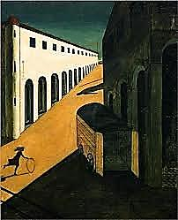
The New Elysian Fields
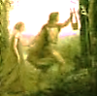
The first thing I did was to have
a billion cubic feet of blue sky
lowered into place over the construction site.

Crews with backhoes and steam shovels
installed the bosky groves and tinkling rills.
Mythoturf®, food-coloring green, poulticed
the muddy wounds in the ground.

Orpheus walked through on his way
to the Beautiful Failure, scattering
a few notes from his lyre like spare
change as he passed.

He understood that they were building the poem.
Temples and statues sprang up
where they sowed dragon teeth
like seed money for a college bookstore franchise.

Then they brought in the dead pagans.

Mighty Homer, crossing the field
with his seeing-eye dog.

(They lob Achilles a soft one or two
at batting practice. He manages
a weak pop fly.)

A slow wind-up, then:
HOMER HITS BATTER!
(Umpires are supposed
to be blind, not pitchers!)

That’s Aristotle, in a rare
first edition of himself,

There’s Plato looking spruce in a clean
white chiton (ideal wear for the weather,
set to Periclean Perma-Summer®).
For all eternity
they ambulate the colonnades
debating Free Will versus Fate
and the metaphysics of a place
that is only what I say it is.

Now and then they cross paths with
a couple of grounds-maintenance guys
talking baseball.
You calls it like you sees it.

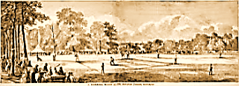

New Elysian Fields, Hoboken, NJ. Site of
the first professional baseball game, 1846.
Instant Myth

Running through the meadow
she startles a quickness
and in a lightning-strike

he staggers out of the cave
eyes black from the dazzle
of her vanishing.
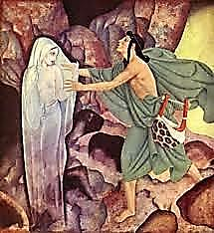
Hermes Psychopompos
Shepherd of the Dead

Cover her eyes. Steal past the dead—their souls
Are still awake—she must not see them—no,
Not yet… They are so weak, their shadows throw
Them on the walls, they have the eyes of moles.

Follow that winding strip—that frozen whirl—
Down to where magma forms a bubbling sod.
Let her trust gravity: it serves the god.
He dwells down there. That heavy heart… Poor girl.

Is that a faint voice echoing: Daughter, daughter!
And on her cheek she thinks she feels a breath.
Come, I will bathe you in the cool, still water.

It walks beside her now. And she is sad. Oh
Open her eyes, god, she must see the Shadow!
It reaches out for her. It is her death.

Orpheus Insufferable
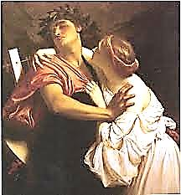
To Hermes Psychopompos

They’re breathless with excitement. I live up
To my distinguished reputation, filling
Their ears with melos, brimming each dry cup.
I am a touring star. I get billing.

One soft arpeggio: there they are, reliving
Trysts under willow trees in summer’s heat.
They weep, and (ah, the dead can be so giving!)
They lay flowers—wilted flowers—at my feet.

These are the scales I practice on the heart.
They rise to meet my songs like grass in meadows,
And I mow through them with a keen C sharp.

It is my Grand Recital on the Harp
That wins the prize: the Emperor of Shadows
Will pin her like a medal to my art.

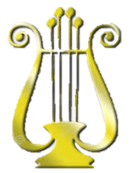
Eurydice Incensed

Having passed the shadowy audition with flying
Coloratura singing and eloquent harping
On themes so dear to the departed—Grieving
In springtime—Death on the eve of the white wedding—

Daguerreotypes of dazzled faces fading—giving
Them ears composed of nothing but their listening—

Leading me stumbling up a mineshaft twisting
Toward that pin-hole radiance thronged by the living,

You turn, and I am that startled vanishing
You needed to sculpt a frieze of pure departing—

A soft, defeated cry stonily dwindling

Into the tragic poem of your regretting
It wasn’t to see my face—Or to see me going—
Or gone—It was to turn—It was the turning:

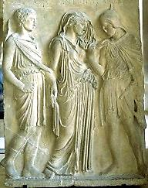
Hermaphroditus
Sacred child of Hermes and Aphrodite, half-siblings,
transformed by the nymph Salmacis into—well—a
hermaphrodite. (Sacred: set part, cursed or blessed.)
Sooner or later it was bound to happen.
She gets around, and so do I—and then some.
Olympic-class jock, agile, slim and handsome,
I’m on the track to get another lap in

(I’m a god when it comes to track-and-field)
When along comes Cheerleading-Pinup-Queen-
On-the-Half-Shell, Beauty-No-Sooner-Seen-
Than-Loved (under the grandstand, mist-concealed).

The child’s a boy, but incest is perverse:
He comes from swimming half-a-nymph one day,
Wrapped in a towel labeled His and Hers.

A marriage made in Heaven? In a way…
There is a better half who likes to say,
Count your blessings. The other tends to curse.
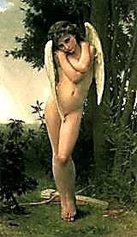
Orpheus in the City of Dis
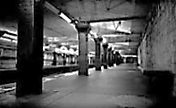
They’re waiting for you
wherever night vision’s poor:
swindles of perception,
optical disillusion.

Dis: city of deprivatives,
insults, assaults. A puncture
is worth a thousand words.
Retrofit your lyre with trigger and barrel.

Walk fast, shoulders
hunched looking crazy
and mean. Ignore the blurt
of a horn, the squealing wheels,

that gaseous burp wobbling
the manhole cover on
its rim, the down-and-outer
in a cubbyhole sucking

brain damage from a paper bag.
Glide along the wall
like moonlight. Easy.
Descend.

(Should you go back the way you came,
up the subway stairs?) Someone’s
stepping out of the shadows. Look!
She disappears.
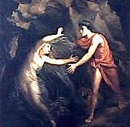
The Orphan in the Dark

Who am I? Open up the book.
I am the orphan in the dark
Lamenting, cupping my one spark.
How could I help but turn and look?

‘Eurydice’, breathes through the cave.
A whisper. A hiss. I grope my way
Back up into the light of day.
There, in the meadow, is her grave.

There, the immortal snake that bit her
Days, weeks, or was it years ago?
‘Eurydice’, whispers the low
Wind in the grass, so cool, so bitter.

I lay flowers on her grave, and then
I rest. I look up at the sky.
I sleep, till I hear the wind sigh:
“It is time to go down again.”
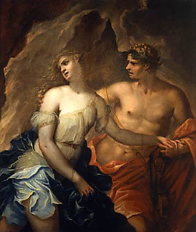
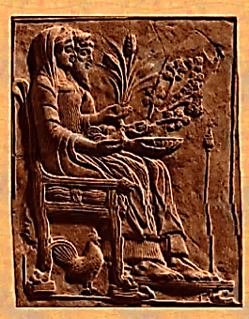
His Grand Recital on the Harp

It is your audience with the King.
No one alive has seen Hades
But you. Play him your melodies.
Let there be no more vanishing!

One long, thin finger seems to wear
A ring of smouldering almandine.
His crown is a penumbra. Fine
Bone-powder whitens his grey hair.

His throne? A sort of solid smoke.
And next him, Queen Persephone.
Her face is chiseled ebony.
She is wrapped in a shadow-cloak.

How shall your music charm this head
That is a pale cloud in the darkness
Around you? Glooms of rocky starkness
Speak Death. His ring glows Hell-fire red.

Evoke for him the Revelry,
The dancing of young, nimble feet,
A blue sky and the summer’s heat,
Cooled by soft breezes from the sea.

That glimmering figment of a head
Is bowed, and down it seems to sink
In thoughts it swore it would not think
Again. Memories of the dead
Meadows, green spots where once he dallied
With nymphs long-gone, the fountains muddy
Now… From the brown to the black study
His heart is moved. His face is pallid.

He would cry out, but, short of breath,
He wheezes as he grants the boon:
You, you will sing a different tune
To see her die another death.

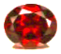
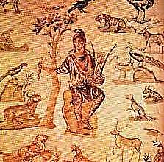
The Song of Orpheus

In the woods, in the forest of
My music, ancient animals
Breathe. I coax from their cries and calls
The hidden harmony I love:

The active quiet of bees humming,
The rest that is the heaving, grave
Sleep of the bear inside his cave,
Those little feet on leaves snare-drumming…
♫

These creatures, ignorant and strong:
I lure them from their shrieks and howls
Through measured consonants and vowels
Into the sacrament of song.

I build long staves across their listening
Haunted by owls that dream of trees
That dream of owls. I fill the breeze
With little eighth-notes, blackly glistening.

I make a clearing for the moon
To see alive the struggling wood
In motives snarled, and call it good,
Because it lives inside a tune.

They are still wild as wind and fire.
The fang gleams, and the eyes glow red.
But with my music they are fed.
They quiver when I touch my lyre.

Head of Orpheus on the Water

Become the note you sing.
Echo of the rising waters.
How the sea’s premonition sounds.

Sing where you will be
with the voice of where you were.

Essential now,
teach the water what water is,
a rashness lost and retrieved
in the mirrors of its motion.

Your voice, Love, is a bodiless honey.
Afloat on a buoyancy that is not hope.

Become the river.
Relax into your delta flats,
work out your intricate metaphors
for a vastness that swallows all qualities.

After the final cadence
your song will sleep in the arms of singing
and the moon’s over the ocean O!

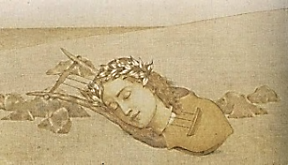
Daphne

How long was it secreted
in a soil of possibilities,
the evergreen germ
in you waiting darkly for its chance?

Is it worth the privilege of denial
when the neutral lodges in the grain,
surviving your flesh
like someone else’s bones?

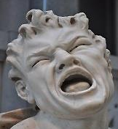
Marsyas

In a spasm of pique
she threw it away,
Minerva of the Many Counsels.

Not from a stag
or a red-crowned crane:
from the shin-bones of a human
knotted into a vessel for the voice.

It wasn’t the ligature
or the strain on her lungs
that screwed her face up into shrewdness.

It was the song she couldn’t abide,
the one she awakened where
It sheltered in the hollows
like a sorrowing thing in a cave.

The destitution of that mortal song
cries and is lavish in the ear,
wave on a sea conch,
spindrift, spendthrift, spent.

Ending, and empty at the center,
resonating, for a while,
in the vice of space and time.

And the flute fell to Marsyas.

He was nosing the leaves for berries.

Cleft-foot demi-goat.
Little gamboling man.

And he brought to bear on the bones
his breath, and the history
of his breath—a freight
of dirty jokes and garlic smells.

The flute fell to Marsyas,

whose death lay inside him
like the core of a fruit
forbidden to gods.
If Apollo pulled him from himself,
it was for the secret he hungered to know—
Where is it happening, the dying in you?
I want to taste it.

Where does it happen?

The secret of the nesting doll
eludes itself. The outside
is what you find in the inmost room.

They pinned his skin to a tree
like a flag.

And the god withdrew.
*

Out of the satyr’s bones
I make an instrument to sing
in memory of those bones
when they could sing themselves
in flesh-tones, blithe in Arcadian woods;
and of the flighty breath
that fluted and fluttered there
a little fluting in the air
once, on a summer’s day.

The Fortunes of Phaëton
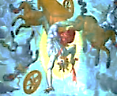
O reckless driver of the sun!
How doomed a joy-ride! What a scare
You gave policeman Zeus up there!
This sort of thing just isn’t done.

You cannot simply haul that star
Like a toy wagon on a string
Across the sky, you silly thing!
Driving so powerful a car

Without a license? By no means
Is such a thing permissible.
You will be held responsible,
Sir Phoebus. So your car careens,

Poor lad, knocking things over left
And right. Unwitting arsonist!
You leave in flames, at every twist
And turn, whole landscapes now bereft

Of vegetation; you break all
The traffic rules, and quite refuse
To yield the right-of-way—till Zeus
Steps in and shoots you down: you fall

To earth and land with a loud thud
Even the Underworld can feel;
You struggle to your feet, and reel
Round, and fall dead on the baked mud.
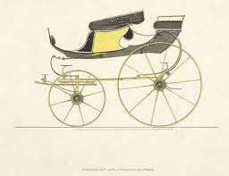
It’s nice to be an open-air
Carriage at times, though, isn’t it?
You ply no whip, you bite no bit:
The driver of the equine pair,

He is the one responsible,
In the law’s eyes, for accidents.
You merely take in the fine scents
Of spring, look spruce, respectable,

Clean, well-kept, elegant and dashing,
On a jaunt through St James’s Park—
And ah, the admiring looks you spark!
Yes, let the horses take the thrashing;

You bask in envy’s tribute-fee
The merely hansom and the trite
Hackney pay you to left and right
As you pass by them haughtily.

How neat a metamorphosis!
The passenger turned vehicle,
The driver, driven—and with skill!
Why didn’t Ovid think of this?

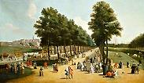
The Planet Mercury
♫

Spinning too close to the Lion’s muzzle—but don’t think
he circles frantically
Like a man engulfed in flames mouthing
the char of his flesh:

He holds himself to the fire and aloof from it,
Janus-faced martyr
To the shadow and the light. Reduced, unflinching,
he exists twice over,

Quickest to lead the Dervish dance of planets—
The Child-God owned
A pocketful of tops he twirled into the darkness
on a dare.

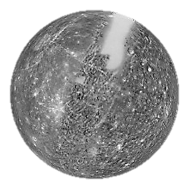
Antique Mercury

Plunging through midnight—
chopped and channeled
in its black glimmer-coat—

Passing scattergrams
of light scrambling
to connect themselves

Into hilltop cities
dangling
in the dark—

Tinted windows flashing back
these distractions—
mystifying the lookers-in:

Mercury…
No driver,
perhaps, but driven—

Always arriving at its motions—
bound for the furthest
point of departure—

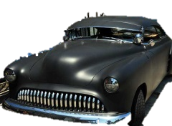
Hg
Hermaphrodite
of the periodic table,
fluent in solidity, cool
metal liquid beading
into silvery
monads in the palm
of your hand.

Rising in sunlight,
excitable blood in a glass
syringe, always
gauging, gauging.

Runner and industrial
run-off, poison
in the felt
hat of the Mad Hatter.

Circling the earth, high
on liquid fuel, paving
space to herald the escape
velocities of brother Apollo.

Shill for a flower.

The essence of these attributes
swirling like clouds
around the central Cloud
that eludes you
eludes you.

I am not I.
I am I’s.

Candygram

He looks so suave and personable
In wingtips, standing in the doorway,
Eyes slightly mischievous, but thoughtful.
Candygram, is all he says.
“What? No name, no return address?”
He shoots back (in a friendly way):
I just deliver—I don’t explain.

And you don’t ask him to. You take
The box, rake off the cellophane,
Lift up the lid, and have a look.
Spell them out: L-O-V-E,
Four letters stamped into the mystery
Of rich, dark chocolate. This is one
Sweet pound of tetragrammaton.
And the dense radiance is such
That you sit down and eat. Not much.

Worm-riddled clod gouged from a grave…
You fall with dreamy lack of haste
And land on a vast pillow of stone
Pock-marked and desolate as the moon.
Figures whiter than a snowdrift,
Souls love or money couldn’t save,
Mouth Eat, dear, offering bone paste.

Baking chocolate, what else?
He smirks as you exclaim: “Some gift!
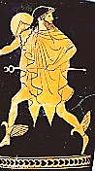
It’s Valentine’s, not April Fool’s.”
He laughs at this, and radiantly
Leaves you there, tears in your eyes:
Who could it be but Mercury,
God of messages, ghosts, and lies?

Dr. Hermes

None of this seems to bother you, somehow:
It’s so much easier than getting born.
Vague shapes, it’s true, are swirling down the hall.
Hunkering in his hearse, out in the night,
Charon is rudely honking on his horn.
That nurse with snaky ringlets looks a fright.

Ah, but you’re calm, and getting calmer now.
Like trampolines arranged to break a fall:
The sop-to-Cerberus, the prescription lotus,
The oxygen mask, for catching your last breath,
And Dr. Hermes there, to walk you through
The Great Transition: It comes over you
In such a gradual way, you hardly notice
The slightly chalky aftertaste of Death.

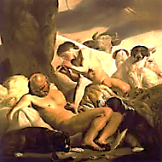
Hermes Argeiphontes
Slayer of Argus.

Io: how Heaven’s Queen despised her!
Zeus was clever: he bovinised her.

So Hera must prevent, somehow,
This assignation with a cow.
She hires one Argus as a keeper
(No-Doze, friends call him, Never-Sleeper):
He is panoptic, many-eyed,
Behind, in front and to the side.

But I, who am God’s trusty pimp,
Have found a way around this crimp
She puts in father Zeus’s plans:
I’ll send the beast into a trance.
I’ll flute a tune for Io’s guardian,
A presto, genial, Mozartean.

How grapple with a thing so light?
How can he see that bevy of bright
Grace notes that flutter past his ears
Like ‘angels smiling through their tears’?
The thrilling trills, the highs and lows
Of rippling arpeggios
Replace, as they dance all around,
Each mundane sight with heavenly sound.

Now bit by bit things disappear:
A thorn-bush there, two poplars here,
Like city street-lamps going out—
And to his great relief, no doubt:
The visible’s his one reality,
An ineluctable modality
That bores him, on a hundred screens,
With copies of quaint pastoral scenes.
It’s time, he yawns, these orbs to steep
In that sweet blindness they call sleep—
And into such deep slumber goes
He never feels the fatal blows.

Zeus rolls aside, exhausted, sated.
The look on Io’s face? Frustrated.
For passion dies in brief elation;
Music’s the only consummation.
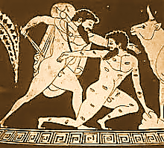
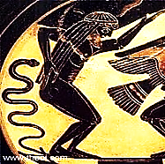
Atlas

A sturdy, simple stevedore
And caryatid, load-bearing column
Of sinew, his face rather solemn,
He has been eons at his chore,

Exerting stolid muscular force.
True, sometimes on him lands a boulder
And he must rub, on the sore shoulder,
(To do this he must first, of course,

Lay down his burden, carefully
And gingerly, upon a table)
Liniments from a jar whose label
Reads ‘AA Hyde & Company,

Spirits of Camphor (Mentholatum)’.
From time to time—for ‘tis no joke—
Heavy his burden feels, his yoke
Uneasy. The enormous Datum

That is the world in which we live
Can’t give itself: It is the gift
Of Atlas, Champion of Up-Lift.
Sometimes there is a bit of ‘give’,

Perhaps in time the Titan’s knees
Develop a tendency to wobble.
His grip grows weak, and should he bobble
That ball… Atlas, be careful, PLEASE!

And what if he should grow annoyed
With us? Though it is large and granite,
Couldn’t he just shot-put the planet
Into the interstellar void?

Dears, there’s no cause to be alarmed:
He is, in all, a rather gentle giant.
That’s not to say he is a mental giant,
However: more like a beast charmed

By its brute strength and ignorance
Till it believes itself a god.
He meddles, with his brain of sod,
In the greater God’s governance,

And with a porter’s sensibility
Re-stacks the goods of His Creation
In the absence of imagination
And theological credibility.

He upholds, not the world alone,
But all its worldliest views, as well,
The official story that we tell
Of sin, and the need to atone,

Till by a Whiggish, slow reform
Through proper channels, necessary
Evils are cured, by ordinary
Means rendering the Good the norm.

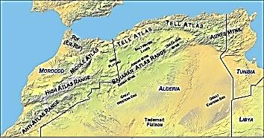
Oh what a grueling punishment
For mad rebellion against Zeus!
Your hunch is of so little use,
Huge Quasimodo, stooped and bent.

Earth is so heavy, weary Atlas!
Small wonder if you groan beneath
Her weight, and have to catch your breath
Sometimes: She is a very fat lass.

Imagine she’s a blue balloon,
And you must hold her lightness fast,
Lest off into the starry Vast
She float, just brushing past the moon.

♫
Proteus, Menelaus

Wing, claw, tooth, tusk… Sunlight will crystallize
That shimmer into a single shape, the real
God’s face. Pinned to himself, he will reveal
Meanings and answers, will be tame and wise.

This is why you have been condemned to roam
The seas: you have offended Zeus. The breach

Must heal. Perform the rites and you will reach
Your Spartan homeland, your Elysian home.

But in those plush Fields, safe from mortal storms,
The man stays tied to his identity:
Cuckolded Hero. Proteus, breaking free,
Escapes into the labyrinth of his forms.

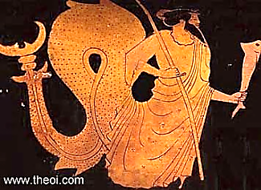

Poem—Tmesis!—of Ulysses

In sight of the belovèd shore,
Shouting for joy through spray and foam,
I, nearly—but for the wind!—home,
Am cast upon the deep once more.

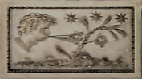

Odysseus

Restored to wife and hearth from years adrift,
You pledge another voyage for the gift.
The god you angered when you maimed his son
Decrees the trespass shall not be undone
Until you reach a distant country and—
Leaving your ship behind you on the sand,
Wagering your weary life far inland, where
No one has ever breathed the salted air—
Do, as the prophet bid you, one deed more,
Planting a lone, propitiating oar.
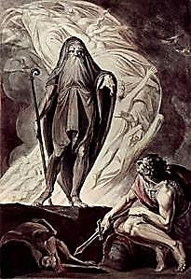
Epyllia

i.
Wrath of the hero
doomed Troy. Sing, Muse, how he cut
down the horse tamer.

ii.
Arms went with the man
from Troy to Carthage to Rome.
(Turnus: to Hades.)

iii.
Halfway through his life
he climbed up from Hell
to the beatific stars.

iv.
Of the mortal fruit
we tasted. Out of Eden
Michael showed the way.

v.
Pick through poets' bones
and find the same old story:
De te fibula.

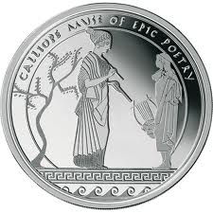
Strange Gods

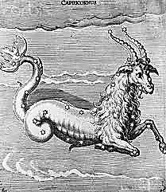
I. Ye Shall Have Other Gods Before Me

My god is not a jealous sort.
He knows the soul, how it will lust
For other, stranger gods. It must
Have its affairs, however short,

With those exotic Ones, queer fish
Of theological fantasia,
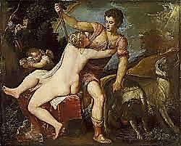
Goat-shaped, or blue, from pagan Asia,
Adonis-like as one could wish.

And when my god is introduced
To the most recent, does he thunder?
No, with sophisticated wonder
He looks him over, quite amused

By his pretensions, the assininity
Of his demand that I believe
His myth and affirm his naïve
Faith in himself. What crude divinity

Have you picked up this time? Did you
Find this one on a sacred mountain,
In an old temple, by a fountain?
He knows that none of them is true.

Your day has come and gone, Dagon.
Your oracles were hard to swallow
Even when the Sybil spoke, Apollo.
And Bacchus left me, for the dawn

Was grey, he found… It ends in boredom,
Like any too-extended tryst,
To be remembered, but not missed.
It fades, each flaming scarlet whoredom,

Into the ashes of such fire
As after sunset fadeth in
The west. Ah, the original sin
Is unoriginal desire,

The worship of a store-bought idol!
I tell him new apostasies
I have committed on my knees:
He only yawns at the recital.

He’s heard it all before, you see.
Do something harder to forgive.
Your treacheries grow repetitive.
You might as well believe in me.

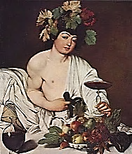

II. The God Who Was Bored

When there is little to amuse me
I am my own Scheherazade.
I dream up a nice, bored young god
Who tells his faithful, You confuse me
With your pedantic rituals
And laws. Do some extravagant thing,
Murder, love self-disfiguring,
Or your belief in me is false

And none will walk the clouds with me.
And then a trembling man came forth
Thousands of captives from the North
Leading in chains: All these for thee!

He cried. For thee I have betrayed
My people into slavery.
So much thou signifiest to me,
Great Lord! A maiden kneeled and made

Two rich red lines appear across
Her forearms with a silvery knife.
Thou knowst how much I loved my life.
The more mayst thou enjoy its loss,

This life sacred to thee, great Lord!
And a man turned lead into gold,
And willed it to the god, and sold
Himself for meat—the god was bored.

Salomé cried, before she had
Herself beheaded, Thou hast tasked me
For calling for John’s head, and asked me
For mine. In this thou mak’st me glad.

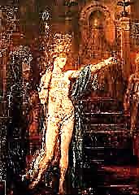
Would it were thou who held the sword!
The mystery of cruelty
Is greater than the mystery
Of love, even mine for thee, great Lord!

The sword struck, the head dropped. How greatly
She died, proud in her passionate madness!
But there was not a trace of sadness
In the god’s eyes, so desperately

Sated with stale self-sacrifices,
Those formulaic martyrdoms
Done to the thumping beat of drums
Borrowed from that gauche cult of Isis.

And then there rode by in a hansom
A well-dressed man, holding a cup.
The Dandy drawled, I give it up,
Lime tea, for one whole day, as ransom

For any languour, so to speak,
You’ve noted in my zeal for ‘thee.’
So many engagements, don’t you see.
I’ll drop a card on you next week.

Oh yes: ‘great Lord.’ The god was thrilled
At such extraordinary cheek:
He had him feted for a week--
And then, of course, he had him killed.

III. Heliogabalus
Assassinated at eighteen years of age.

A beast to Dio Cassius,
A monstrous mockery of Man
To Gibbon and Herodian:
Tremendous Heliogabalus!

He launched his scandalous reign and life
Outraging Roman piety,
Flouting Vestal virginity
By taking a priestess to wife.

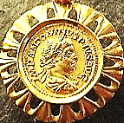
For feasts Rome had not seen his fellow.
Out of the palette of his moods
He chose the colour-schemes of foods:
Blue feasts gave way to green and yellow.

He is, when not yet seventeen,
Already married to a man,
A charioteer far handsomer than
His rivals. The Emperor is keen

As any debutante to dance
The High Priest’s Dance for Senators
Playing audience under threat of force:
He sways in a narcotic trance.

In smoothest silks of gold and blue
He shimmers as he minces. See
How the boy beckons teasingly
With a curled finger, peeping through

The doorway as the sun peeks over
The brightening shoulder of a mountain
Or eyes the glass beads in a fountain:
‘How you must pine to be my lover!’

The other ‘temple prostitutes’
And courtesans are common whores
Compared with him, who is, of course,
Ishtar, when sluttishly it suits

His Syrian soul, which corruscates
With exquisite corruptions of
Divine hermaphroditic love.
He even haunts the Janus gates

For pity, lavishing that love
On gruff Centurions passing by,
And coaxes many a shuddering sigh.
He dares to set himself above

The mortal run, even deprecate
The powers of Venus next to his.
On Hubris follows Nemesis.
O Sacred Beast, you know the fate

Of those in your…especial line:
The head from shoulders rudely rent
And down a river’s current sent,
Trailing a slick as red as wine.

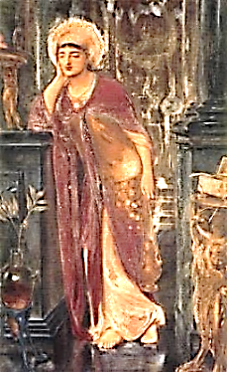

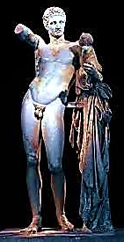
Hermes on a Plinth

Hermes Bearing the Infant
1. Dionysus, by Praxiteles.
Swift god, poised on your marble plinth,
I lose myself in you, and find
My selves, quick-changing masks of mind
In motion. You are my labyrinth.

Athena has her cult, but you,
Supreme god of the Hellenists,
Most raffiné of anarchists,
Have not received your proper due.

You are the master and the spark
Of Phoenix-fire inspiration
When image yields to Imagination
The Mysteries hidden in its ark.

To Ruskin you are the great Cloud In The Queen of the Air.
Shepherd who veils Athena’s sky,
Weans us from visibility
Till Death comes for us in a shroud.
You come to life, facunde
The truth of dreams, in their obscure nepos Atlantis! You speak!
Unsure allure, is my demesne,
A nether-kingdom, where, between
Two truths, the falser is the truer.

What, is the messenger a liar?
I am the bringer and the news
Of some fresh fable to peruse
In the Library of Desire.
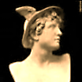
I am the electric currents thought
Is made of, their far-flung connexions
Flowering out in all directions.
I am the hand and the thing wrought.

How strange to have a mind so rich!
Your lightest jest is infinite;
You are, of course, the soul of wit,
And wit is like the lightning, which,

Writes your mercurial son, Shakespeare,
‘Doth cease to be / Ere one can say
“It lightens”.’ Unities defray
In you, and disparates cohere.

3.
No other god has quite my rare
Olympian temper. In me, Platonic
Ideas grow perverse, ironic,
Because I juggle them in air.

In me are truth and lie compounded.
Where I preside, one truth belies
Another, contradictories
Meet, and their play is free, unbounded.

A middle-class hallucination
Viewed from the suburbs of perspective,
What is the ‘real’ but a collective
Failure of the Imagination?

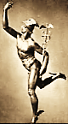
It is a myth composed of myths,
This everyday reality,
This politics, this history…
Over their shattered megaliths

You glide, swift as a skimming bird
Over the waters of a dream.
For things are neither as they seem
Nor otherwise. Then how absurd

To give such credence to the real!
It includes unreality.
To be, to seem to be, to be
Or not to be, fact or ideal:

In essence, are they not the same?
In your eyes, Hermes, it is so.
The truth of dreams is all we know,
Yet these still carry falsehood’s name.

I fly on moonlit wings, and see
The dawn before you mortals do.
From me comes Adam’s Dream—comes true,
And is a dream again, through me.

The soul of speed, you take brief rests
En route: these we call here and now.
Your dreams are real, but we are slow
To realise them, fell arrests

Of day fixate them in a pose
Of daydream, of mere fantasy,
Mystified by the sophistry
Of fact. But when the night draws close

Or leaves us, when crepuscular
Or pale auroral charms take hold
In opal or vermilion-gold
And every is is as it were,

Then we are in Hermetic space.—
Yet all that’s yours, you steal, sweet thief!
From every Book of Truth, a leaf,
From every pack of lies, the ace.

4.
Lend me the lightness of your wings,
Lord. Make my spirit bold and free
To outrace the perpetually
Receding earliness of things

Back to a time when time is not,
Or weighs as lightly on the bosom
As rose leaves, or an apple blossom,
Or is a dream, a passing thought,

Or is a youth himself: no scythe
In hand, no grizzled beard, no cowl.
A lyrebird is Athena’s owl,
And all is beautiful and blithe.

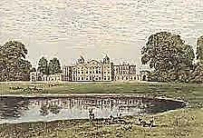
5.
There is a Country House on high.
A terrace gives on a trim lawn
And by the poplar stands a fawn.
Oh! Isn’t it a lovely Lie?

A boy named Time (blue is his eye)
Is lounging on that endless lawn.
He makes the gestures of a yawn.
‘Oh isn’t it a lovely Lie?’

The lie of this green land we live in
Is fashioned from Time’s timeless dream
Beside the Heraclitean stream;
A lie we live so well even Heaven

Believes it, and consents to be
That Country House wherein we say
The perfect lines to keep the play
That briskly-moving, buoyantly,

Charmingly and amazingly
Droll and sensational premiere
Performance of itself poor, dear
Reality’s too dull to be.—

But these are moments, moments only.
Time, with his pale blue eyes, reminds
Us he is Eden’s whore, who finds
Us fools, and leaves us poor and lonely.

6.
When I let fall an idle wing,
Looking around; when I stand still
Mid-errand, and from a high hill
Admire a meadow and a spring,

A vine-clad cave, a shady grove:
In that so-brief repose you have
Your being. But ah, the wings wave,
The moment’s gone, I’m on the move!

IMPULSE is my primordial name:
‘Make love to me!’ The shepherd’s prod.
Perhaps the ‘fiat lux’ of God?
‘Die, Love!’ quicker than fear or shame.

Now I must drive you far beneath
The earth, with my compulsive crook,
Down to where you at last shall look
Upon the faceless face of death.

Gnomics

1.
The rod that ripples is a serpent
That straightens and becomes a rod.
Moses relinquishes to Aaron
The voice that spoke with living God.

2.
Tiresias walking in the forest
With a stick parted snake from snake.

From man, a woman. From a woman
The Man who died for living’s sake.

3.
Brother Apollo gives to Hermes
The double helix and the staff.
Goddess with god engenders gender
Whose self will not be cut in half.

4.
In a secret woodland clearing
Lives the pristine androgyne
Whose wand is trance and transformation,
Quick branch, bright candle and a sign.

Hermes Trismegistus
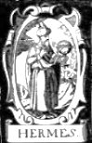
Magus

The dream of the alchemist
is an ache in the mist.
The corruptible sorcerer
errs to the core,
Hears a babble of bells
when he summons music
with his spells.

The golden affinities lie
in mineral oblivion.
*
Inside the changeling
was an angel.
He lived to word
the world.
With a wave of his wand
he assembled dawn.
As soon as he saw
what he was
He wasn’t.
He only wants.
*
God into goddess
goes. She gets with child.
It lies mute, in a trance,
almost-transmuted
Substance, no sex,
too many sexes: useless excess.
No place for the atavist
from Plato’s primal race:
Hermaphrodite,
living epitaph!
The phallus
erects its obelisk.
The vagina
is a grave.

Liminalia
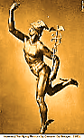
The compass needle trembles. He who is lost
Hesitates. You will meet me at the crossroads.

Sorceries of twilight—hourglass granulating,
Sand melting into glass: these are mine.

I read my hoard of secret spells by the stars’ pin-light.
Before Dawn comes to you, she comes to me.

I diced with the moon and won you extra time
To admire the Eternal before you disappear.

I lead you to the less-than-real-abode,
The placeless place. I traffic in your vanishings.

I am the quick of lightning and a thought.
What you call now and here: my little rests.

I take messages from near to far so fast
I confuse Space. Distance thinks it is here.

The Real? Look for it at the edge of a far shimmering.
There I have set my boundary stone.

That city you saw in the desert: a mirage?
Perhaps it is the desert that isn’t there.

The tree bursts into itself, blazing like a vision.
It has swallowed the soma of your gaze.

The table of square roots and to dream of a card trick:
I lay them impartially before you.

Take these things into evidence.
Hold them up to the radiance you see by.

You, too, were entered into evidence
When you entered the radiance.
The Sicilian Expedition
Thucydides, The Peloponnesian War, 6

A minor god, despite your many aspects,
Essentially good-natured, almost more human
Than divine, and so you had a greater share
In the daily life of the people than the more austere
Or blustering deities, huge in their armor
Or unattainable in their sashed loveliness.

They evoked your name at crossroads—
All of them so haunted, so accursed,
And you had power over the dead
Buried in wait there, in the motionless space
Where flows of traffic pass each other in their haste.

At the entrance to their houses they placed you
On a pedestal. You were the sentry, bluff and phallic,
Cock-blocker of calamity’s approach.

And so it was more than untoward, it was an omen of disaster
When your images were smashed by unknown hands
On the eve of the Sicilian Expedition, as if to ensure
The beginning of the end of the Athenian Empire,
Greatness destroyed by demagogues in the name of that greatness.

And so, no minor god, after all, great Hermes,
But the most faithful and witty companion
Of the Athenians in the time of their ascendancy,
The first to feel the bitterness to come.

At war’s end, as the Spartans dismantled
The city walls, the work was accompanied
By the strains of your beloved instrument.
Citizens wept to hear—ghosting the curt percussion
Of hammer against stone—the sound of flutes playing
Thin, cruel, hieratic music, suitable for a god’s departure.
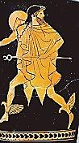
Constellations

Hermes guides us through the last Duino Elegy.
* * *
Even the constellations deceive. —Sonnets to Orpheus

Beyond the shooting galleries, the shrill laugh,
The gaudy prizes winking from the shelves,
I am that shadowy figure with the staff.
Follow me to the outposts of yourselves.

Above the mist’s rippling handkerchief—
That warm, wept stream—those flocks of sorrow, bleating
Quietly in the dark—stand on this cliff:
Watch as they take their shapes for one last meeting.

You raised them over you on cold, clear nights,
Cast over space a skeletal poetry.
Ah, but the space: it grows and grows. Orion

The Hunter and his glittering prey, the Lion:
Drifting apart now—tattered little kites—
Shedding their names… Irrevocable… Free.
\

*

The

Epilog

Spoken by

Great Hermes *

Lords and Ladies

Fresh out of Hades

Go put on your gayiades

Beneath the cool Playiades *

We lay down our bony burden

Leave things as found profound uncertain

Your good words our only guerdon

Good readers gently draw the curtain *

