* Fabulous Beasts *

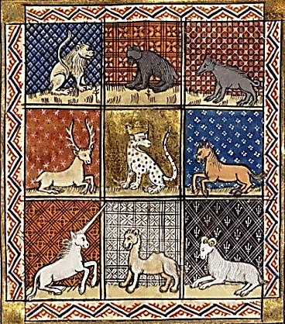

Arthur Chapin

Table of Contents

The Tufted Puffin 4
Chicken 6
The Antidote to Moles 7
Woodchuck 8
Rats in the Attic Library 10
Maxims and Reflections of La Poochefoucauld 12
Small Threnody 14
Minuscule Elegy 16
Cortège 17
Monster Movie 20
King Rex the Tyrant 22
David Graybeard and the Kerosene Cans 25
The Ancient Origins of Erotic Art 27
Happy Dancer 28
Golden Retriever on a Sunday Morning 29

Zephyr

Grand Entrance 32
Personality Profile 33
Genealogy 34
New England Gnomics 35
In Catilinam 36
Empty Bowl 37
Conscientious Engineer 38
Poem: Her Tongue, How It Sticks Out 39
Skeletonics 40
Nine Life Slices 42
Triolets from the Garden of Zephyr
1. Butterfly 44
2. Mockingbird 45
3. Catnip Patch 46
4. Waldo and Michel 47
Scratching Post 48
Cuisine Beguine 49
Gardening Tip 50
Leave Me Alone 51
Will and Testament 52
Where Do Good Cats Go? 54

As the Crow Flies 56

The Tufted Puffin

A tufted puffin, on the Island of Baffin,
Once saw a man eating a toasted muffin.
“How strange,” thought the puffin, “to see a man
Eat a toasted muffin on the Island of Baffin!”

But friends! That timorous tufted puffin
Was hungry, and desired that muffin.
And so, with a tentative, worried look
(The customary look of the tufted puffin),

He slowly approaches the man with the muffin.
(A tufted puffin, you see, doesn’t often
Encounter a muffin or a man.)
“Please, sir,” he asks, shyly eyeing the muffin,

“I know I’m…just a…tufted…puffin,
But might I have some toasted…muffin?
“Some toasted muffin, did you say?”
Blusters the man. “You’re a tufted puffin!

“What? Give you a piece of toasted muffin?
I’d just as soon dine on roasted puffin!”
He thunders, and frightens the bashful bird,
Who wishes he’d never set eyes on that muffin,

Toasted or cold. He goes fluttering off in
A sputtering funk, the poor flustered puffin,
Off from his perch on Baffin Rock
(A place to which puffins repair rather often),

And now he is far out at sea, out at sea!
Where the wind-battered waves toss furiously.
Ah! Pity that ruffled, buffeted puffin,
Lashed by the wind and the spray of the sea!

“I wish I had never laid eyes on that muffin!
I’d be back on my perch, where a tufted puffin
Belongs, somewhat hungry, it’s true, but safe
And dry—though bereft, indeed, of a muffin,

Toasted or cold. It’s unlikely to soften,
The heart of that hard-hearted man with the muffin.
I suspect it’s as hard as Baffin Rock,
Which water and wind will never soften.

But wait! After all, I’m a TUFTED PUFFIN,
With a gullet to cram fish and other foodstuff in,
And wings as well. Suppose I just
Swoop down on the man, like a dive-bombing puffin,

And simply make off with that toasted muffin?”
Which he did.—And the man, who had more than enough in
His two hands to feed both himself and the puffin,
Ended up with—and this is the moral—…nuffin.

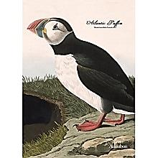
Chicken

Scratching the ground
As if earth had an itch,
With gallinaceous twitch
It bickers around

Its feeding place—
So busy, not in the least
Like those great birds who feast
On gulps of space.

Ah! What memorial
Save yolk on a dish
Or two halves of a wish
For the rasorial?

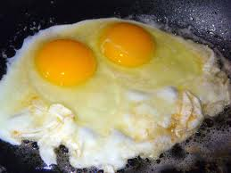
The Antidote to Moles

The antidote to moles
Consists of dropping down their holes
Thick tufts of human hair
(It acts like itching powder there),
Some castor oil (the stuff will stick
To fur in a thick, stubborn slick),
And, finally, if these measures fail,
A seven-week-old gilded stale
Of human urine. The mole’s mate
Will kick him out. Henceforth his fate
Will be to writhe in dirt, scratching
At skin that won’t stop itching,
Digging out blood that will refuse
To clot, mingled with oily ooze—
Thus he’ll go slickly, itchily slinking
Off to die somewhere, blind, unloved, and stinking.
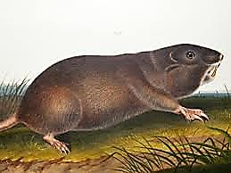

Woodchuck

Nietzsche the gardener says,
An estimable enemy
Returns your gaze.

If I must have a foe,
Let it be an Über-Rodent
Or Overcrow.

A certain foe of mine
Subverts my plot—an undermining
Catiline,

A groundhog none can kill.
Smoke bombs and poison pellets only
Inflame his Will.

And if I quarantine
Inside a chicken-wire cage
My leafy green,

He sizes up the hoard,
Pops up from underneath and drags
The smorgasbord

Down through an earthen drain.
What stratagem could stump his extra-
Moral brain?

I try hard to destroy you,
But only make you stronger, chuck—
Or merely annoy you.
In such an enemy
I can take pride. (I think I’ve seen you
Climb a tree.)

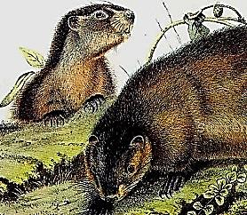
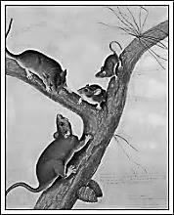
Rats in the Attic Library

The Books:
Formidable defences were placed
at their disposal. This bookcase
was their ark, their aron kodesh. אהרן קודאש
Mesh wire flourishing along the shelves.
Bait traps, poison-packets littering the floor.
What an education for the rats to negotiate
so many prohibitions and incitements…
The branches of learning.

The Rats:
If they could put their struggle into words
they might write poems about how hard
it is to get at the Essential. They’re hungry
for the glue that holds the things together.

We have more need of it
Than they. That is why
It is ours.

The loftiest shelves were the greatest challenge,
but they mastered the lie of the levels, reduced
the infrastructure of the Beautiful and True
to the elements of an intramural agronomy.
One could picture little cities with their temples
springing up from this sophisticated economy.

Survival is subversion
Eating away
The Monument of Famine.

* * *

The books are part of the rats.
What the rats did to the books
is part of the books.

What do we gnaw?

The Tanakh, split into two roughly
equal fractions of Testament:
Samson-work of many teeth.

mettame et ha-Yadayim.
מאטאם שעון מזרחי יאדאיים Tannaitic literature employs the phrase mettame et ha-Yadayim (‘rendering the hands unclean’) to convey what is commonly understood by ‘canonical’. According to rabbinic enactment, hands that came into direct contact with any biblical book contracted uncleanness in the second degree, so that without prior ritual washing
they rendered it unfit for priestly use (Kelim 15:6; Yad. 3:2; 4:6). Whatever the true origin and purpose of this legislation (Yad. 3:3–5; Tosef., Yad. 2:19; Shab. 13b–14a; TJ, Shab. 1:6, 3c), the effect was to make the phrase ‘rendering the hands unclean’ synonymous with canonical.
Even a fractured Canon
can dirty the hands.

*

Fragments of the Fragments of Heraclitus…

*

Goethe is partially devoured.

*

What have they done to The Rat Man?

*

Food for thought.

Food.
‘If the Book is merely tasted, it is
nothing. But if the Book is swallowed,
it has been accorded the status of food.
This is the principle of ach’shevei.’
—Rashi (93a, DH Mipnei
she'Yecholah)

*

Is their gnawing
a kind of knowing?

The scrolls are in our bellies
And the taste is sweet.

* * *

My share increased in dispossession:

Religion [of what] remains
[when everything has
been taken
away].

*
Maxims and Reflections of La Poochefoucauld

In the misfortunes of our dearest masters there is something that does not
displease us.
*
First one dog barks, then another, and soon the entire neighborhood resounds
to a cacophonous chorus. The polite phrase for this? “Public opinion.”
*
Salivation History.—What is this thing the chien moyen sensuel so piously
honours with the name “religion”? A conditioned response to the ringing of a bell.
*
Xenophanes, you were right. God is only the mirror image of Dog. Even His priests
wear collars.
*
The Cynic’s Riposte.—Plato: “Somewhere in the Eternal Realms is the perfect Idea
of Bone.”—Diogenes: “No doubt. And the Platonic Idea of Mange.”
*
Language is is an unruly kennel: the words never quite get used to each other’s sense.
*
The Enlightenment.—Once we barked at the moon; now we bark at the sun.
*
Go on with your circular quest till you bite your own tail, continue till you
swallow yourself entire! At least you will never be hungry again.
*
Whatever can be gummed does not deserve to be eaten.
*
Bone-Burying.—If for once we understood why we bury them, perhaps we would
remember where.
*
Bone is two things: food and toy. And yet a third: private property.
The origins of culture and society.

“Even a stray dog finds a bone to crunch,” reads the ancient proverb. Then why do
our philosophers never get it right?
*
Clearly, whoever still uses the phrase “the marrow of the matter” has never
chewed on a rubber bone.

My critics complain: “His aphorisms are mere word-play, with no relation to reality.” Wasn't it Heraclitus who said, “Dogs always bark at what they do not recognize”?
*
Bedouin dogs have a saying: “You might as well bury your bones in the shifting sand.”
*
Wisdom is easily identified: it is always that voice barking in the wilderness.
*
Vanity, vanity, all is—squirrel!
*

small threnody

i.
the cockroach came in search of food
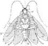
& found his fate instead
began deadset on getting fed
& ended simply dead
the looter of the cupboard shelf
became the reaper’s pelf
and rummaging through scraps of trash
became the trash itself
for humankind’s immortal grudge
reduced him to a smudge
the best of us but leave behind
a brittle chitinous rind

the roach is dead besmutched with gore
we shall not see his like again
for seconds minutes maybemore
now let the threnody begin

oh carried in a little bin
he sleeps among the coffee grounds
nor hears the shrieks & keening sounds
of all his mournful cockroach kin
the cries are loud the tears are many
beating of thorax torn antennae

ii.
the roach is dead but should we care
three more just crawled across the chair
the roach is a generic creature
devoid of individual feature
who could parse such faceless vermin
into a sam a sue a herman
not i for one in fact the chances
are that only a st francis
could find it in his heart to loveall
creeping things that grope and grovel
& could the gentleman from assisi
preach to roach and not feel queasy

the roach has reached the other shore
we shall not look on such a one
for seconds minutes maybemore
now let the obsequies be done

oh bear him in his little bin
he sleeps among the coffee grounds
nor hears the shrieks & keening sounds
of all his mournful cockroach kin
the cries are loud the tears are many
beware o humans left if any

Minuscule Elegy
For the Fallen Ants

i.
For those who swarmed to form a living bridge
And, as their comrades crossed the raging streamlet,
Fell
Into its current and were muscled
Along toward a hapless doom:
May these few words, too small to drape the grandeur
Of such a selfless deed, stand sign and sigil
For these honored dead.

ii.
For those who, foremost of the swart phalange
In toil and formication of pitched battle,
Fell
To pinches of an armoured foeman,
Leaving their brittle dolmens there:
May these slight and unworthy verses poultice
The piercèd thorax with a hymn of glory,
Pledge of deathless praise.
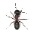
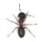

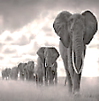
Cortège

I.

Tome Tome TOME TOME, the footnotes pound

Into the impressionable GRound.

The earth booms like a kettledrum

As on, with stately stomp, they come.

Balanced, with sombre steps and slow,

Between procession and tableau,

They Move their bodies’ ponderous cargo

At a deliberative largo,

Whilst raising to the blood-red sun

A valedictory orison,

Blaring, through pairs of ivory commas,

Their morituri salutamus.

While in the trees the grave macaques

Sit quiet as books arranged in stacks,

They trudge with stiff arthritic pain

Across a yellowing parchment plain

Toward the place that is, for them,

Definitive terminus ad quem.

II.

As in their solemn ranks they pass,

Flattening the savannah grass;

As lingering truancies of day

Slink off before the encroaching grAy,

The moon, in gown of borrowed light,

Decrees a pause from fight-or-flight

Down from her little podium hill,

Shushing her creatures to be still

With ghostly finger at her lips.
Now the tentative little sips
Of svelte gazelles cease in the sedge
That rims the shrinking water’s edge.
Turtles withdraw into their shells
To meditate like monks in cells.
The riddle of the female penis
Puzzles the minds of the hyenas.
Baobabs, with their crazy-angled
Limbs and branches, appear entangled
In radical reassessments. Lions
Ponder their sanguinary science:
‘Ah! Is this life, or mere existence,
Chasing zebras into the distance?’

III.
Having transfixed her silly broods
In taxidermic attitudes,
The moon retires to write her memoirs.—
But who could count the many grim wars
She has witnessed? She could spend ages
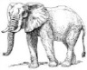
Blackening all those pallid pages
Her chronically memorious Muse
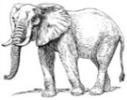
Must ask Methuselah to peruse.

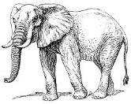
and yet she has her helpful scholars.
(Call them inveterate recallers.)
Nothing about their gait seems hurried,
Nothing triumphal, nothing worried,
Much that’s greatly resigned. (Can Fate
Arrive too early or too late?)

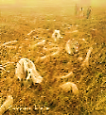
The place they reach—where mountains topple—is
The graveyard (or, in Greek, νέκροπολις)
Where they lie down with grateful groans
On an ancestral bed of bones.

IV.
Distinguished moon, be kind, upraise them!
Don’t let the scholiast worms deface them.
(Remember how they sat all night
Beneath your papery slips of light
In baggy, wrinkled coats, and wept
Over your works, when jackals slept?)
Set them among the beasts that track
Their prey across the Zodiac,
To qualify their savage frisks
With little silvery asterisks. *
Grant them this high sabbatical *
Until your last, pale page is full *
Of darkness; till in the sublime *
And cavernous Study Hall of Time * *
The Ancient of Days lays down his head * *
And sleeps, and snores, to wake the dead. *

Monster Movie

Wolfman and Dracula,
The Mummy and the Fly
Are playing poker on an oil drum
In a warehouse on the sly.

There’s just one naked light bulb,
It dangles from a string
Like a killer in a noose the night
They hang him at Sing-Sing.

“Where’s Frankenstein?” Says Wolfman.
“He’d better show his face.”
“Keep your shirt on,” laughs the Mummy
As he deals himself an ace.

“He’s a dead man!” snarls the Wolfman
And cracks himself a beer.
Count Dracula the pretty boy
Primps in an empty mirror.

The Fly is hanging from the ceiling.
(He’s eyeing the beer cans.)
Wolfman looks up and growls: “You cheat!
Quit looking at our hands!”

“Next time we do it my way, see?”
Wolf chomps on his cigar.
“Relax,” says Mummy through his gauze.
“That sounded like his car.”

But no, it was the Heat outside.
(When has crime ever paid?)
They’d come with crosses, silver bullets,
And a tall can of Raid.

“What’d I tell you?” Wolfman howled.
“That Frank’s a dirty rat!”—
The coppers cuffed his hairy paws
While the beast snarled and spat.

The Vampire bared his fangs, but he
Was looking pretty scared.
The Mummy came unwound. The Fly
Just rubbed his hands and stared.

And now the place is empty,
The bulb swings to and fro,
The cards lie scattered on the floor
And Frank’s in Mexico.

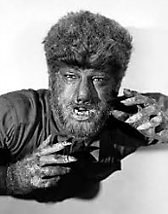
King Rex the Tyrant

Every Sunday or so, when with heart
high-sorrowful and cloyed
he rested from his day job,
you would not see him at his usual pasturage,
ripping meals from that great meat orchard
as he crashed his way down to a skyline luridly inflamed.

At such intervals, the animal world retired
to lick its wounds in silence, free
of those deafening shock waves from the swamp
when the thick-skinned King (who was also very thin-skinned)
pulled up short at his dinner to roar at his food:

DON’T LOOK AT MY HANDS!

Often you would find him in his palace
entertaining guests, in a genial mood,
eating, at most, two servants, and passing up a canapé.
A curtain would part to reveal, for connoisseurs,
the botches of his "abstract expressionist" paintings,
or he would read with a suavely modulated growl
from his latest forays into the realms of Erato.

And when the great gilded grandfather clock
in the hallway banged the ineluctable hour,
his chorus of toadies knew what to say:

Sire, won't you favor us with a little Debussy?

And we shuffled through the double doors
into the auditorium.
Industrial-strength kettledrum footsteps
crescendo'd from stage right.
He squeezed into view, his head bedizened
with a dandruff of klieg light shards.
He landed on the piano bench, squared
his shoulders to put a little wallop into it,
and then it was difficult to deny
that the up-and-down Clonk Clank Clownking
had begun.

Fine lacquered rosewood flew into chunks
of lumber exploding toward the ceiling
like a cloud of broken teeth, snapped strings
flailed like riot hoses slipped from the grasp.

All this time he watched over his work
with satanic eagle eyes hooded
by the ancestral crests of his orbital bones.

But now and then those eyes
seemed to look out at us in perplexity,
as if to ask why destiny had appointed him
to level the lyrical to the literal
with such monstrous finesse—
like that dream of a pagoda poised
over its reflection in a lake
collapsing into splinters of the physical damage
he was inflicting with those vengeful vestigial hands.

Ah, he could swallow a tank,
but an octave he could not span!

On and on the pounding softened us up
like the overture to a beach landing,
no place to hide in the inland of the ear,
he continued to torture Debussy,
blatantly violating the Geneva Accords,
and not to dangle from the rafters
by a piano wire was sufficient reward
for the strain of faking rapturous attention
and what else could we have done but pretend to listen
to what most of us still deny they ever saw?

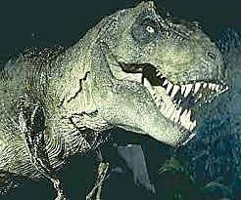
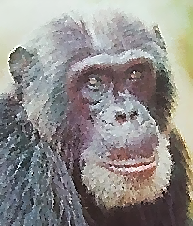
David Graybeard and the Kerosene Cans
And he dwelt in
On the day that David burst into his dazzle the land of Gombe...
The screech magnificoes were at their thrash,
Shaking great hanks of yellowing green in the sizzle
Of the sun—A bang. Heads turned. A flash.—

Hunched coteries howled to behold them baltering down
Past nits and picks of tufted hair—O Master
Of thunder-shine!—twin cans that battered on
Ahead of his long reach: he, scampering faster,

Caught up to what he had pushed with conative thrust.—
And the old Alpha’s crass and grabbed potestas
Loosened—he lost his ancient sway. In the must
Of his pride walked David now, in a dangle of testes,

Steward of Oestrus, ready his dung to fling.
And the stoop of the years brought gladness to his glands,
Much rump and postured fealty. For the King
Was righteous in his judgments and commands.

Some say when white-haired age had dimmed his eyes
To dark Sheol he would not knuckle under,
But in wet season still patrols the skies,
Pissing the rain, banging the cans of thunder.

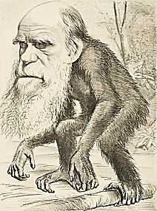
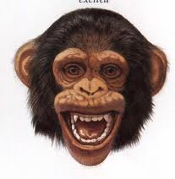
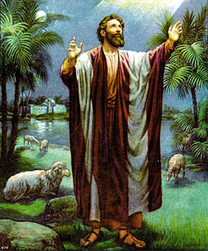
The Ancient Origins of Erotic Art

Beating your chest, ripping out hanks of grass
(Lust in the animal kingdom of the mind),
You ooh-ooh-ooh when she presents her ass,
Inviting you to reproduce your kind.

O that good old bonòbo bump-and grind
On simian Cupid’s archery range, that sass,
That waggle of a red bull’s-eye your blind
Heat-seeking muscle couldn’t miss!—Alas:

Inklings of thought invade your horny heart,
A skinny homunculus with an egg-shaped head
Gestates inside a mutant chromosome

Till you’re that four-eyes who reads Proust in bed
And pens some elbow-patched and dusty tome
On the ancient origins of erotic art.

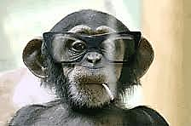
Happy Dancer

Swollen with bloody joy (fresh from the kill)
Who is that happy dancer at high noon
Repeating himself in cartwheels down the hill?
Baboon!
Baboon!
Baboon!
Baboon!
Baboon!

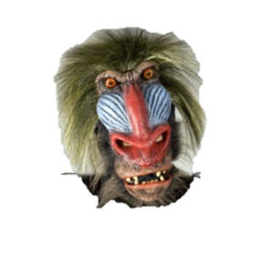

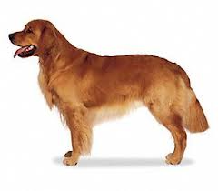
Golden Retriever on a Sunday Morning

At crack of dawn you walk the neighborhood,
Disturbing the peace, as if it were your mission.
You barked once: it was good; and what is good,
You think, can only improve with repetition.

From one end of the leash the sounds escape;
At the other end (to poignant fate resigned)
Wincing Reluctance takes a human shape
In order to be dragged along behind.

More than a bark, a sort of barkle shoots
From your mouth at rakish angles, lighting a blaze
Of pantomime in rooms, as shadowy mutes
Leap to their windows, shaking the Fists of Praise.

Why should you think that so much as a Darn it!
Is in their thoughts? Much rather a Hark! Hark!
It is the sound of bumptiousness incarnate,
Made flesh to yell among us, for a lark.

But that is what the whited cats most hate,
So suddenly uncurled from their porch chairs:
How you so placidly vociferate
Past an arched gauntlet stiffening on the stairs.

Some heads are cocked: What news needs such an early
Edition, in such boldface hype?—Inside
Your bushel of exclamation marks, there’s clearly
A light that has no present plans to hide.

You anoint your nose with soil, you are relentless
To tell its weight in sound to every smell;
Only the dried up and the utterly scentless
Reach out in vain for a lusty decibel.

The lions, the bears, the less hirsute performers—
The floppy-footed clowns kicking up sawdust—
Is it they who merit billing so enormous,
Painted in strokes that range from broad to broadest?

Or is the circus in that raucous tent
Your ruckus raises everywhere it goes?
So the announcement is the Great Event,
The Carnival Barker himself the Show of Shows?

You are no leper, sir; that is not Esau’s
Pelt you wear—it is Joseph’s coat. The park
Awaits; children will greet you from their seesaws:
Go, mingle the golden sunshine with the bark.

Ignore the finger-wagger, the head-shaker,
Spread the Good Noise, and stride on blithely by;
Offer a funhouse mirror to your Maker,
The imperious Impresario in the Sky.
* Z e p h y r *

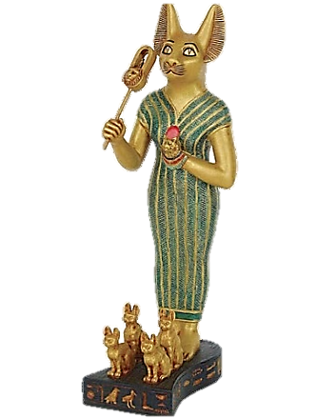

Do you see that kitten chasing so prettily her own tail? If you could look
with her eyes, you might see her surrounded with hundreds
of figures performing complex dramas….

--Ralph Waldo Emerson

* * *

When I play with my cat, who knows but that she regards
me more as a plaything than I do her?

--Michel de Montaigne

Grand Entrance

The door swings open. Paws advance.
Important whiskers. Golden pants.
Sound the trumpet. Bang the drum.
Here comes the littlest Panjandrum.

Personality Profile

A cobby tabby,
Not at all crabby,

Inclines to chubby,
Legs rather stubby…

Stroking her fur
Evokes a purr

A pleasing chirp
Will oft usurp.

Her puffy coat
Is brown—but note

The downy white
Streaks that highlight

The chest and belly
(As soft as jelly).

White spats enclose
Tenacious toes

From which extend
Those claws that rend

In two the moth
And satin cloth.

Her morning chore’s
To stop your snores

With urgent meows
Designed to rouse

You (with some screaming)
From pleasant dreaming.

Why ask the Maine
Coon to explain

Why the Maine Coon
Wakes up so soon?

A Maine Coon Cat
Is just like that.

Genealogy

Of hardy stock,
Foe to the lock,

This cat will pout
If not let out.

Bred on the farm
To do rats harm,

She slept by day
On bales of hay

In dusty loft.
At night, with soft

And stealthy tread,
She left her bed

To find and termin-
Ate whiskered vermin.

New England Gnomics

Under the sky
The vole will die.

But in the house
Death takes the mouse.

(The Maine Coon Cat
Will see to that.)

And let the bug
Upon the rug

Fall to its knees
And makes its peace

With the just God
Of the arthropod

When the Coon Cat
Inspects that mat.

In Catilinam

For vehemence of declamation,
What squirrel could top that Cicero
Hopping-mad on the branches’ tips?
Loftily conscious of his station,
He sneers down on the wretch below.
Scolding-hot scorn pours from his lips
While a grave senatorial bird
Appears to nod at every word.

Down there, in no particular hurry,
Deaf to this savage indignation,
The culprit yawns. The invective climbs
To further heights of righteous fury,
With pitiless enumeration
Of all the scoundrel’s plots and crimes—
But if he hears, he gives no sign,
This lazy little Catiline.

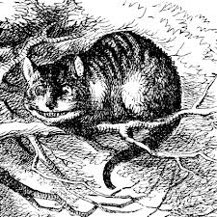
Empty Bowl

She opens her mouth. Her intense
Eyes follow me, full of soul.
Declamatory vehemence
Denounces the empty bowl.

Poem: Her Tongue, How It Sticks Out

So much is packed into your microcosm
(Item: one exquisitely creased nose blossom),
You have so many golden links with Heaven,
I’m pressed to give each genuinely Pseudo-
Dionysian charm its proper kudo
(Or is it kudos?) in these poems you live in.

Thus if I slight your pink slip of a tongue
I slight the All. (How could I leave unsung
Even your smallest stubs of grace? They tip
The world.)—Rose petal, slim slice of prosciutto,
All unexpectedly it will protrude, oh-
So-daintily subtending the upper lip!

With that sublime naïveté a few old
Statues embody (gaudy eyes bejeweled),
You stare, clueless what joy you give sad Pluto
As he peers up at you from his dark meadow:
You, brightly bannering your fail bravado,
Your slice of rose, your petal of pink prosciutto.

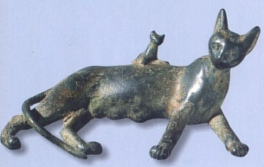
Skeletonics

Diminutive Zephyr,
Though slow as a heifer,
Likes raw Hasenpfeffer,
And will endeavor
In ways that are clever
To seize the leveret
By the neck bone, and sever it.

Ah, the spring fever it
Must be that plays deliberate
Havoc with prudence,
Making the blood dance
Hot in the veins of the two tense
Legs of the bunny
In weather that’s sunny,
That makes him incautious
When he should be nauseous
With fear of the huntress
Who will flay, or will undress,
If you will, the poor coney
Down to the bone, he
All the while screaming
At his unseaming
While blood comes streaming
From guts that are steaming
And the bad dreaming
Ends only with death, and bugs teeming.
(It’s nature’s law.)

And then the guffaw,
The religious awww!
At the white of her paw
And her delicate claw
Stop short at the ghastly jaw
Gaping aside
Naked of hide
Of the creature that cried
As he struggled and died
In the jaws of the Zephyr:
Last week’s Hasenpfeffer,
Gone now forever.

We rub her nose
In shames and no’s
But each of us knows
That that’s how it goes.
She does what she does:
She is what she will be and was.
We clean up the bones and the fuzz.

And should we ever
Locate the lever
The turns off her habit
Of killing the rabbit
I’m not sure we’d grab it.

Nine Life Slices

1.
A crack in the door.
A paw. An arm. A shoulder.
Two green eyes. A cat.

2.
Come over here you
Make me uncomfortable
Go away pet me.

3.
Sitting at the door,
Déjà vu. Wasn’t I here
A moment ago?

4.
Sitting by a tree
I am startled by the sound
Of one leaf falling.

5.
Loud noises issue
From a mouth whose shape outlines
A small, empty bowl.

6.
Since I don’t know how
To pull the door open, I’ll
Keep pushing at it.

7.
Clearly the world is
Structured like a scratching post.
Good thing I have claws.

8.
Cherry blossom.
Cherry blossom. Cherry blossom.
Cherry blossom. Finch!

9.
Crouched behind the bush…
What you see is a rose, not
A rose-colored nose.
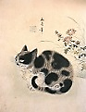
* Triolets from the Garden of Zephyr *

1. Butterfly

Creeping discreetly through the grass,
I see a butterfly flutterby.
(The snack’s too light. I let it pass.)
Creeping discreetly through the grass,
I’m stalking robins, which—alas!—
Though plump and slow, my form descry
Creeping discreetly through the grass.
(I see a butterfly flutterby.)

2. Mockingbird

The Mockingbird’s a shocking bird.
Why must she squawk at me? It’s rude.
Even Audubon, I think, concurred:
The Mockingbird’s a shocking bird.
And am I in the least deterred
From my designs upon her brood?
The Mockingbird’s a shocking bird.
Why must she squawk at me? It’s rude!

3. Tawny Interloper

That tawny interloper pissed
All over my catnip patch again.
Instead of wincing when I hissed,
That tawny interloper, pissed,
Just raised his tail, and then—and then—
That tawny interloper pissed
All over my catnip patch again!

4. Waldo and Michel

That crazy Waldo loves to chase his tail.
(I’m playing in the catnip with Michel.)
We note (it really seems beyond the pale)
That crazy Waldo loves to chase his tail.
We watch, we search for clues, and yet we fail
To find sufficient reason why the Hell
That crazy Waldo loves to chase his tail.
I’m playing in the catnip with Michel.

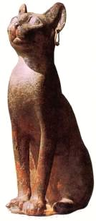
Scratching Post

How
can
this
human
stand
to
stay
on
his
two
thin
legs
that
way
day
in
day
out?
What
is
it
he
begs
for?
It
must
be
a
truly
HUGE
treat.
(On
those two flat feet!)

Cuisine Beguine

I’m bored with what rattles in cardboard.
But as for the steel that won’t stain,
It is filled with things fit for a lord:
How I love what the bright cans contain!

From the locker of Mr. Jones, Davy
Come some of the riches I crave,
Harvest reaped from the salt-seasoned wave:
For this I’d enlist in the Navy.
(And I don’t understand why you skimp
On the cans that envelop the shrimp.)
Yet the flesh of the chicken is braver
(I refer to its splendorous flavor).

But above all I wish to assert
That I think I’d desert from the Navy,
Even crawl through the desert, if only
I was sure that my just dessert
Would consist of the Slices in Gravy.
(With milk on the side, who’d be lonely?)

I confess it has caused me some hurt
That you’ve chosen to be so inert
In perceiving how awful a crisis
You cause when you hold back those beautiful Slices.

Gardening Tip

You plant the stuff because you like to watch a
Cat nip catnip:
How cute to see Yours Truly
Go about it!

You never thought to put, beside that patch, a
Bit of ratnip—
Which shows how much you really
Know about it.

Look into it, then, could you, while I catch a
Little catnap?—
Try not to be unduly
Slow about it.

Leave Me Alone

Leave me alone.
I have no truck with your untidy ways, your Brobdingnagdian pretences leave me cold as stone.

Leave me alone.
I do not speak your tongue, your unportending syllables to me are as the click of bone on bone.

Leave me alone.
I’ll sit here by the window and gaze out at the lawn, so prickly with the life of birds and
bugs, which I shall make my own.

Leave me alone.
Do not attempt familiarities, nor try my tummy with your clumsy, prizing hands, you shan’t
extort from me the rusty tribute of a groan.

If you would win the softening of my sneer today, there’s nothing you can coo
or babble, nothing you can say.

Just go away.

Will and Testament

Item.—To Michel:
Half of my soul,
The wishing well
Of my slices bowl.

Item.—To the tawny-furred
Tom: the mockingbird
And his joy-buzzer rasp,
Just past his grasp.

Item.—To all mockingbirds:
Such things…! I have no words.

Item.—To my humans:
More discernment
Than they have hitherto shown.
When they sit out on the lawn,
May they be lonesome
A little,
In the evening.

Also the Busy Ball,
Long idle
And spent.
Plus, my catnip mouse,
That bit of old string,
Any old thing
Of mine they find about the house
In the weeks ahead
As my absence settles in
Like dust
On the chairs in the kitchen.

And oh: my wrinkled
Papers, that clutch
Of crinkled
Bags and such,
Tamped thoroughly flat:
They can have that.

Where Do Good Cats Go?

On tippy-toes you nibble at your ease
Those juicy treats that hang from tuna trees.
Mice run from you or yield, just as you please.
That’s all I know.

You knead the clouds, leap down from shelves of air
And land on puffballs. Oh what handsome fare,
What creature comforts, tasty creatures there
Where good cats go!

Discreet, obedient angels come on call
To keep your food bowl brimming, or to haul
Away the kitty litter—then they all
Leave you alone.

You rub your cheek against the world, you toss
It in the air and pat it with your paws
Until its yarn unwinds. You can, because
It’s stuff you own.

A downward glance will show the place of howls
Where fire-cats poke at veterinarians’ bowels
And dogs in trees wince at those thunderous growls
And glowing eyes.

And mockingbirds won’t look so smug or sly
Seeing Death’s wingèd fur ball hurrying nigh
(If what I’ve heard is true, that cats can fly
In Paradise).

You lie on flowers beside the River Cream,
Dismember bugs (with which the grasses teem),
Or simply curl into a ball and dream,
Where good cats go.
Into the flow you dip a drowsy paw
Sometimes, and from the milky liquid draw
A fish, and watch it dangle from your claw.
That’s all I know.

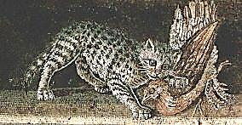
As the Crow Flies

High in the reaches combing the sky,
Wind through his feathers whistling by,

Stillness in motion, Angel the Crow
Shadows his signature over the snow.

Where he is flying, which of us knows?
Storm clouds gather, a dark wind blows.

Swift through the rise and the dip of his wings,
Swift through the marrow and air of his bones,

Swift through the honeycombed haunt of the marrow,
The wind is flying—the dark wind moans.

