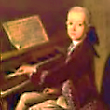
Notes of a Concert-Goer
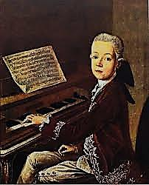
Notes of a Concert-Goer
dans le Neuvième Arrondissement
♫

Speaking as a Parisian ghost-about-town as well as a somewhat dingy ‘Inn-
Spectre’. In the Afterlife, partly under the influence of Mr V, I have become
much more interested in music than I was in life, Dears. One could say my
‘I’ is becoming ‘all ears’, but perhaps one shouldn’t. Here are some reviews.

1.
Not the arts only, all of life
Aspires to the condition of
Music, where all the passions love
Themselves, yes, even pain and strife.

As Nietzsche tells us in The Birth
Of Tragedy, in dissonances
The very soul of suffering dances,
Exulting in its trials on earth.

On a blind giant’s shoulders rides
(In Schopenhauer’s allegory)
The lame man who can only see,
Beset by instincts on all sides.

But that poor crippled, seeing mind
Finds fleeting Heaven in the ear
When the Will, imageless and clear,
Sings Passion purified and kind.

Music in which mere repetition
Holds sway narcotically but serves
To soothe or stimulate the nerves;
While that of genius, with a ‘vision’—

And yes, I mix my metaphors
Advisedly: every ‘aesthetic’
Is, on some level, synaesthetic—
Such melody as Mozart pours

Over our heads like sacred oil,
Anointing us with happiness
That brings us close to gods (they bless
This angel resting from his toil):

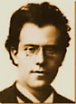
Such music is our sacred bread,
Or should be consecrated thus,
Estranging and enlarging us,
Joining the living and the dead

In tentative and secular
Communion: so intense, so clear,
Tuned to the inner eye and ear,
It sings in candles like a star,

Shines like brass fanfares! Though the bliss
Of the young dancer fades, alas!
In moments musicaux, the ‘was’
Is momentarily an is.

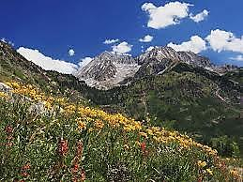
2. After an Evening of Mahler

Suppose that music, audible,
♫
Is only writing in the ear;
Then writing, it is equally clear,
Is music intellectual,

The melody that thinking makes,
Or rather the polyphony
Of its conflicted symphony,
Mahler-esque, dark, where lightning breaks

Only at times on the overbearing
And rather sophomoric Storm
And Stress at the loose edge of form.
Ah, best when all the pompous blaring

Of brassy fanfares and the dense
Black Nietzschean moustachioes
Of Nihilist dissonance find repose
In the Slow Movement, where the tense,

Brow-beating histrionics and
Heroics give way to a free,
Pure flow of complex reverie
And thought with thought walks hand in hand

Through Alpine glades in bracing air,
Crisp vistas of nostalgia,
With cow-bells tinkling, and ah!
Nietzsche and God are with us there.
3. Chopin

Recently I heard Rubinstein’s
(Arthur’s, I mean) Chopin: It is As distinct from the Russian
Sublime. Chopin! Strange, how in his composer-pianist Anton Rubinstein.
Hands a brief nocturne redefines
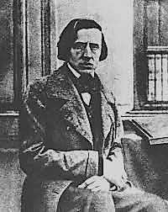
The world, and modulates its key.
One’s hearing grows chromatic: birds
♫
In the trees trill in minor thirds,
Full of Polish melancholy.

Refined, and yet through Marsyas’ throat
His pain at times forced melody.
For resolution endlessly
Deferred is the true modern note.

4. Richard Strauss

But, Beecham’s Rosenkavalier!
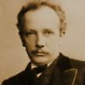
At Covent Garden I was present
And through the ears of a quite pleasant
Young man heard all, and shed a tear
♫

For the great Marschallin, and scoffed
At Baron Ochs when Mariandel,
Whom on his knee he tries to dandle,
Proves, when the sly disguise is doffed,

To be the man who steals his catch.
Margarethe Siems lived the rôle
With her clear notes and tender soul,
And what a queenly She to watch!

And ah, the splendid final scene, Beginning with the
As the celesta silvers over, duet, ‘Est ist ein Traum’.
The rose-red fire that burns ‘twixt lover
And lover when the Marschallin

Leaves Sophie and Octavian
Alone together, is a dream’s
Dream-consummation. And those gleams
Of dissonance? They are the wan

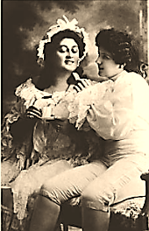
Smile of Princess Marie, resigning
Her claim with an auf Wiedersehn
To youth we shall not see again.
Clouds with them take their silver lining

When into nothingness they fade,
Leaving in memory a rack,
At most. She thinks (and turns her back),
Es ist vorbei! Yet, how well-played!

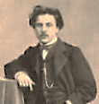
5. Fauré

Last night I went to hear Fauré:
♫
Piano Quartet in C Minor.
In chamber music there’s no finer
Expression of Provençal gai

Saber (save in the Violin
Sonata, also wrought when he
Was a young man passionately
In love). The scherzo, sparkling in

The mind as Keats’s beaded bubbles
Brim full the cup of vintage wine,
Moves in an agile, elfin line
Through that love’s dark and gathering troubles:

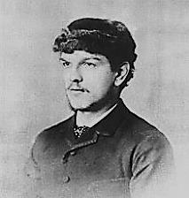
Rebuffed proposal, heart’s wound, rage
And sorrow, the dispiriting chore
Of running the Conservatoire,
♫
The politics… The War. Old age.

6. Debussy

Now the mysterious L’Après
Midi d’un Faune wafts through the gloom
And like a poisonous flower in bloom
Nijinsky with himself doth play! Théâtre du Châtelet, May 29, 1912.
Ah, quel succès de scandale!

(His leaps are such miraculous things:
He seems to hover in mid-air
Before descending; one could swear
Hermes had lent the boy his wings!)

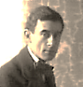
7. Ravel and l’Enfant et les Sortilèges

♫
And as for those svelte ear machines
Of the Swiss-Basque Maurice Ravel,
That paradis artificiel
Of pastoral wallpaper scenes

Torn by a child in petulant rage,
Where shepherds beating on a tabor
Make soft lament for love’s lost labour,
And innocence must turn the page

And hear the woodwinds’ mortal quavers:
I rode in one, vicariously,
Through a young lady named Marie
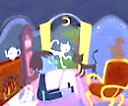
At the Opéra last month. One savours

The rich, expressive ether of this
Precise nostalgia of the ear
In an aloof child engineer
Who prizes a frail, guarded bliss,

The benediction falling on
Him softly in the shadowy garden,
When, hurt, he gains the creatures’ pardon
And he and innocence are one.

8. Vaughan Williams A pupil of Ravel’s. I astral-travelled to Gloucester
Cathedral to hear the premiere, September 1910.

Fantasia on a Theme by Thomas
Tallis: haunted as an old chapel,

The strings sound. The old story, apple
And fall and death, and distant promise…

♫

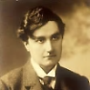
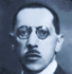
9. Young Turks

But in a way that makes one wince, key I attended the second, placidly received per-
Relationships are savagely formance of The Rite of Spring. Since its
Distorted, the ears rhythmically raucous debut it had quietly metamorphosed
Assaulted by the mad Stravinsky! into a cornerstone of the Repertoire, Dears!

(Diaghilew’s a man of charm
♫
And money. Gawkers stand on chairs
To watch pariah and homme d’affaires An impresario and art-collecter, interested in
Walk by the cafés arm in arm.) acquiring some of Aubrey’s erotic drawings.

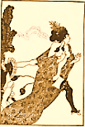
*

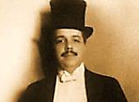

But when the gate of light’s unlocked

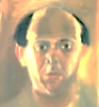
And I walk home into the Vast,
♫
Let it be to the mystic last
Strains of Schoenberg’s
Verklärte Nacht.
♫

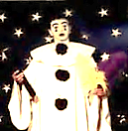
Sprechstimme, a glissando, shrill,
Death-pale expressionist nightmare,
Mad-clowning of Pierrot Lunaire…
The twentieth century is ill.

The Serialist Schoenberg
and his Disciples

[A screed against Serialism and the ‘Emancipation
of the Dissonance’, by the amateur musician, Mr V.]

Beyond the highest tessitura
Of an Expressionist soprano
The high, thin keys of the piano
Make a cold musica obscura,

Sound of the interstellar void,
A black noise as of some dark matter
Whose hymns to itself make glass shatter:
This is the music I avoid—

That is, of the twelve-tone variety.
In dodeco-cacophony
Of an affective palette free
Of every affect save anxiety,

It blandly ignores the nature of
The intervals. So dissonance
Must be freed? What, freed of nuance?
Insults to hearing win no love.

Theory’s Pyrrhic victory
Over the ear only accents
The split ‘twixt intellect and sense
In fractional overtones so high

That they amount to a dog-whistle
Music for dogs, and the dogs do
Not like it. And our poor ears, too,
Feel they are suffering a dismissal.

The hexachord is universal,
An aural grammar Nature ingrains
In foetal ears and foetal brains.
By a mechanical reversal

To embitter music, scorn the natal
Desire for consonance, and blame
Ears for not relishing the game,
Will to this music prove quite fatal.
